LOYOLA COLLEGE
Chennai – 600 034

Department of Data Science
PRACTICAL RECORD

Course Title : ____________________________
Dept. No. :
Name :
Semester :
Year :

Loyola College, Chennai – 600 034
Department of Data Science
BONAFIDE CERTIFICATE
Dept. No. :
Name :
Class :
This is to certify that this is the bonafide record of the practical work done in __________________________ at the Loyola College Data Center, during the year ______________.
Head of the Department Staff-in-Charge
Date : ________________
Submitted for the ________________________ Data Science Practical examination held on ________________ at Loyola College, Chennai – 600 034.

Internal Examiner External Examiner
CONTENTS

Sl. No. | Title | Date | Page No.
1 | Exploratory Data Analysis with Titanic Dataset | 01-07-2026 | 3-4
2 | Simple Linear Regression | 02-07-2026 | 5-6
3 | Multiple Linear Regression | 07-07-2026 | 7-8
4 | Polynomial Regression | 10-07-2026 | 9
5 | Regularization Techniques | 17-07-2026 | 10
6 | Logistic Regression | 24-07-2026 | 11
7 | K-Nearest Neighbour | 05-08-2026 | 12-13
8 | Decision Tree Classification | 20-08-2026 | 14-15
9 | Random Forest Classification | 21-08-2026 | 16-17
10 | Support Vector Machine | 25-08-2026 | 18-19
11 | K-Means Clustering | 28-08-2026 | 20-21
12 | Hierarchical Clustering | 02-09-2026 | 22-23
13 | DBSCAN Clustering | 07-09-2026 | 24-25
14 | Principal Component Analysis | 15-09-2026 | 26-28

Exercise – 01

Exploratory Data Analysis with Titanic Dataset
1. AIM
To perform exploratory data analysis on the Titanic dataset by examining its structure, missing values, statistical summaries, distributions, relationships and visual patterns.
2. ALGORITHM
1. Load the Titanic dataset.
2. Inspect rows, dimensions, data types and missing values.
3. Generate statistical summaries.
4. Perform the cleaning and transformations in the notebook.
5. Create the exploratory visualizations.
6. Interpret the observed patterns.
3. PROGRAM
import pandas as pd
import numpy as np
import matplotlib.pyplot as plt
import seaborn as sns

data = 'Dataset/titanic.csv'

df = pd.read_csv(data)

df.head()

df.tail()

df.sample(5)

print("Rows and Columns:", df.shape)

df.info()

df.describe()

df.size

df.columns

df.isnull().sum()

missing_percentage = (df.isnull().sum() / len(df)) * 100

print(missing_percentage.sort_values(ascending=False))

plt.figure(figsize=(10, 6))

sns.heatmap(
df.isnull(),
cbar=False,
yticklabels=False,
cmap="viridis"
)

plt.title("Missing Values Heatmap")
plt.show()

# Fill Age missing values
df["Age"] = df["Age"].fillna(df["Age"].median())

# Fill Embarked missing values
df["Embarked"] = df["Embarked"].fillna(df["Embarked"].mode()[0])

# Fill Cabin missing values
df["Cabin"] = df["Cabin"].fillna("Unknown")

print(df.isnull().sum())

print("Number of duplicate rows:", df.duplicated().sum())

df = df.drop_duplicates()

print("Shape after removing duplicates:", df.shape)

plt.figure(figsize=(6, 4))

sns.countplot(data=df, x="Survived")

plt.title("Passenger Survival Count")
plt.xlabel("Survived")
plt.ylabel("Number of Passengers")

plt.show()

survival_counts = df["Survived"].value_counts()

plt.figure(figsize=(6, 6))

plt.pie(
survival_counts,
labels=["Did Not Survive", "Survived"],
autopct="%1.1f%%",
startangle=90
)

plt.title("Survival Distribution")

plt.show()

plt.figure(figsize=(6, 4))

sns.countplot(data=df, x="Pclass")

plt.title("Passenger Class Distribution")
plt.xlabel("Passenger Class")
plt.ylabel("Number of Passengers")

plt.show()

plt.figure(figsize=(6, 4))

sns.countplot(data=df, x="Sex")

plt.title("Gender Distribution")
plt.xlabel("Gender")
plt.ylabel("Number of Passengers")

plt.show()

plt.figure(figsize=(7, 5))

sns.countplot(
data=df,
x="Sex",
hue="Survived"
)

plt.title("Survival by Gender")
plt.xlabel("Gender")
plt.ylabel("Number of Passengers")

plt.show()

plt.figure(figsize=(7, 5))

sns.countplot(
data=df,
x="Pclass",
hue="Survived"
)

plt.title("Survival by Passenger Class")
plt.xlabel("Passenger Class")
plt.ylabel("Number of Passengers")

plt.show()

plt.figure(figsize=(8, 5))

sns.boxplot(
data=df,
x="Survived",
y="Fare"
)

plt.title("Fare Distribution by Survival")
plt.xlabel("Survived")
plt.ylabel("Fare")

plt.show()

g = sns.catplot(
data=df,
x="Pclass",
hue="Survived",
col="Sex",
kind="count",
height=5,
aspect=1
)

g.fig.suptitle(
"Survival by Passenger Class and Gender",
y=1.05
)

plt.show()

plt.figure(figsize=(9, 6))

sns.scatterplot(
data=df,
x="Age",
y="Fare",
hue="Survived",
style="Sex",
size="Pclass",
sizes=(50, 200)
)

plt.title("Age vs Fare by Survival, Gender and Class")
plt.xlabel("Age")
plt.ylabel("Fare")

plt.show()

numeric_columns = [
"Survived",
"Pclass",
"Age",
"SibSp",
"Parch",
"Fare"
]

correlation = df[numeric_columns].corr()

print(correlation)

plt.figure(figsize=(9, 7))

sns.heatmap(
correlation,
annot=True,
cmap="coolwarm",
fmt=".2f",
linewidths=0.5
)

plt.title("Correlation Heatmap")

plt.show()

4. OUTPUT

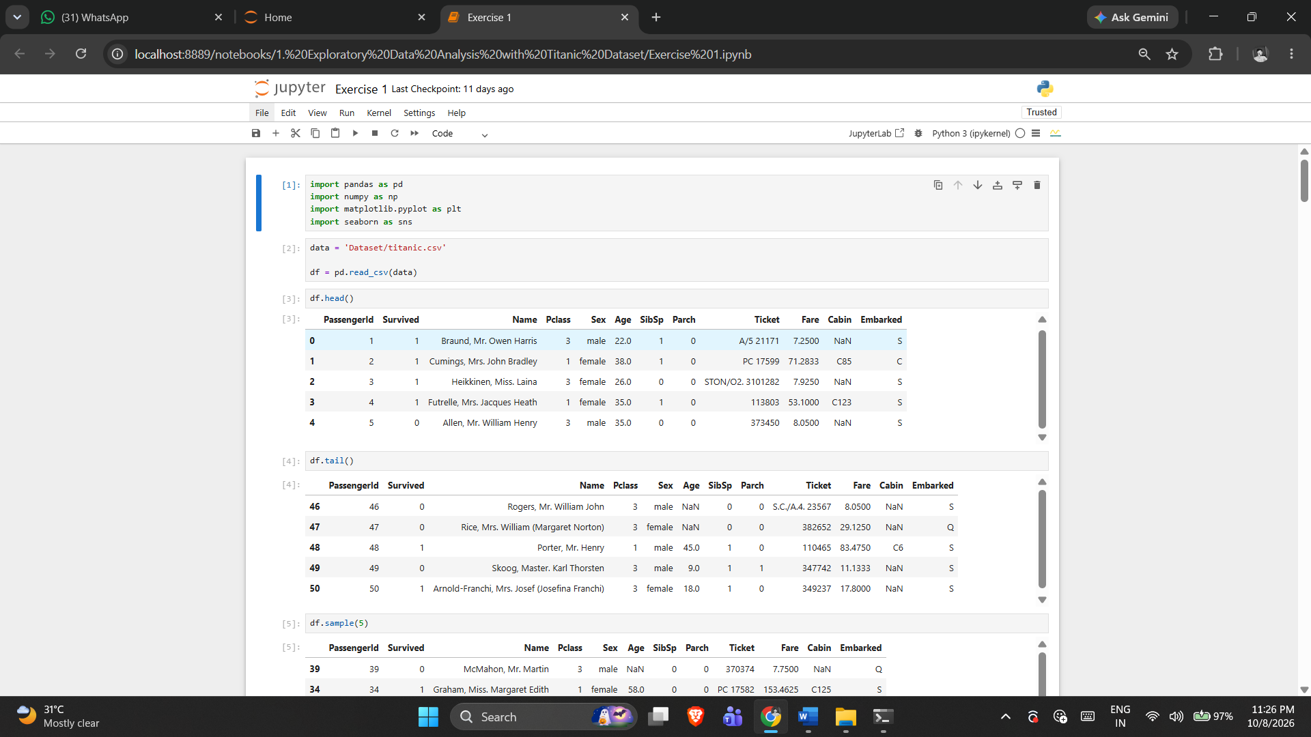

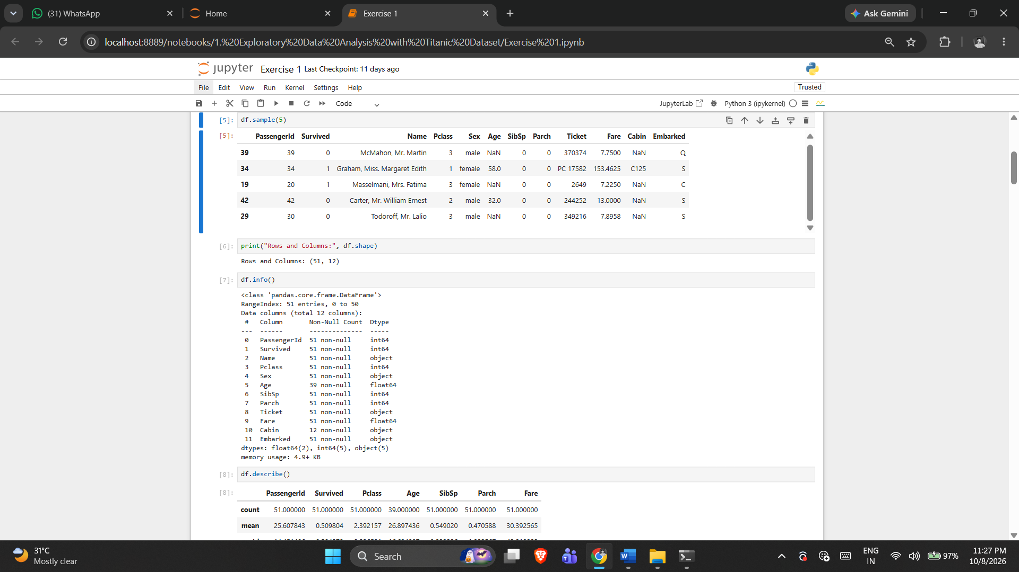

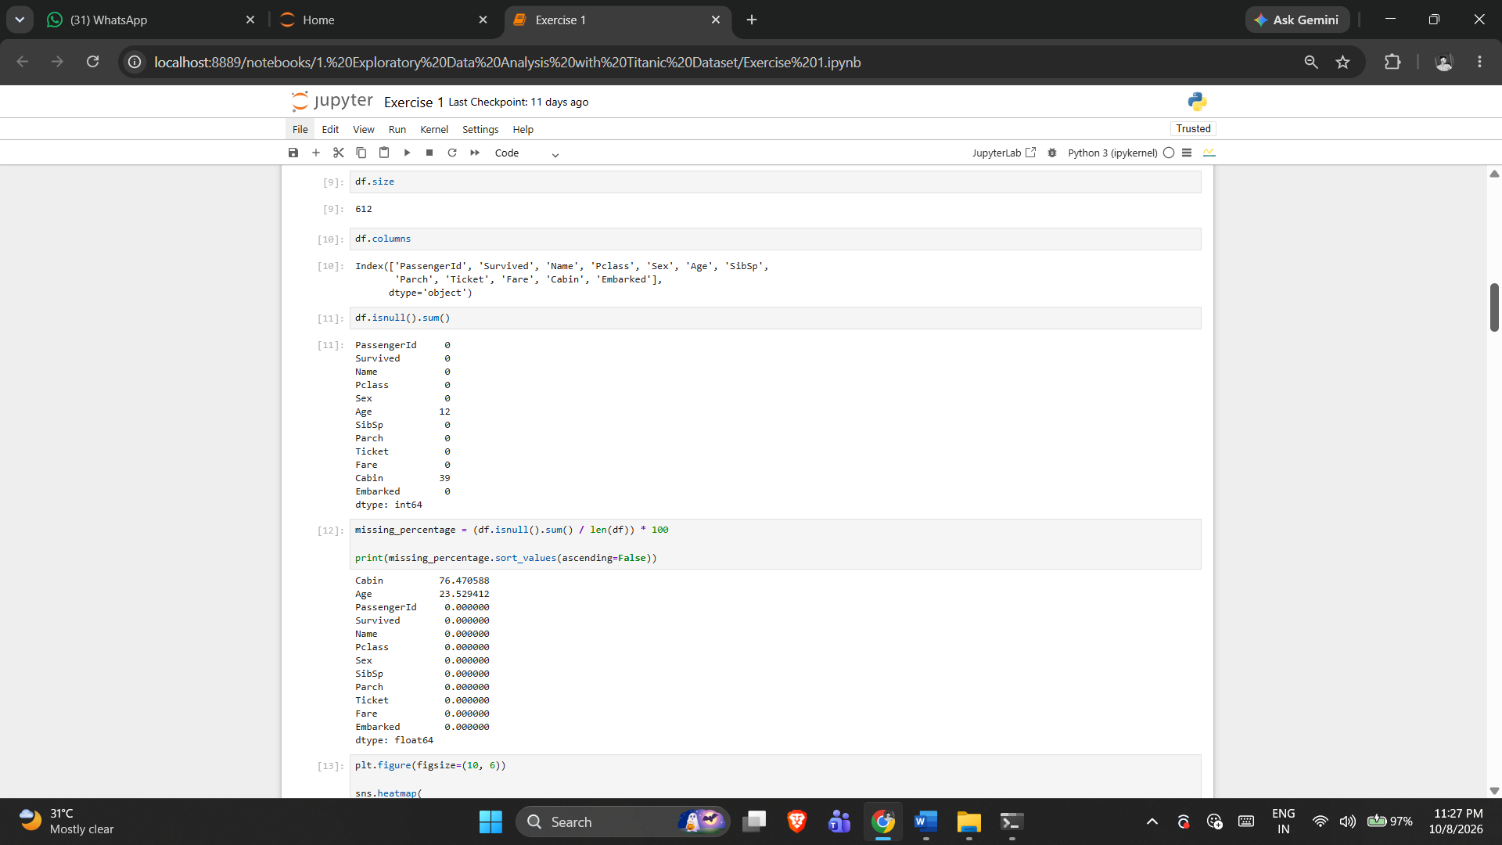

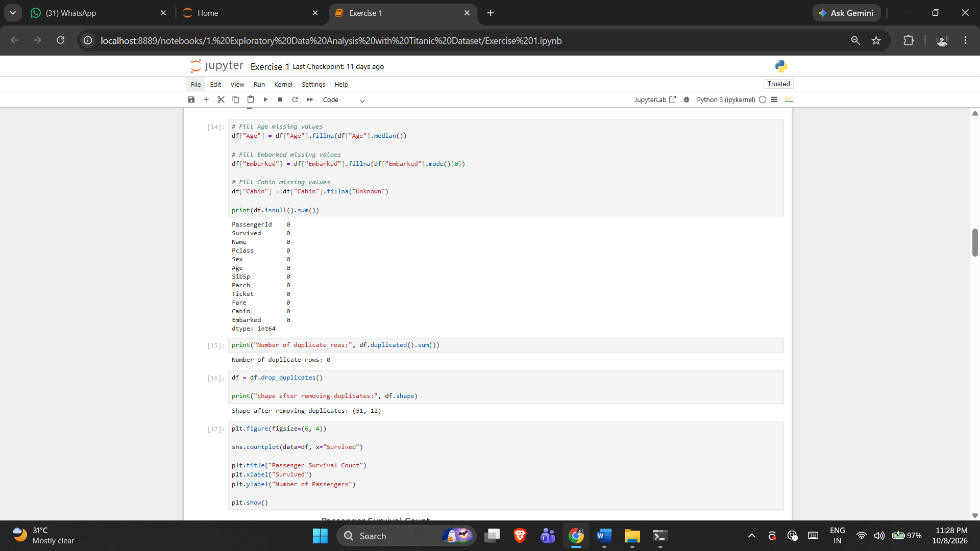

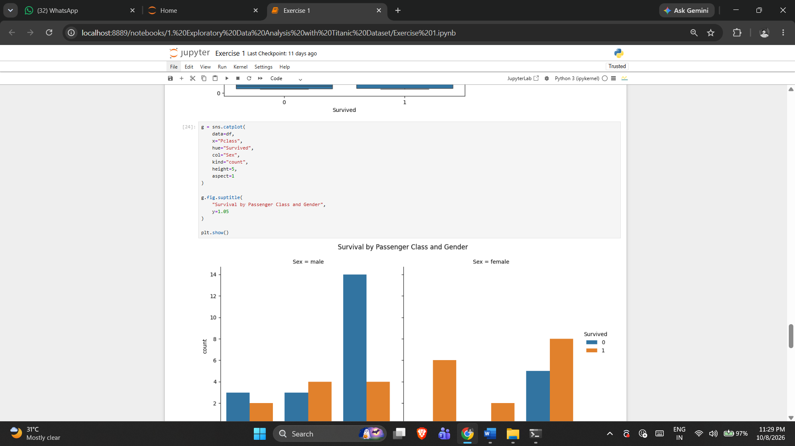

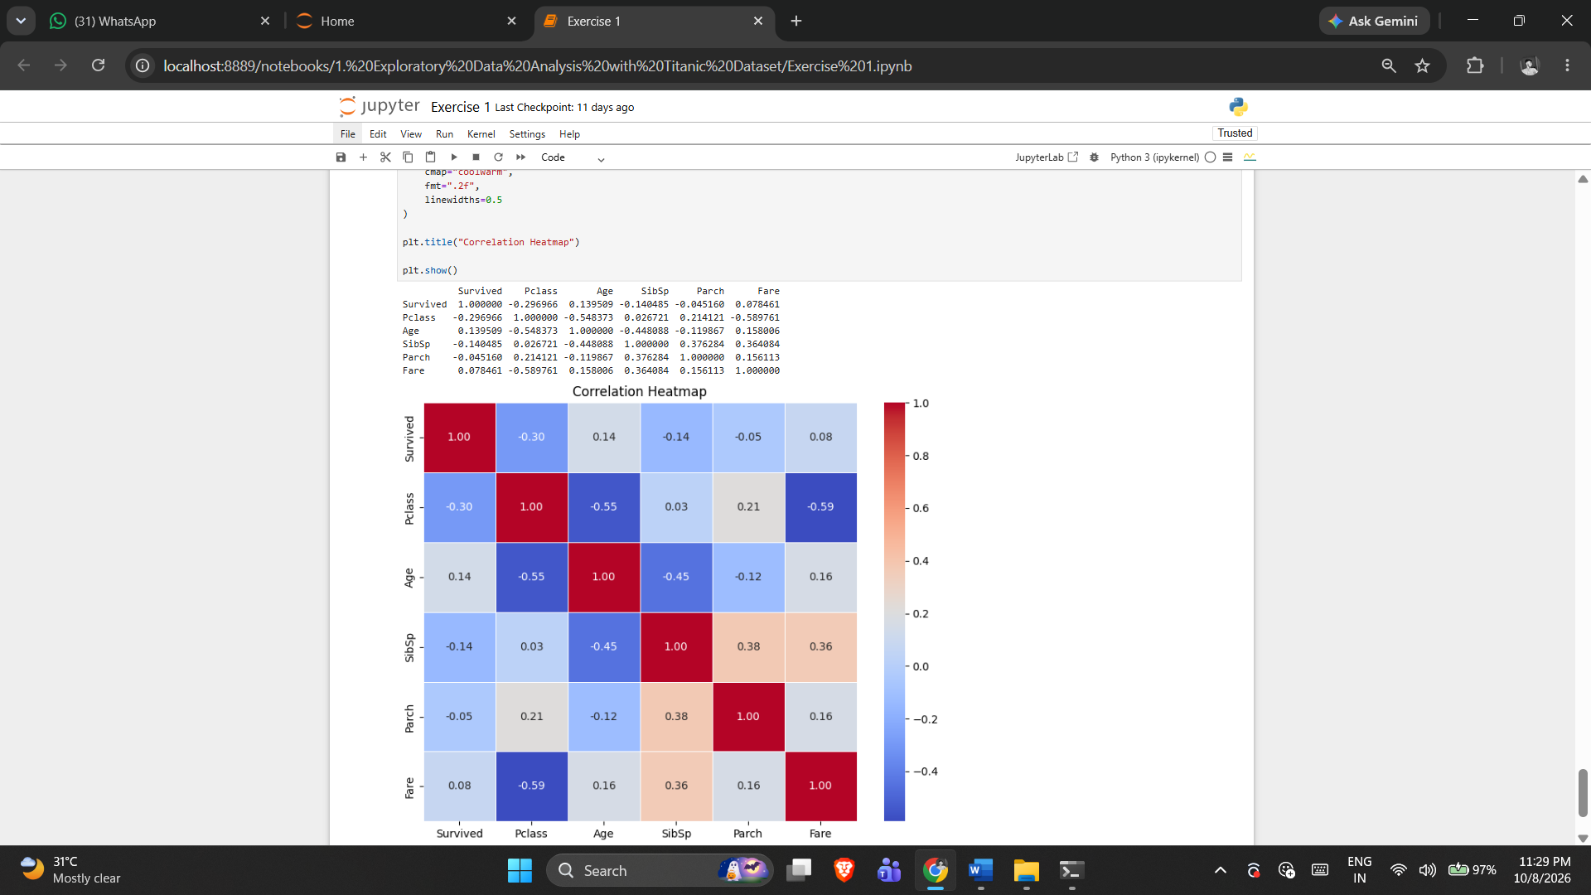

5. RESULT
Thus, the Exploratory Data Analysis with Titanic Dataset practical was implemented successfully using the program from the corresponding Jupyter Notebook.

Exercise -2

Simple Linear Regression

1. AIM
To implement and demonstrate Simple Linear Regression using the dataset, preprocessing, model or analysis workflow provided in the corresponding Jupyter Notebook.
2. ALGORITHM
1. Load the regression data.
2. Select the independent and dependent variables.
3. Split the data into training and testing sets.
4. Train Linear Regression.
5. Generate predictions.
6. Calculate the notebook's evaluation metrics.
7. Plot the fitted regression relationship.
3. PROGRAM
import pandas as pd
import numpy as np
import matplotlib.pyplot as plt
import seaborn as sns
from sklearn.model_selection import train_test_split
from sklearn.linear_model import LinearRegression
from sklearn.metrics import mean_squared_error, r2_score

data = "Dataset/Salary.csv"
df = pd.read_csv(data)
df = df[['YearsExperience','Salary']]

df

df.size

df.shape

df.isnull().sum()

X = df[['YearsExperience']] # Independent Variable
y = df['Salary'] # Dependent Variable

model = LinearRegression()

model.fit(x1,y1)

x1,x2,y1,y2 = train_test_split(X,y,random_state= 42,test_size=0.2)

y_pred = model.predict(x2)

print("Actual Values:")
print(y2.values)

print("Predicted Values:")
print(y_pred)

print("Coefficient (Slope):", model.coef_[0])
print("Intercept:", model.intercept_)
print("Mean Squared Error:", mean_squared_error(y_test, y_pred))
print("R2 Score:", r2_score(y_test, y_pred))

YearsExperience = [[2.1]]
predicted_salary = model.predict(YearsExperience)

print("Predicted salary for 2.1 years:", predicted_salary[0])

plt.scatter(X, y, color='blue', label='Actual Data')
plt.plot(X, model.predict(X), color='red', linewidth=2, label='Regression Line')

plt.xlabel("Experience")
plt.ylabel("salary")
plt.title("Simple Linear Regression")
plt.legend()
plt.show()
4. OUTPUT
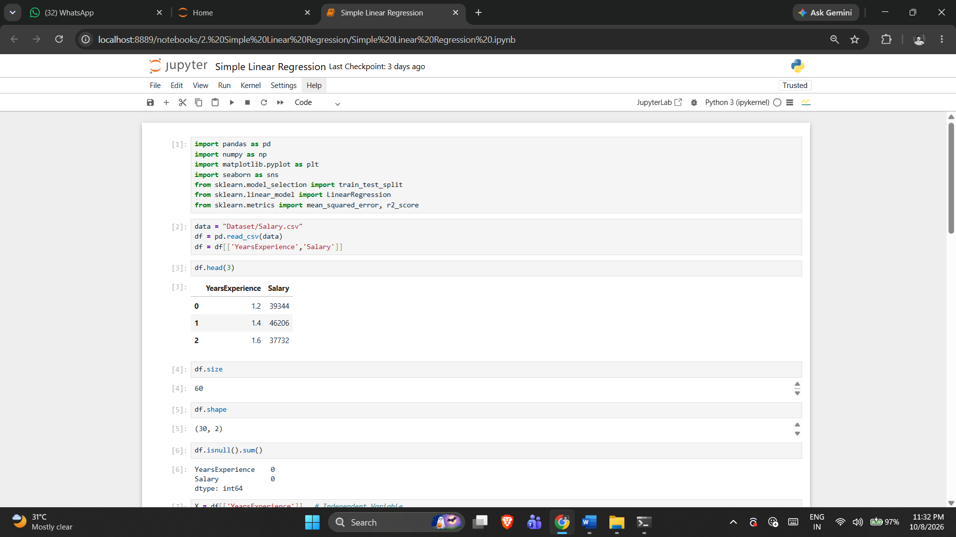

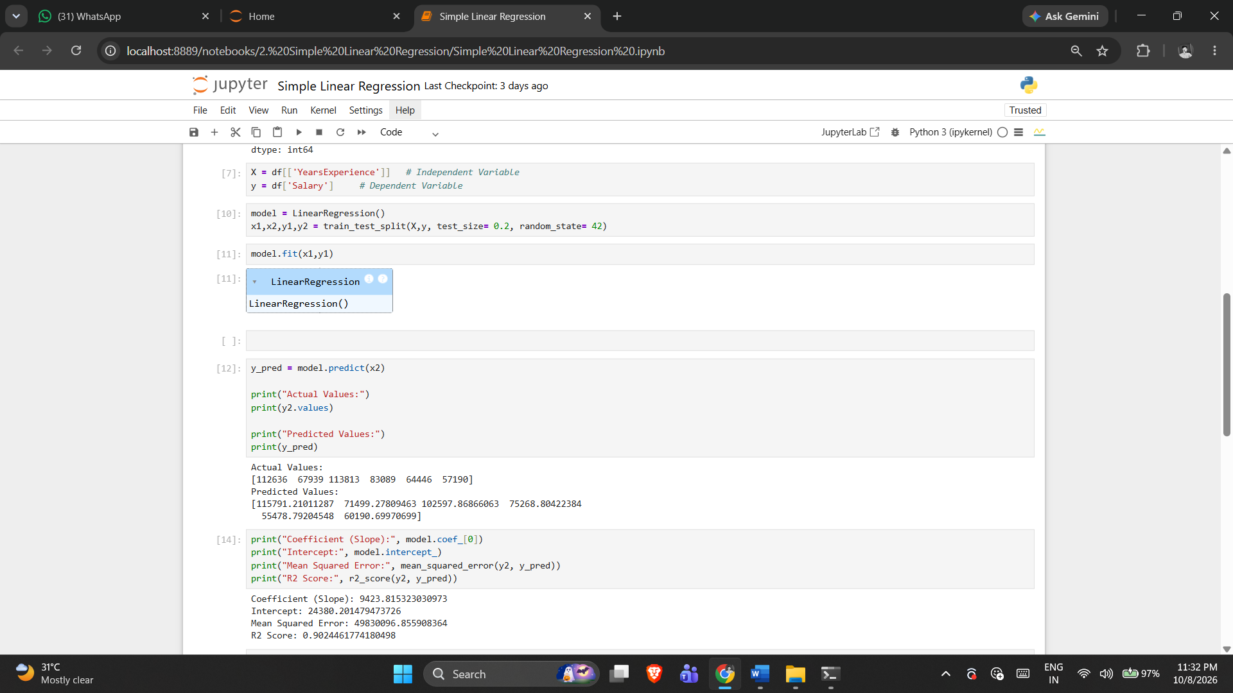

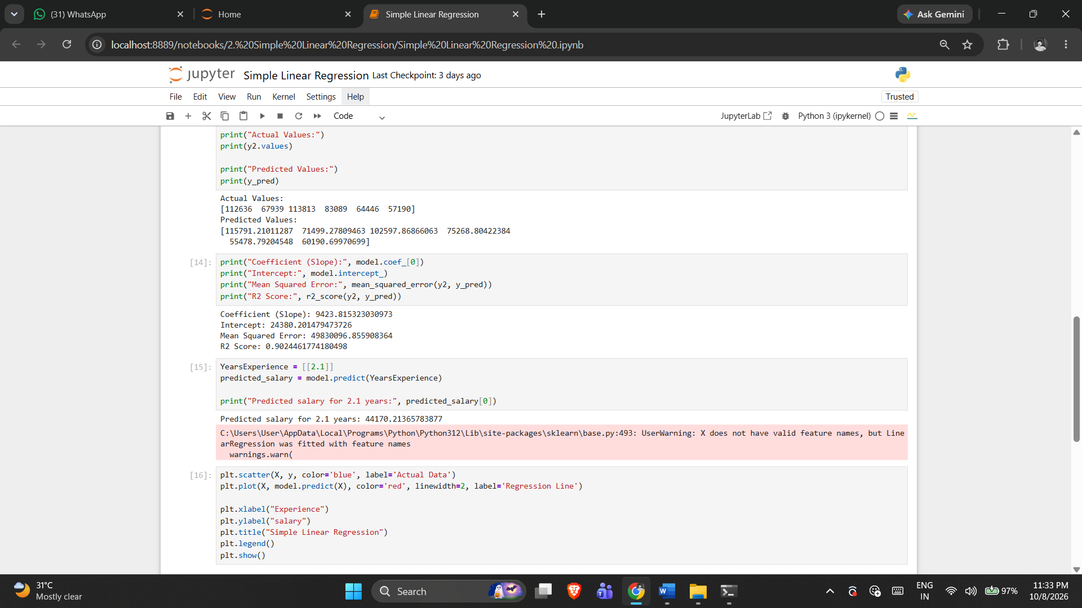

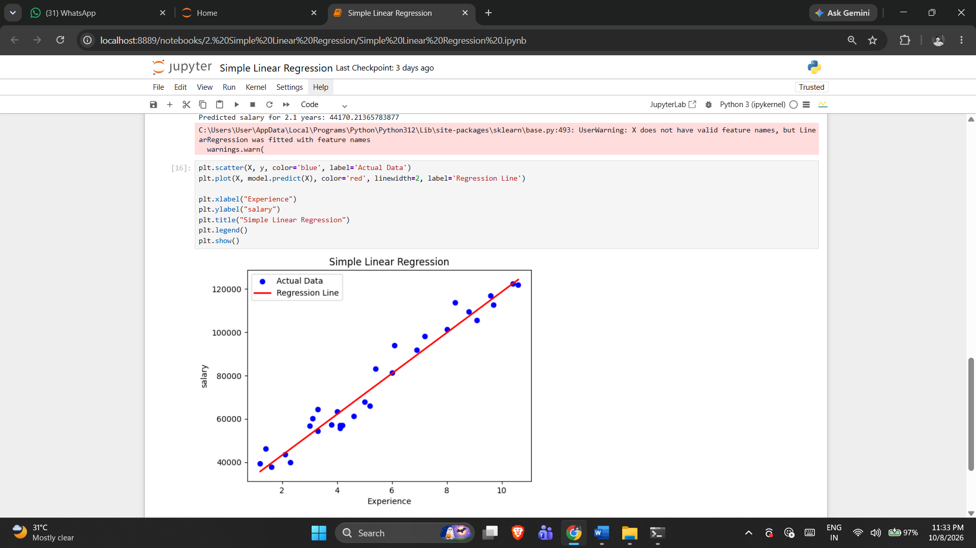

5. RESULT
Thus, the Simple Linear Regression practical was implemented successfully using the program from the corresponding Jupyter Notebook.

Exercise -3

Multiple Linear Regression
1. AIM
To implement and demonstrate Multiple Linear Regression using the dataset, preprocessing, model or analysis workflow provided in the corresponding Jupyter Notebook.
2. ALGORITHM
1. Load the regression dataset.
2. Select the target and multiple predictor variables.
3. Split the data into training and testing sets.
4. Train the multiple linear regression model.
5. Generate predictions.
6. Calculate the regression metrics implemented in the notebook.
7. Display the notebook's visual analysis.
3. PROGRAM
import pandas as pd
import numpy as np
from sklearn.model_selection import train_test_split
from sklearn.preprocessing import LabelEncoder
from sklearn.linear_model import LinearRegression
from sklearn.metrics import (
mean_absolute_error,
mean_squared_error,
r2_score,
mean_absolute_percentage_error,
explained_variance_score,
max_error
)

data = 'Dataset/Housing.csv'

df= pd.read_csv(data)

df.head()

df.info()

le = LabelEncoder()
for col in df.select_dtypes(include="object").columns:
df[col] = le.fit_transform(df[col])

X = df.drop("price", axis=1)
y = df["price"]

x1, x2, y1, y2 = train_test_split(X, y,test_size=0.2,random_state=42)

model = LinearRegression()
model.fit(x1, y1)

y_pred = model.predict(x2)
y_pred

mae = mean_absolute_error(y2, y_pred)
mse = mean_squared_error(y2, y_pred)
rmse = np.sqrt(mse)
r2 = r2_score(y2, y_pred)
mape = mean_absolute_percentage_error(y2, y_pred)
evs = explained_variance_score(y2, y_pred)
maxerr = max_error(y2, y_pred)

n = x2.shape[0] # Number of observations
p = x2.shape[1] # Number of predictors

adj_r2 = 1 - ((1-r2)*(n-1)/(n-p-1))

print("\n========== Regression Evaluation ==========")
print(f"Mean Absolute Error (MAE): {mae:.2f}")
print(f"Mean Squared Error (MSE): {mse:.2f}")
print(f"Root Mean Squared Error (RMSE): {rmse:.2f}")
print(f"R² Score: {r2:.4f}")
print(f"Adjusted R² Score: {adj_r2:.4f}")
print(f"Mean Absolute Percentage Error (MAPE): {mape:.4f}")
print(f"Explained Variance Score: {evs:.4f}")
print(f"Maximum Error: {maxerr:.2f}")

print("\nIntercept:")
print(model.intercept_)

# In[21]:

print("\nCoefficients:")
coef = pd.DataFrame({
"Feature": X.columns,
"Coefficient": model.coef_
})
print(coef)

new_house = [[5000,3,2,2,1,1,0,1,0,1,0,1]]

prediction = model.predict(new_house)

print("\nPredicted House Price:", prediction[0])

import matplotlib.pyplot as plt
plt.figure(figsize=(6,6))
plt.scatter(y2, y_pred)
plt.plot([y2.min(), y2.max()],
[y2.min(), y2.max()],
'r--')

plt.xlabel("Actual Price")
plt.ylabel("Predicted Price")
plt.title("Actual vs Predicted Values")
plt.show()
4. OUTPUT
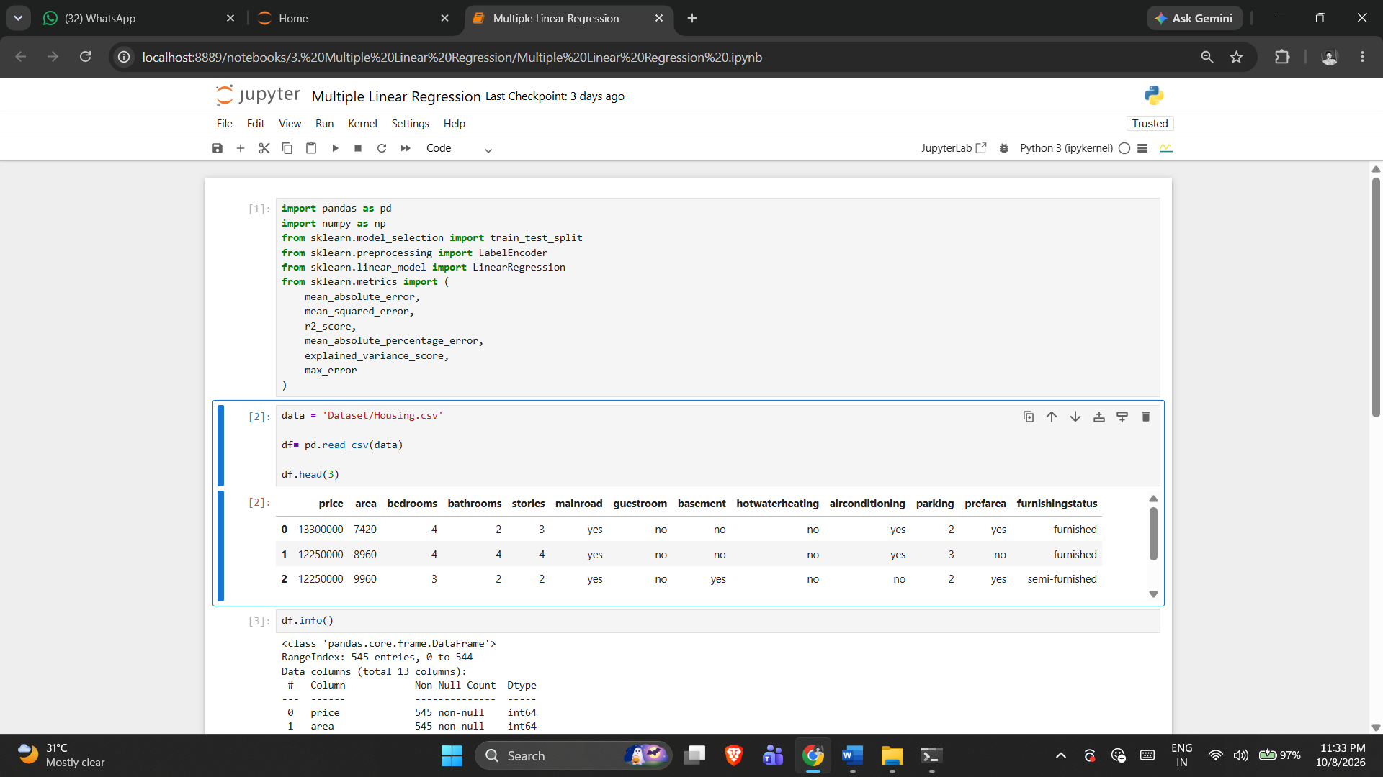
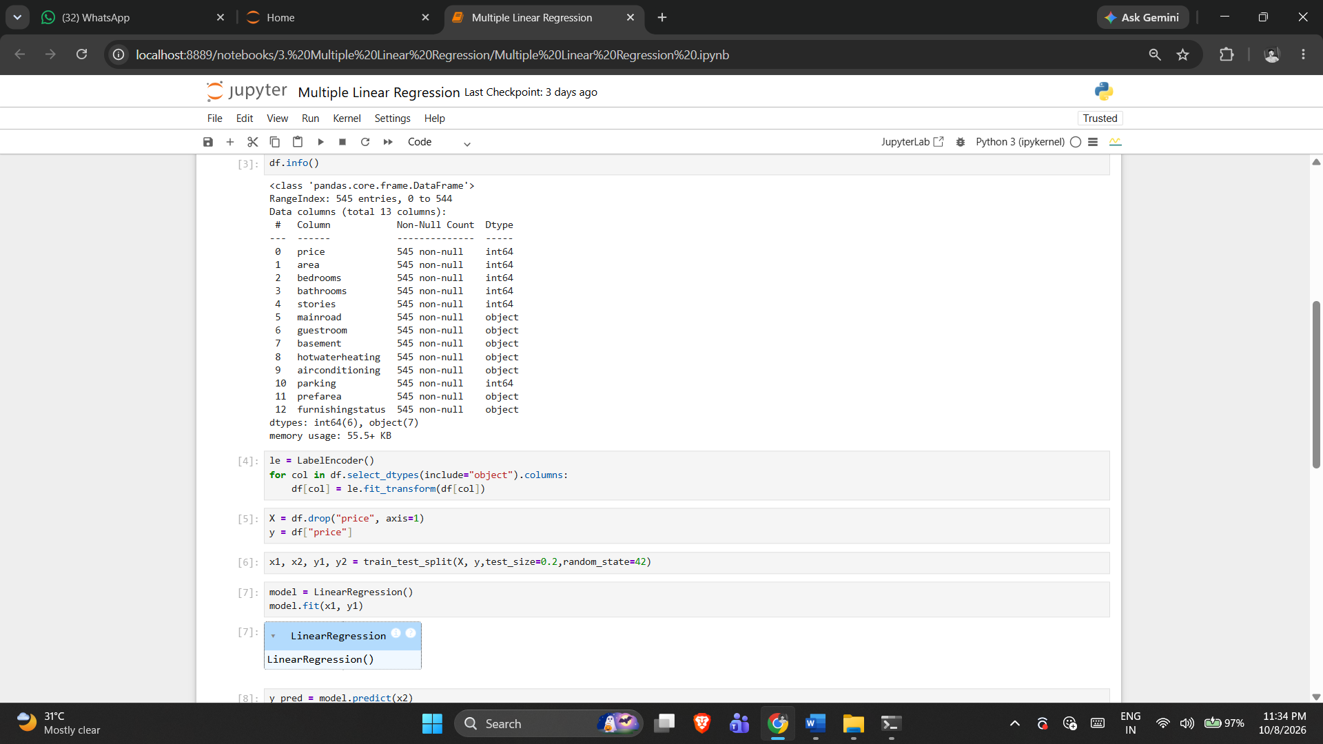

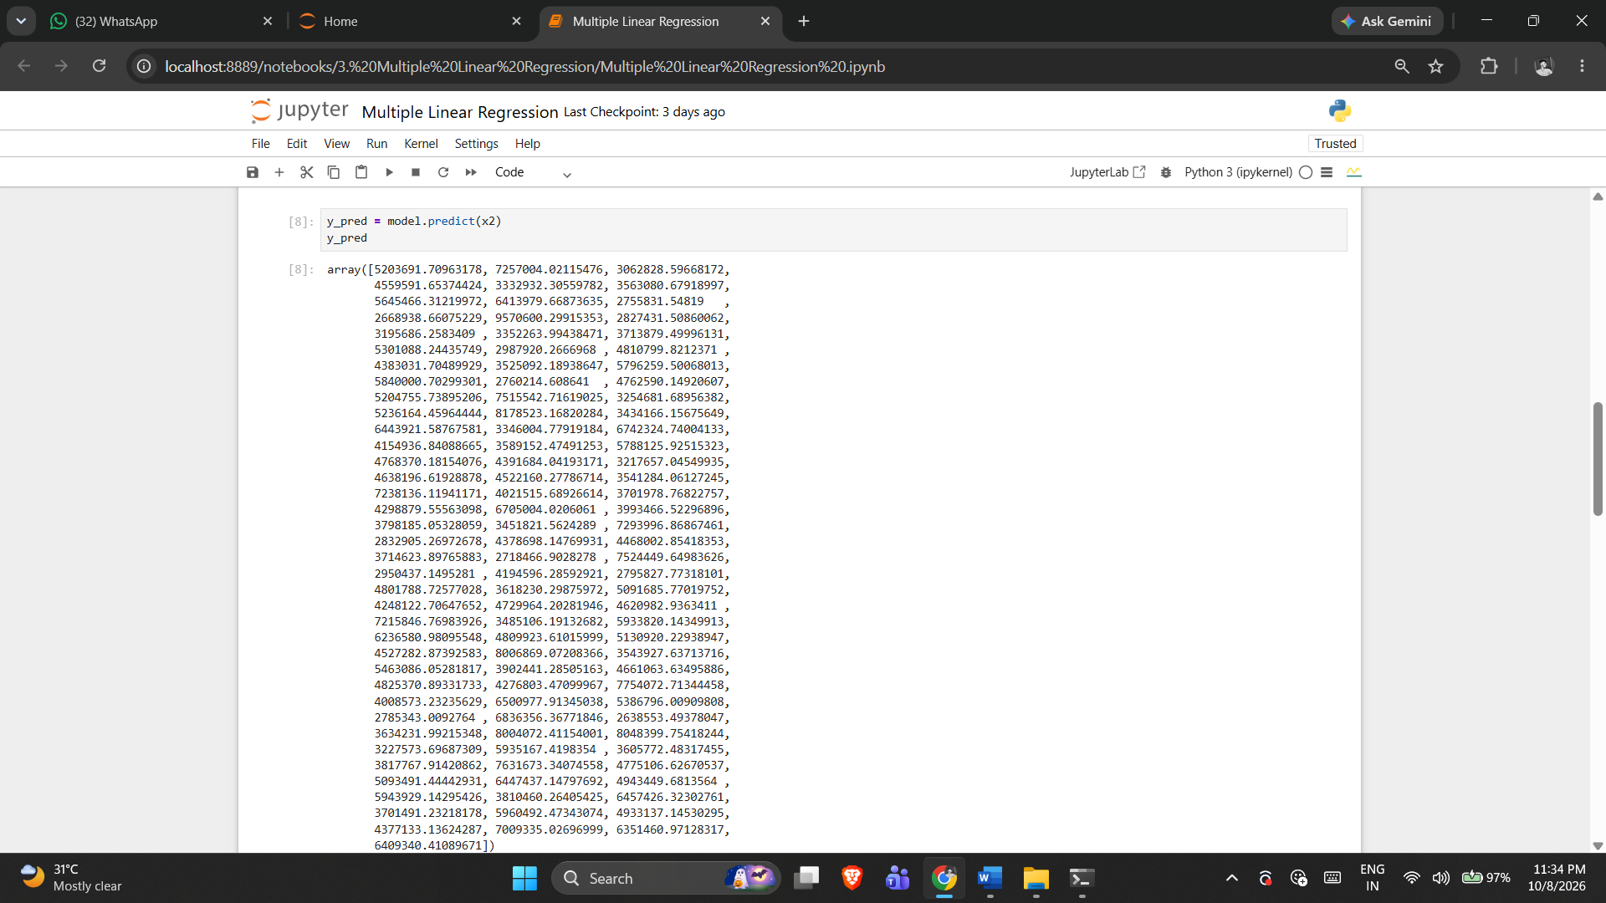

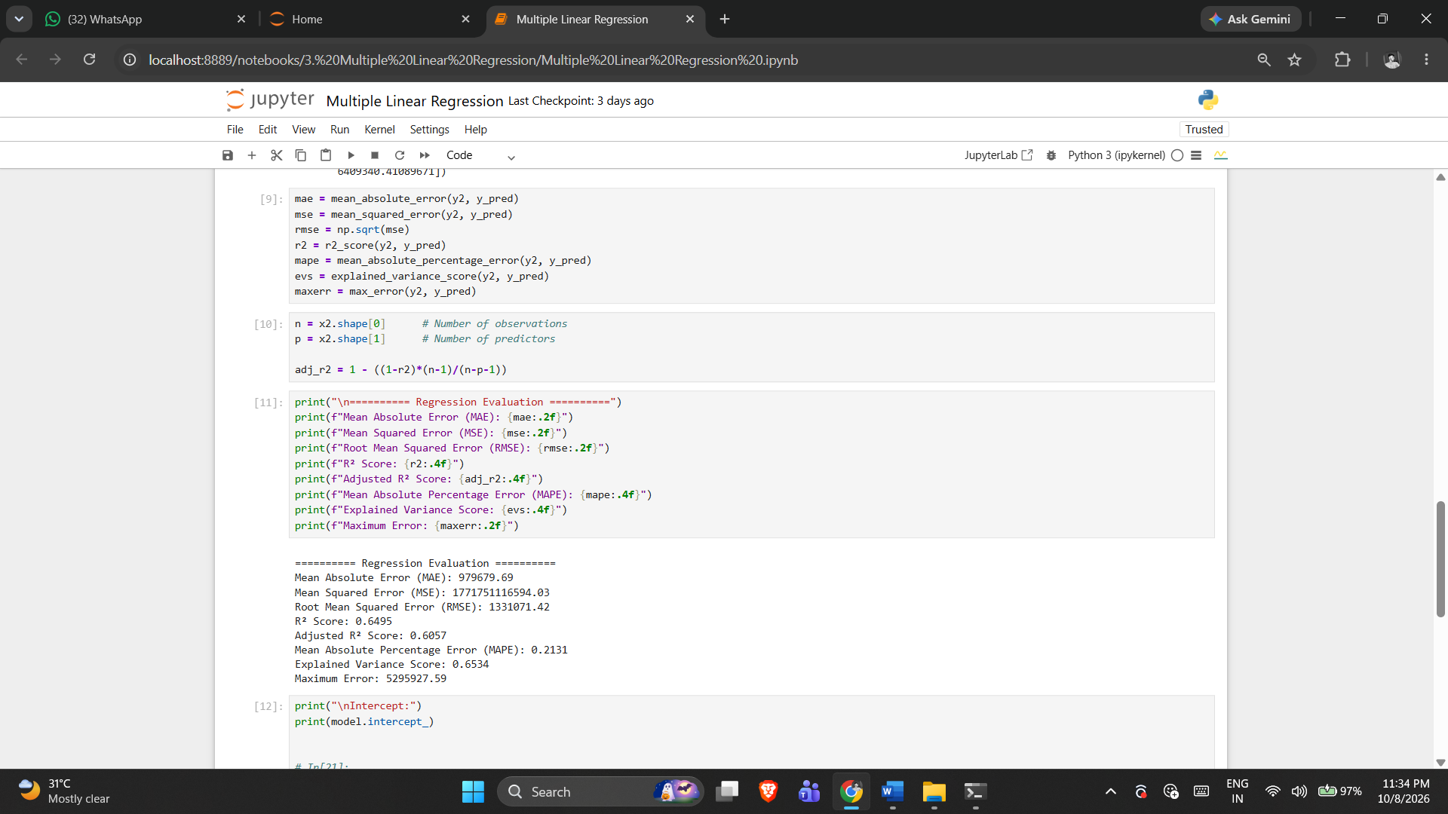

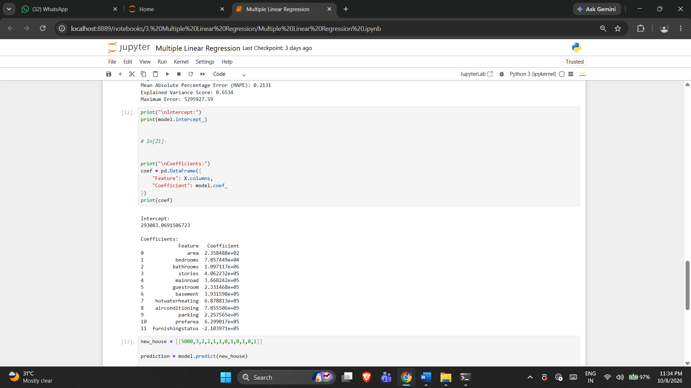

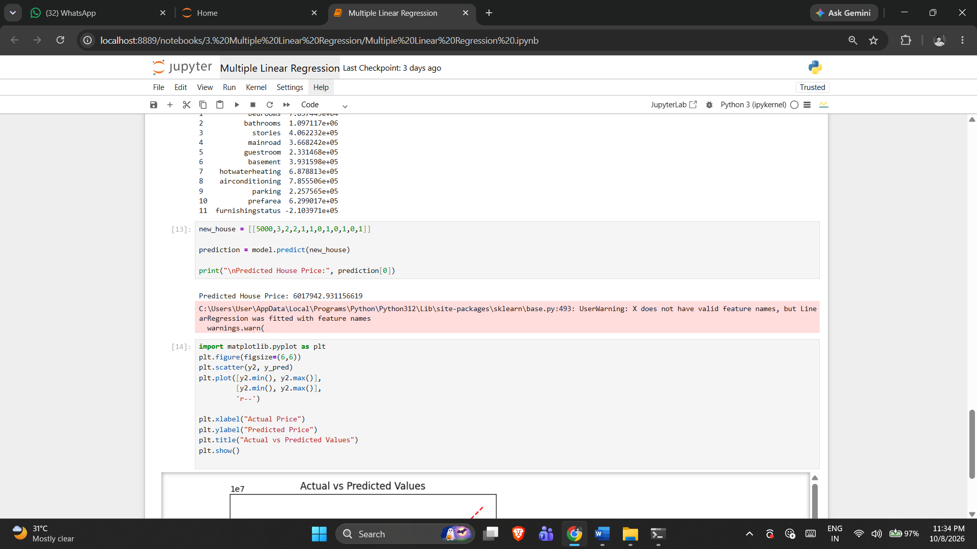

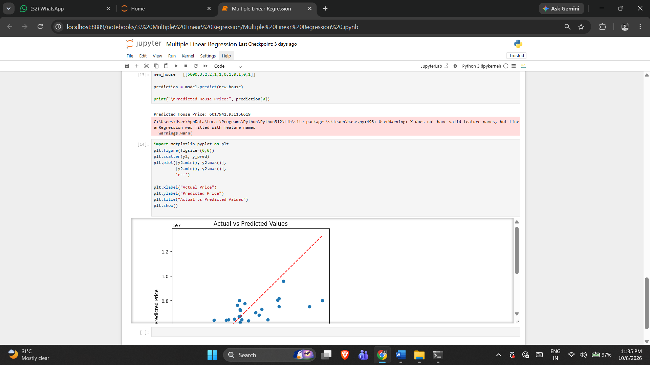

5. RESULT
Thus, the Multiple Linear Regression practical was implemented successfully using the program from the corresponding Jupyter Notebook.

Exercise -4

Polynomial Regression
1. AIM
To implement degree-2 polynomial regression, evaluate its predictions with the notebook's regression metrics, and visualize the fitted curve.
2. ALGORITHM
1. Load and inspect the fish dataset.
2. Encode the Species feature.
3. Separate Weight as target.
4. Split into training and testing sets.
5. Generate degree-2 polynomial features.
6. Train Linear Regression on transformed features.
7. Calculate all metrics implemented in the notebook.
8. Plot the polynomial relationship for Length3 and Weight.
3. PROGRAM
import pandas as pd
import numpy as np
import matplotlib.pyplot as plt
from sklearn.model_selection import train_test_split
from sklearn.preprocessing import PolynomialFeatures
from sklearn.linear_model import LinearRegression

from sklearn.metrics import (
mean_absolute_error,
mean_squared_error,
r2_score,
mean_absolute_percentage_error,
explained_variance_score,
max_error
)

data = 'Dataset/fish.csv'
df = pd.read_csv(data)

df.head()

df.info()

df.shape

df = pd.get_dummies(df, columns=['Species'], drop_first=True)

X = df.drop("Weight", axis=1)
y = df["Weight"]

x1, x2, y_train, y_test = train_test_split(
X,
y,
test_size=0.2,
random_state=42
)

poly = PolynomialFeatures(degree=2)

X_train_poly = poly.fit_transform(x1)
X_test_poly = poly.transform(x2)

model = LinearRegression()

model.fit(X_train_poly, y_train)

# Prediction
y_pred = model.predict(X_test_poly)

mae = mean_absolute_error(y_test, y_pred)
mse = mean_squared_error(y_test, y_pred)
rmse = np.sqrt(mse)
r2 = r2_score(y_test, y_pred)
mape = mean_absolute_percentage_error(y_test, y_pred)
evs = explained_variance_score(y_test, y_pred)
maxerr = max_error(y_test, y_pred)

# Adjusted R²
n = X_test_poly.shape[0]
p = X_test_poly.shape[1] - 1

adj_r2 = 1 - ((1-r2)*(n-1)/(n-p-1))

print("\n========== Evaluation Metrics ==========")

print("MAE :", mae)
print("MSE :", mse)
print("RMSE :", rmse)
print("R2 Score :", r2)
print("Adjusted R2 :", adj_r2)
print("MAPE :", mape)
print("Explained Variance :", evs)
print("Maximum Error :", maxerr)

X = df[['Length3']]
y = df['Weight']
poly = PolynomialFeatures(degree=2)

X_poly = poly.fit_transform(X)

model = LinearRegression()
model.fit(X_poly, y)

X_grid = np.arange(
X.min().values[0],
X.max().values[0],
0.1
).reshape(-1,1)

plt.figure(figsize=(8,6))

plt.scatter(X, y, color="blue", label="Actual Data")

plt.plot(
X_grid,
model.predict(poly.transform(X_grid)),
color="red",
linewidth=3,
label="Polynomial Curve"
)

plt.xlabel("Length3")
plt.ylabel("Weight")
plt.title("Polynomial Regression")
plt.legend()
plt.show()
4. OUTPUT
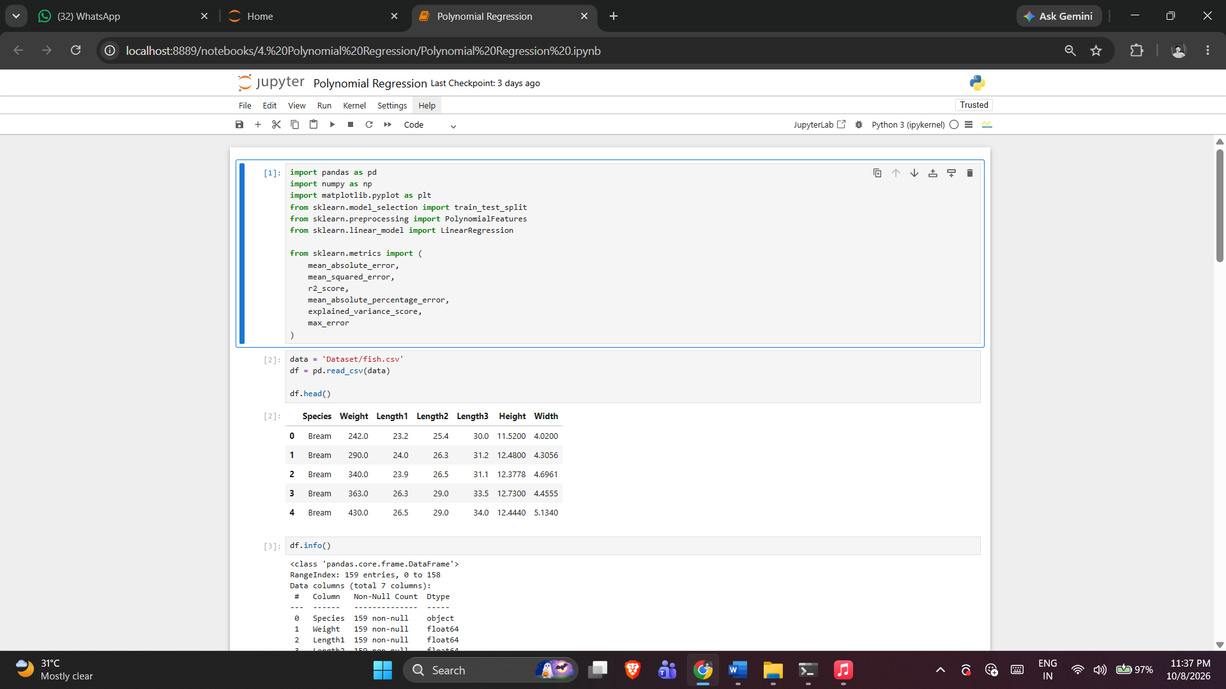

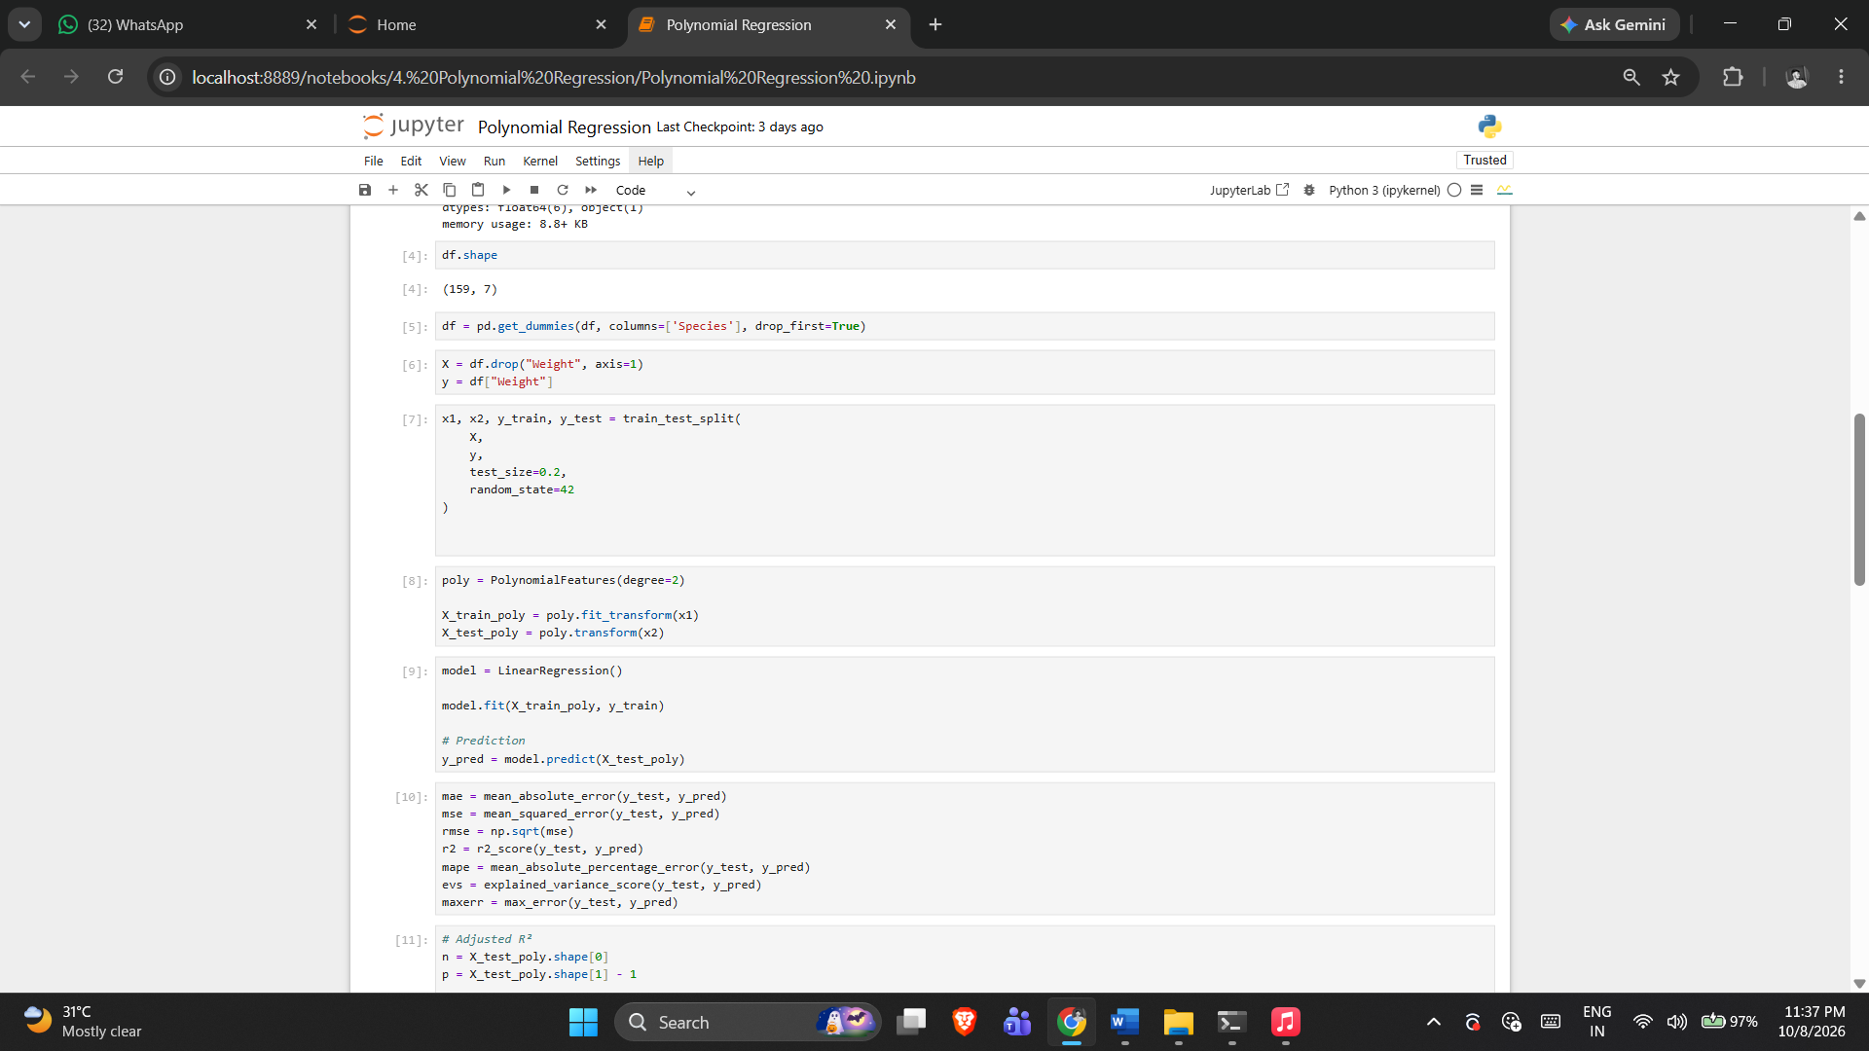

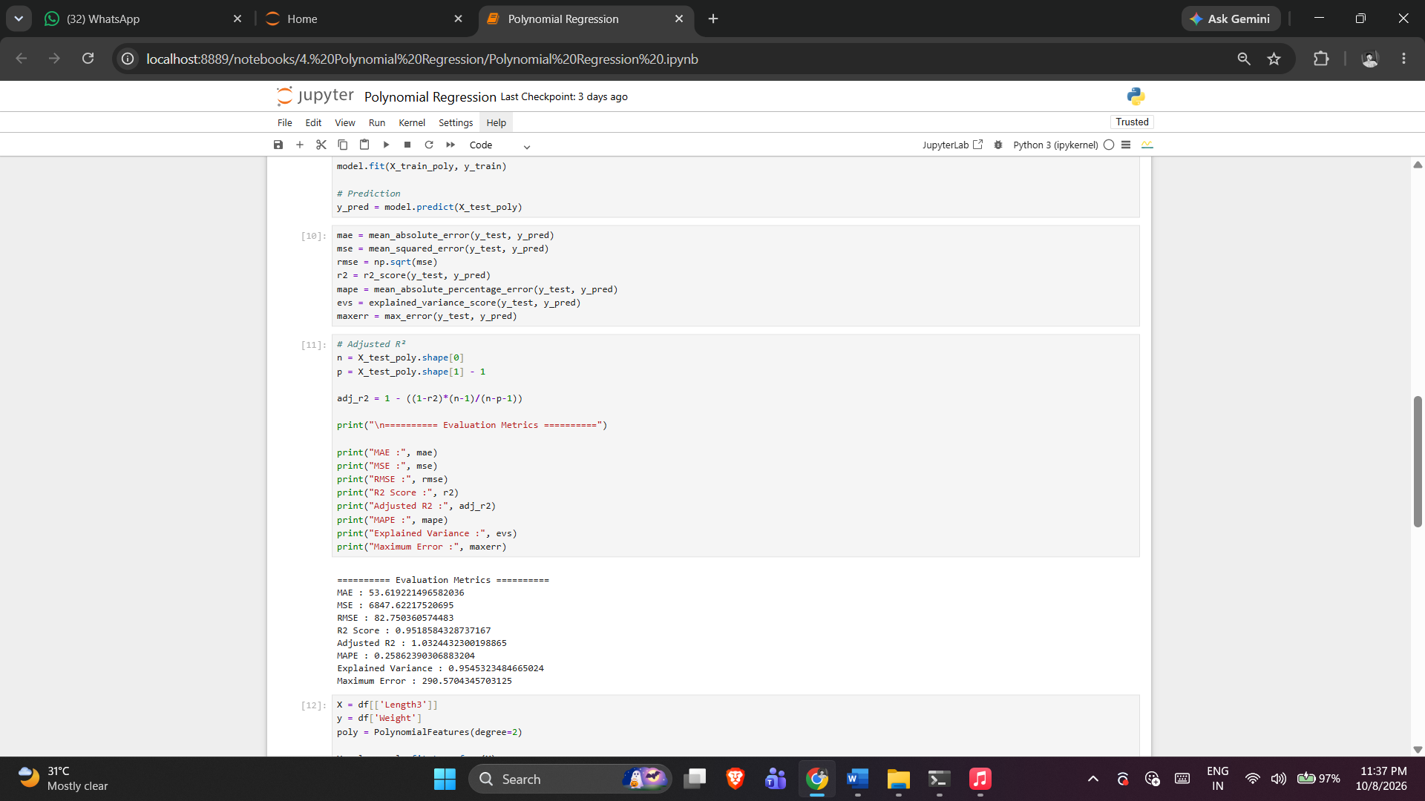

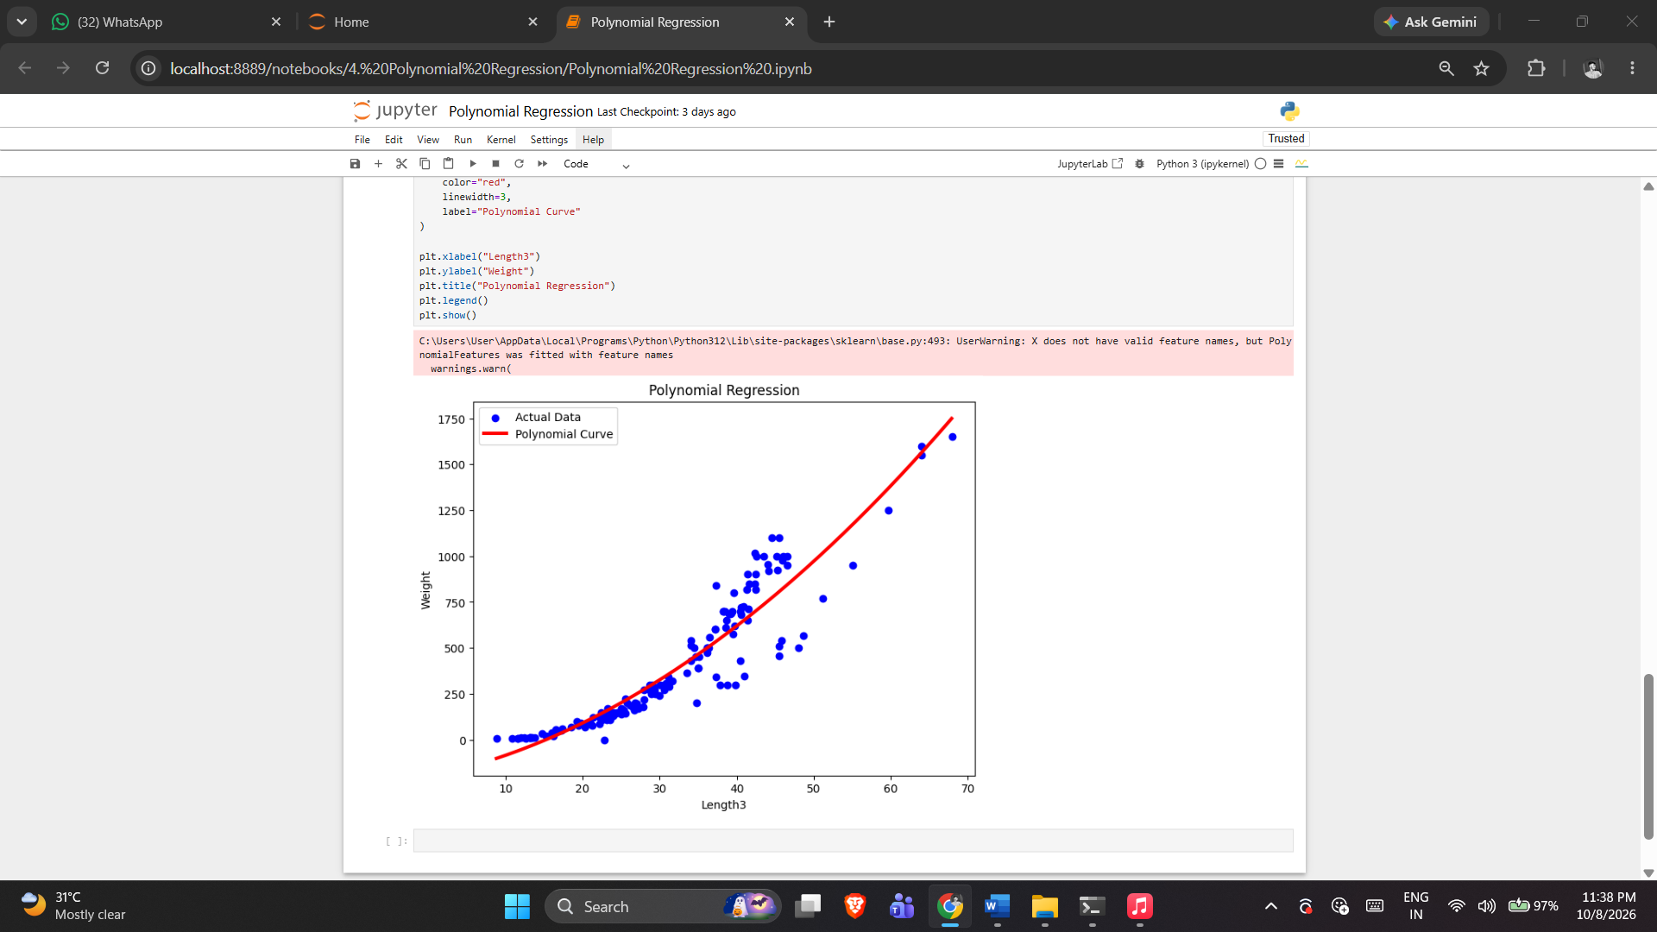
5. RESULT
Thus, the Polynomial Regression practical was implemented successfully using the program from the corresponding Jupyter Notebook.

Exercise -5

Regularization Techniques
1. AIM
To implement and demonstrate Regularization Techniques using the dataset, preprocessing, model or analysis workflow provided in the corresponding Jupyter Notebook.
2. ALGORITHM
1. Load and prepare the regression data.
2. Separate predictors and target.
3. Split the data.
4. Train the regularization models implemented in the notebook.
5. Generate predictions.
6. Compare models using the notebook's evaluation metrics.
3. PROGRAM
import pandas as pd
import numpy as np
import matplotlib.pyplot as plt

from sklearn.model_selection import train_test_split
from sklearn.preprocessing import StandardScaler, PolynomialFeatures
from sklearn.linear_model import LinearRegression, Ridge, Lasso, ElasticNet
from sklearn.metrics import r2_score

data = 'Dataset/Housing.csv'
df = pd.read_csv(data)
df.head()

df = pd.get_dummies(df, drop_first=True)

df.head()

# In[5]:

X = df.drop("price", axis=1)
y = df["price"]

# In[6]:

X_train,X_test,y_train,y_test = train_test_split(
X,
y,
test_size=0.2,
random_state=42
)

# In[7]:

scaler = StandardScaler()

X_train_scaled = scaler.fit_transform(X_train)
X_test_scaled = scaler.transform(X_test)

# In[80]:

poly = PolynomialFeatures(
degree=4,
include_bias=False
)

X_train_poly = poly.fit_transform(X_train_scaled)
X_test_poly = poly.transform(X_test_scaled)

print("Original Features :", X_train.shape[1])
print("Polynomial Features :", X_train_poly.shape[1])

# In[81]:

linear = LinearRegression()

linear.fit(X_train_poly, y_train)

train_pred = linear.predict(X_train_poly)
test_pred = linear.predict(X_test_poly)

train_r2 = r2_score(y_train, train_pred)
test_r2 = r2_score(y_test, test_pred)

print("LINEAR REGRESSION")
print("Training R2 :", round(train_r2,4))
print("Testing R2 :", round(test_r2,4))

# In[83]:

ridge = Ridge(alpha=100)

ridge.fit(X_train_poly, y_train)

train_pred = ridge.predict(X_train_poly)
test_pred = ridge.predict(X_test_poly)

ridge_train = r2_score(y_train, train_pred)
ridge_test = r2_score(y_test, test_pred)

print("RIDGE")
print("Training R2 :", round(ridge_train,4))
print("Testing R2 :", round(ridge_test,4))

# In[ ]:

lasso = Lasso(
alpha=0.1,
max_iter=50000
)

lasso.fit(X_train_poly, y_train)

train_pred = lasso.predict(X_train_poly)
test_pred = lasso.predict(X_test_poly)

lasso_train = r2_score(y_train, train_pred)
lasso_test = r2_score(y_test, test_pred)

print("LASSO")
print("Training R2 :", round(lasso_train,4))
print("Testing R2 :", round(lasso_test,4))

# In[77]:

elastic = ElasticNet(
alpha=0.1,
l1_ratio=0.5,
max_iter=50000
)

elastic.fit(X_train_poly, y_train)

train_pred = elastic.predict(X_train_poly)
test_pred = elastic.predict(X_test_poly)

elastic_train = r2_score(y_train, train_pred)
elastic_test = r2_score(y_test, test_pred)

print("ELASTIC NET")
print("Training R2 :", round(elastic_train,4))
print("Testing R2 :", round(elastic_test,4))

# In[78]:

comparison = pd.DataFrame({

"Model":[
"Linear Regression",
"Ridge",
"Lasso",
"Elastic Net"
],

"Train R2":[
train_r2,
ridge_train,
lasso_train,
elastic_train
],

"Test R2":[
test_r2,
ridge_test,
lasso_test,
elastic_test
]
})

print(comparison)

# In[79]:

# In[62]:

comparison["Difference"] = comparison["Train R2"] - comparison["Test R2"]

print(comparison)

comparison.plot(
x="Model",
y=["Train R2", "Test R2"],
kind="bar",
figsize=(10,6)
)

plt.title("Reducing Overfitting using Regularization")
plt.ylabel("R² Score")
plt.xticks(rotation=10)
plt.grid(axis="y")
plt.show()

4. OUTPUT
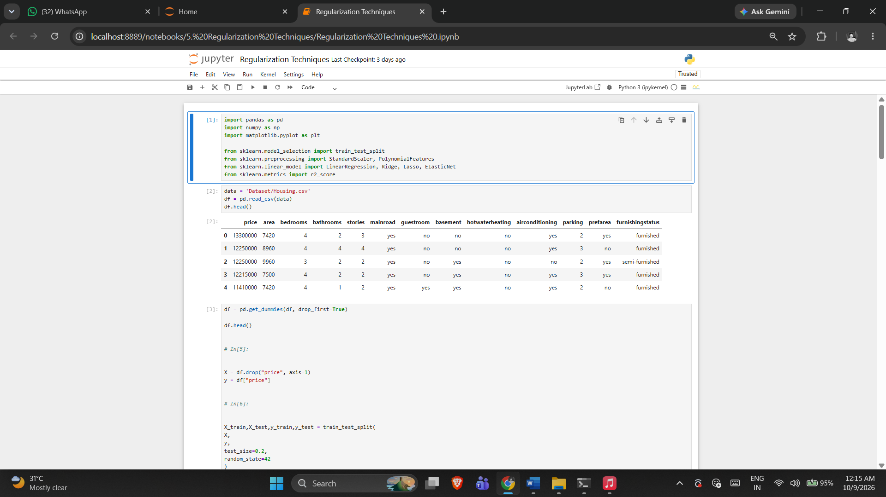

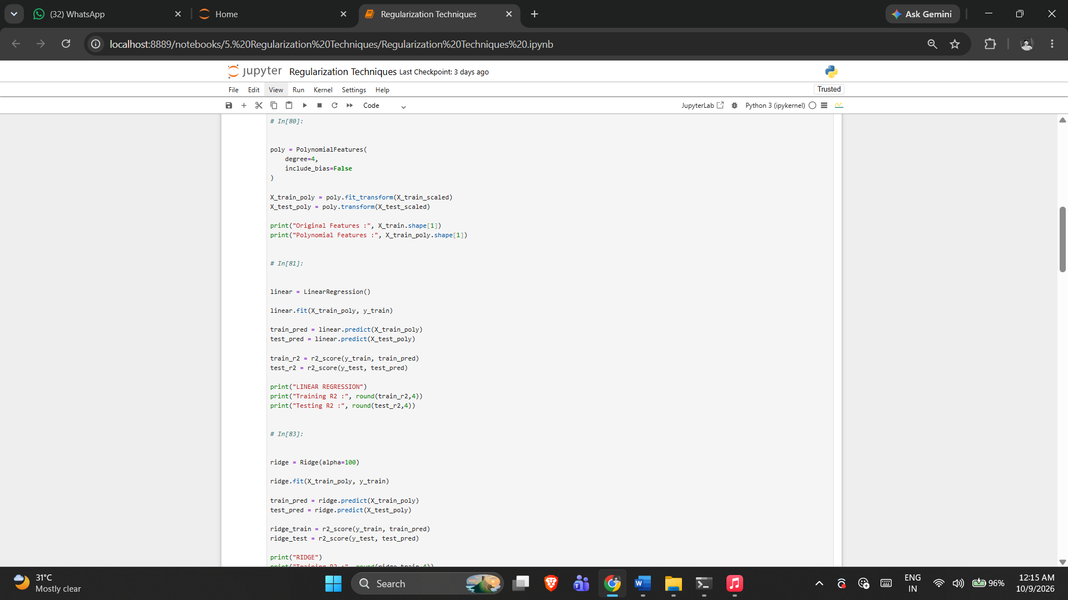

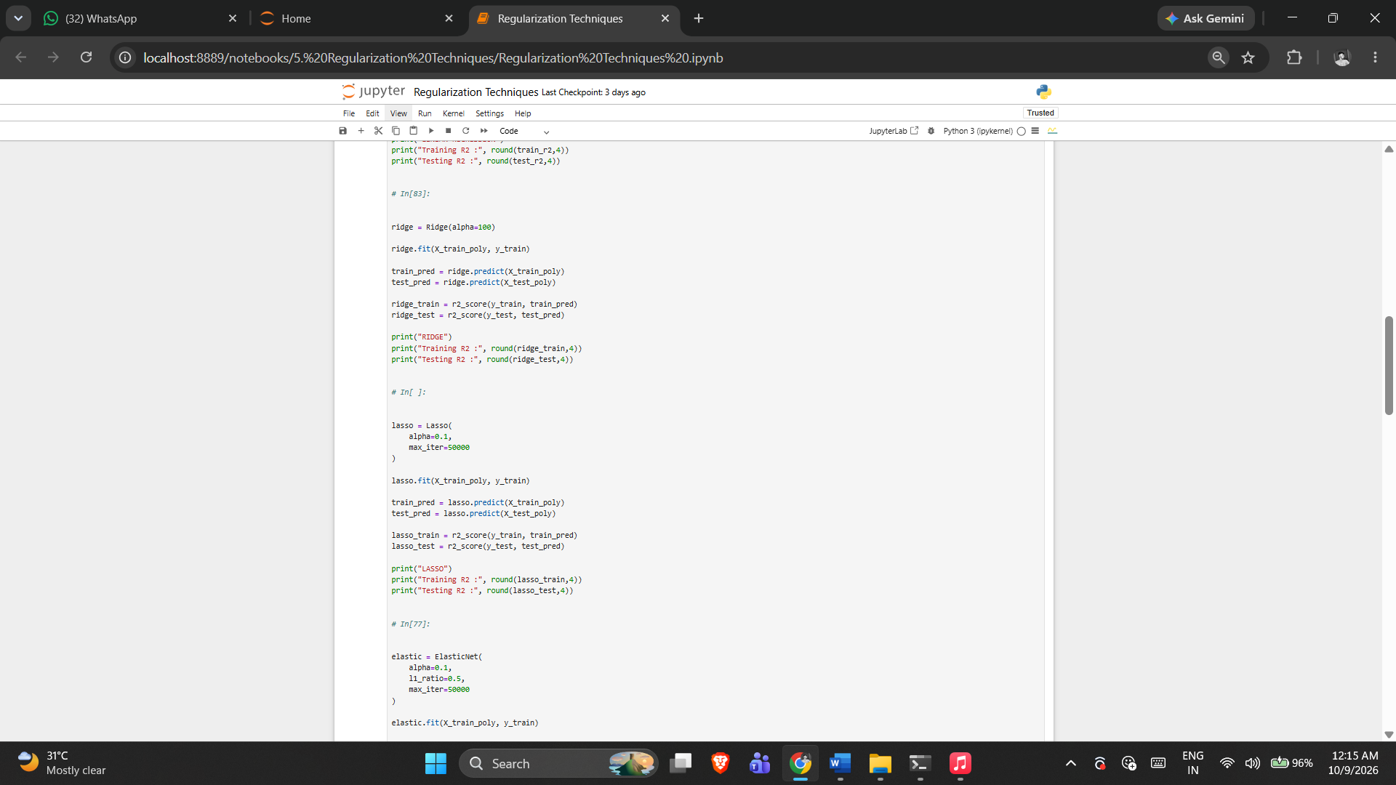

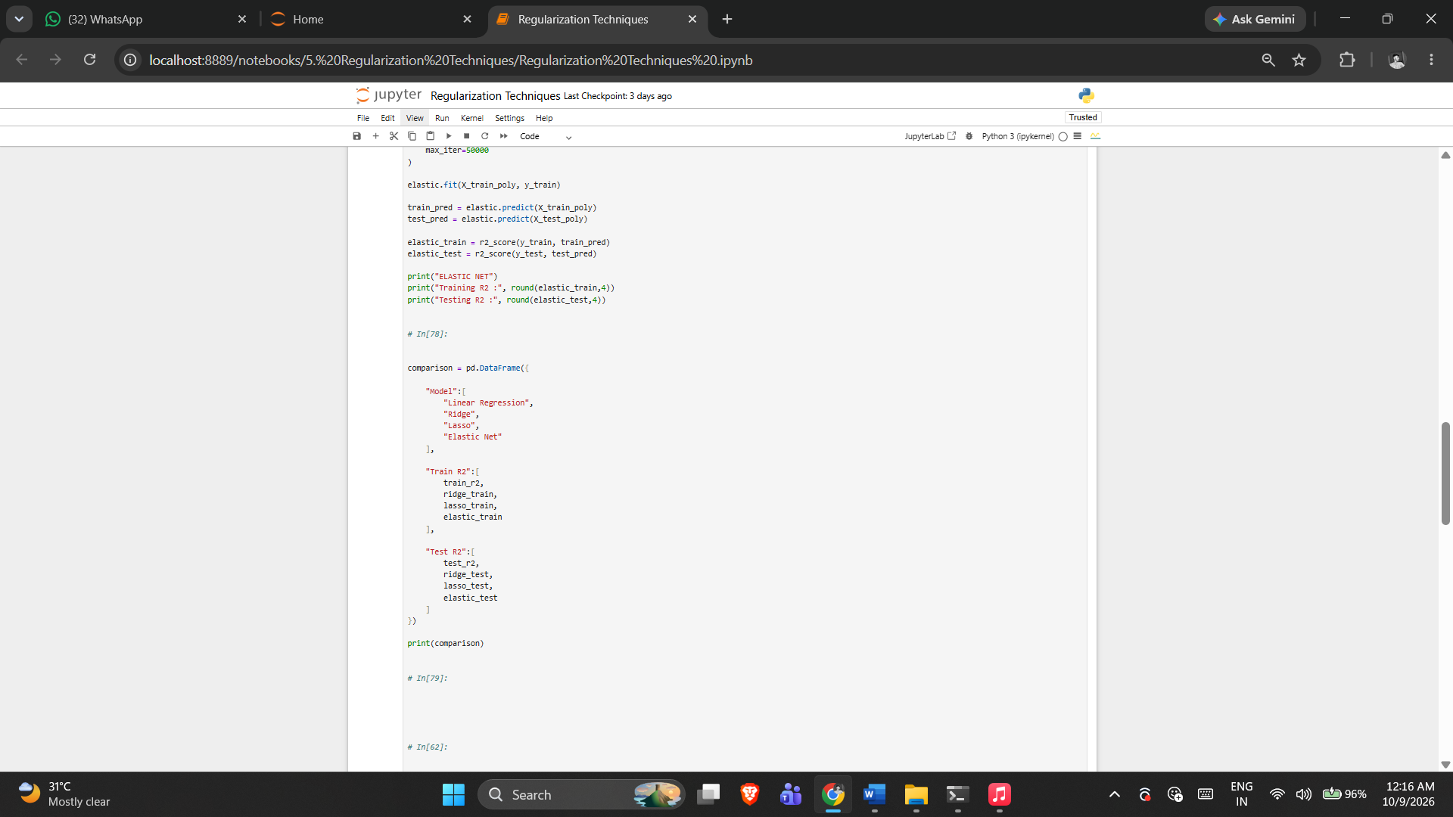

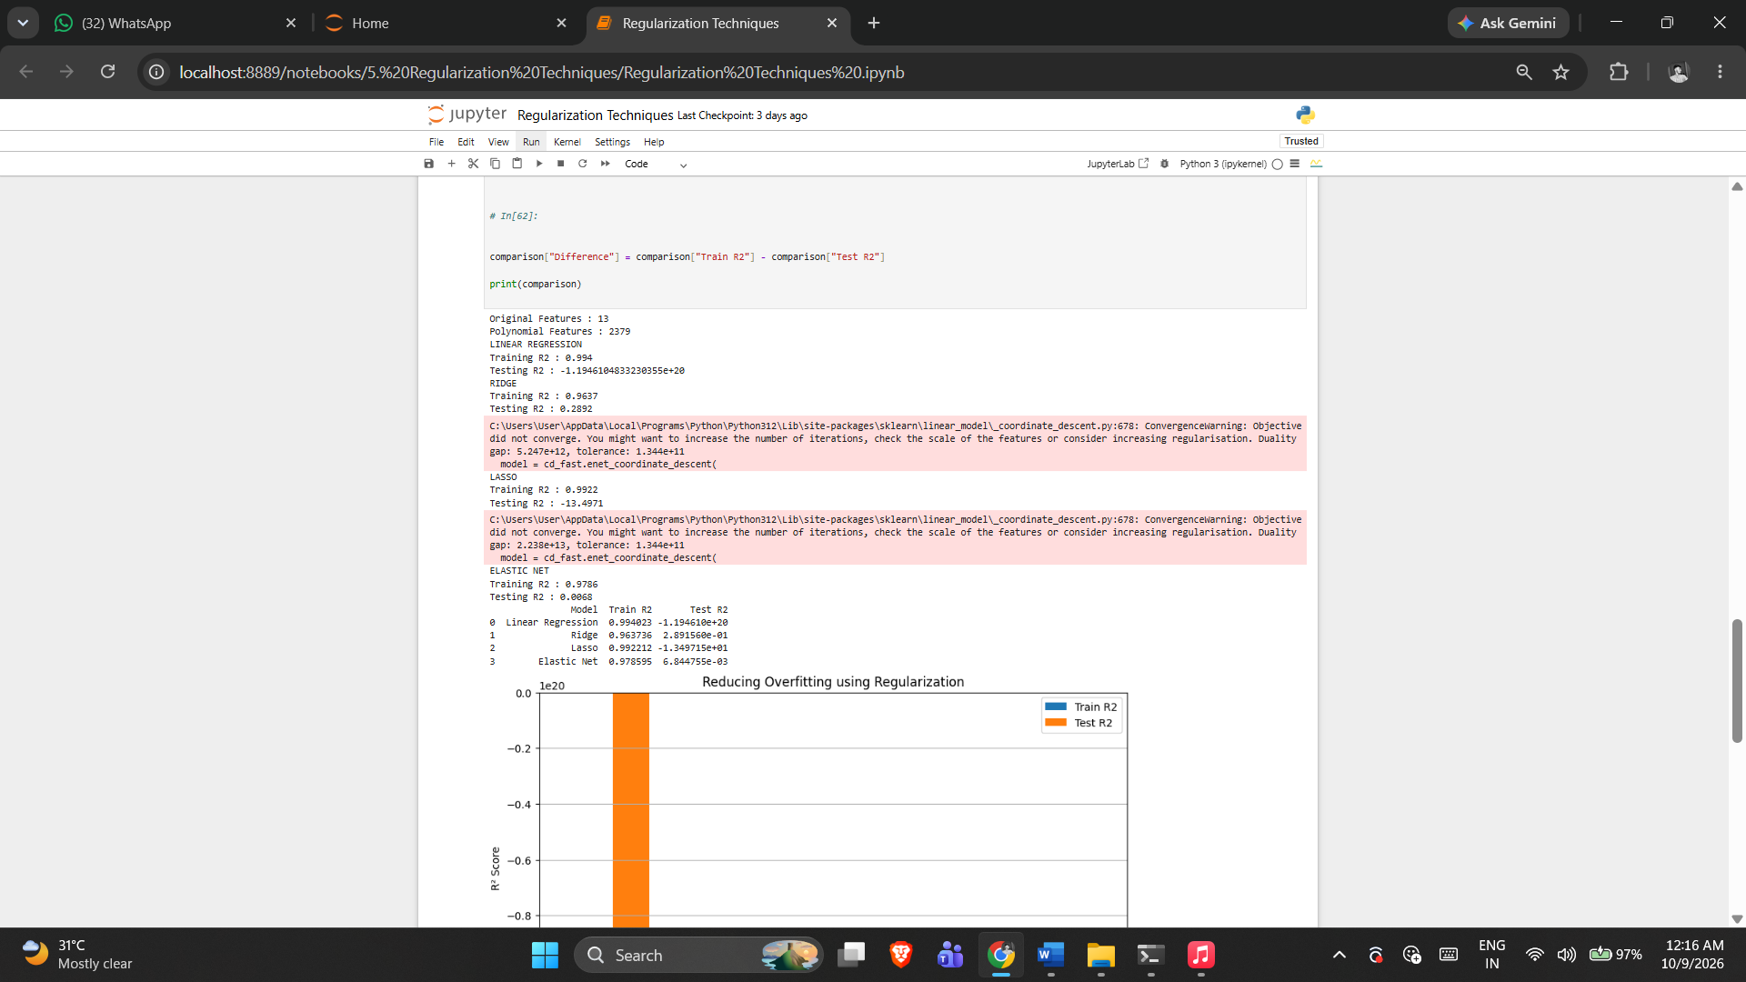

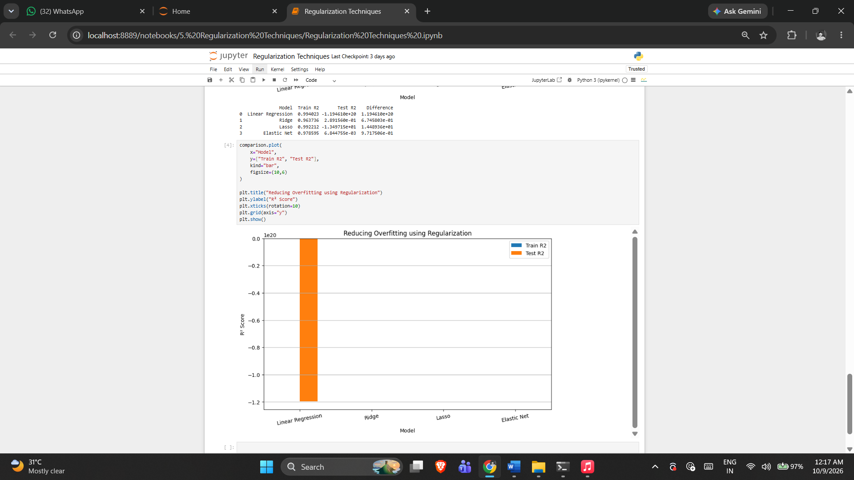

5. RESULT
Thus, the Regularization Techniques practical was implemented successfully using the program from the corresponding Jupyter Notebook.

Exercise -6

Logistic Regression
1. AIM
To implement Logistic Regression for binary heart disease classification and evaluate the model using the metrics implemented in the notebook.
2. ALGORITHM
1. Load the dataset and separate features and target.
2. Identify numerical and categorical features.
3. Create the preprocessing pipeline.
4. Split the data into training and testing sets.
5. Train the Logistic Regression model.
6. Predict the test set and calculate the notebook's metrics.
7. Display the model performance.
3. PROGRAM
#!/usr/bin/env python
# coding: utf-8

import pandas as pd
import matplotlib.pyplot as plt

from sklearn.model_selection import train_test_split
from sklearn.impute import SimpleImputer
from sklearn.preprocessing import LabelEncoder
from sklearn.preprocessing import StandardScaler
from sklearn.preprocessing import MinMaxScaler

from sklearn.linear_model import LogisticRegression

from sklearn.metrics import (
accuracy_score,
precision_score,
recall_score,
f1_score,
confusion_matrix,
classification_report,
roc_curve,
auc
)

df = pd.read_csv("heart_disease_dataset.csv")

print("First 5 rows:")
print(df.head())

print("\nDataset Shape:")
print(df.shape)

X = df.drop("Heart Disease", axis=1)
y = df["Heart Disease"]

print("\nFeatures:")
print(X.columns)

print("\nTarget:")
print(y.name)

categorical_columns = X.select_dtypes(
include=["object"]
).columns

numerical_columns = X.select_dtypes(
exclude=["object"]
).columns

print("\nCategorical Columns:")
print(list(categorical_columns))

print("\nNumerical Columns:")
print(list(numerical_columns))

imputer = SimpleImputer(strategy="most_frequent")

X[categorical_columns] = imputer.fit_transform(
X[categorical_columns]
)

print("\nMissing values after imputation:")
print(X.isnull().sum())

label_encoders = {}

for column in categorical_columns:

encoder = LabelEncoder()

X[column] = encoder.fit_transform(
X[column]
)

label_encoders[column] = encoder

print("\nData after Label Encoding:")
print(X.head())

X_train, X_test, y_train, y_test = train_test_split(
X,
y,
test_size=0.20,
random_state=42,
stratify=y
)

print("\nTraining data:", X_train.shape)
print("Testing data :", X_test.shape)

scaler = StandardScaler()

X_train_scaled = scaler.fit_transform(X_train)

X_test_scaled = scaler.transform(X_test)

# minmax_scaler = MinMaxScaler()

# X_train_scaled = minmax_scaler.fit_transform(X_train)

# X_test_scaled = minmax_scaler.transform(X_test)

model = LogisticRegression(
max_iter=1000,
random_state=42
)
model.fit(
X_train_scaled,
y_train
)

print("\nLogistic Regression model trained successfully.")

y_pred = model.predict(X_test_scaled)
# Probability of class 1
y_probability = model.predict_proba(X_test_scaled)[:, 1]

accuracy = accuracy_score(
y_test,
y_pred
)

precision = precision_score(
y_test,
y_pred
)

recall = recall_score(
y_test,
y_pred
)

f1 = f1_score(
y_test,
y_pred
)

print("\n================================")
print("CLASSIFICATION METRICS")
print("================================")

print("Accuracy :", round(accuracy, 4))
print("Precision :", round(precision, 4))
print("Recall :", round(recall, 4))
print("F1 Score :", round(f1, 4))

cm = confusion_matrix(
y_test,
y_pred
)

print("\nConfusion Matrix:")
print(cm)

print("\nClassification Report:")
print(
classification_report(
y_test,
y_pred
)
)

# ============================================
# 15. ROC Curve
# ============================================

fpr, tpr, thresholds = roc_curve(
y_test,
y_probability
)

# ============================================
# 16. Calculate AUC
# ============================================

roc_auc = auc(
fpr,
tpr
)

print("\nROC-AUC Score:",
round(roc_auc, 4))

# ============================================
# 17. Plot ROC Curve
# ============================================

plt.figure(figsize=(8, 6))

plt.plot(
fpr,
tpr,
label="Logistic Regression (AUC = {:.3f})".format(
roc_auc
)
)

# Random classifier line
plt.plot(
[0, 1],
[0, 1],
linestyle="--",
label="Random Classifier"
)

plt.xlabel("False Positive Rate")
plt.ylabel("True Positive Rate")

plt.title(
"ROC Curve - Heart Disease Prediction"
)

plt.legend()

plt.grid()

4. OUTPUT

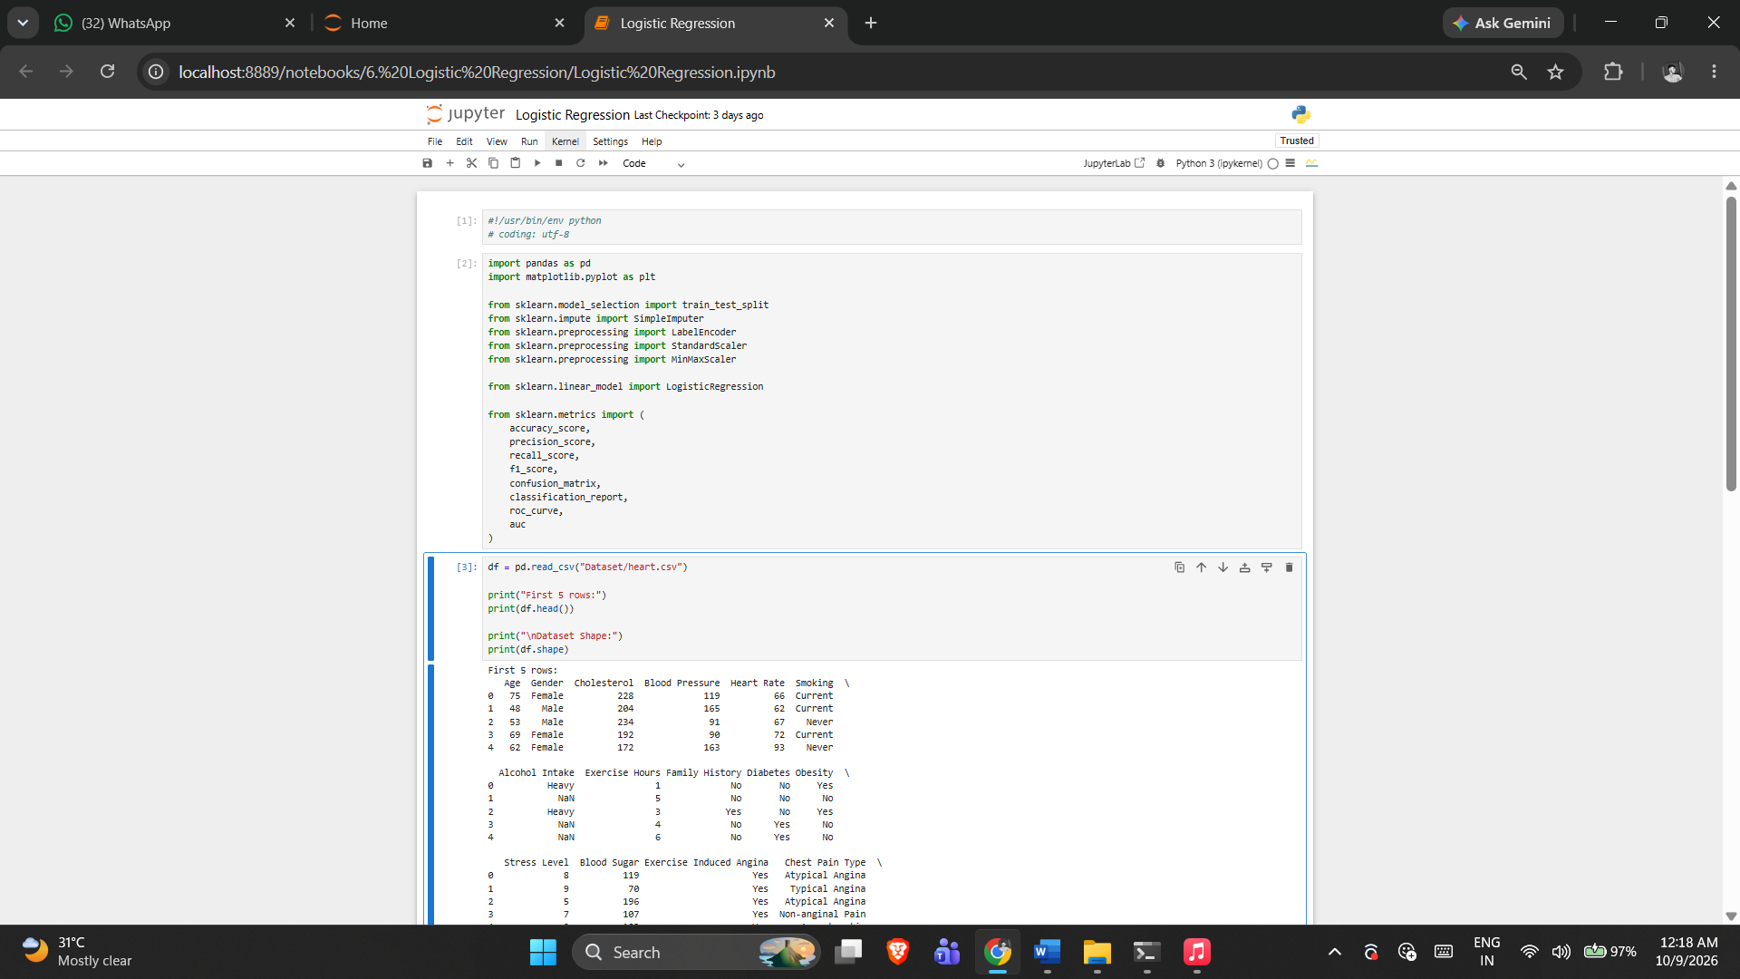

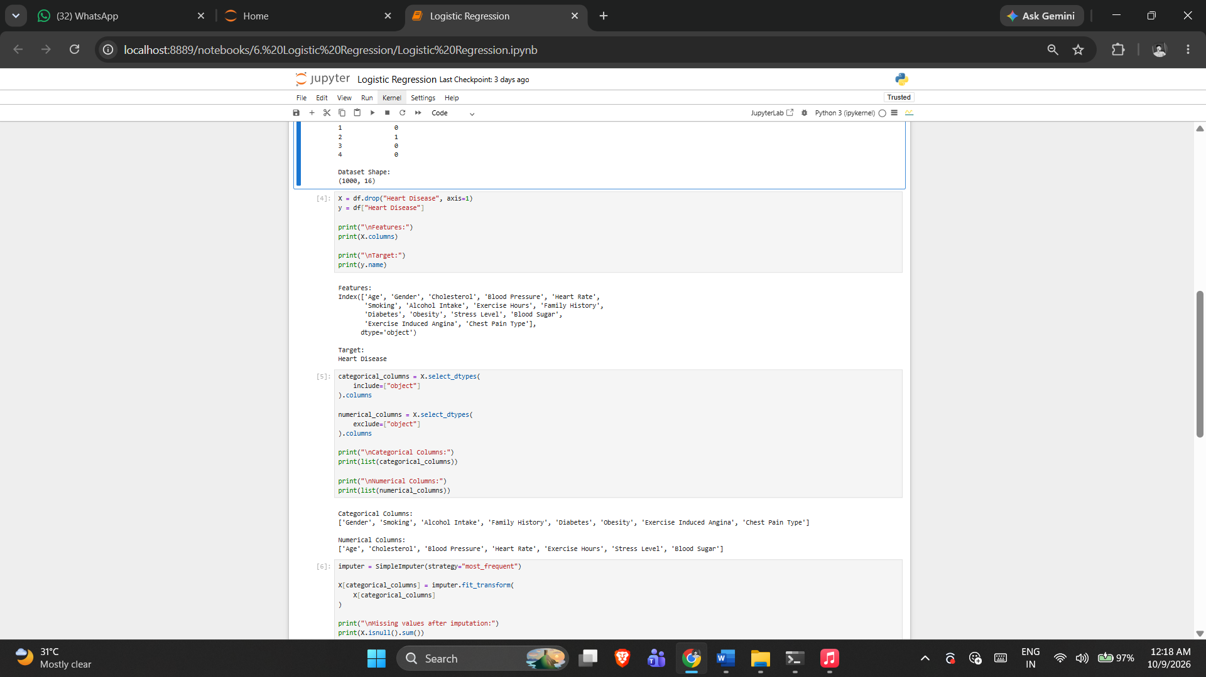

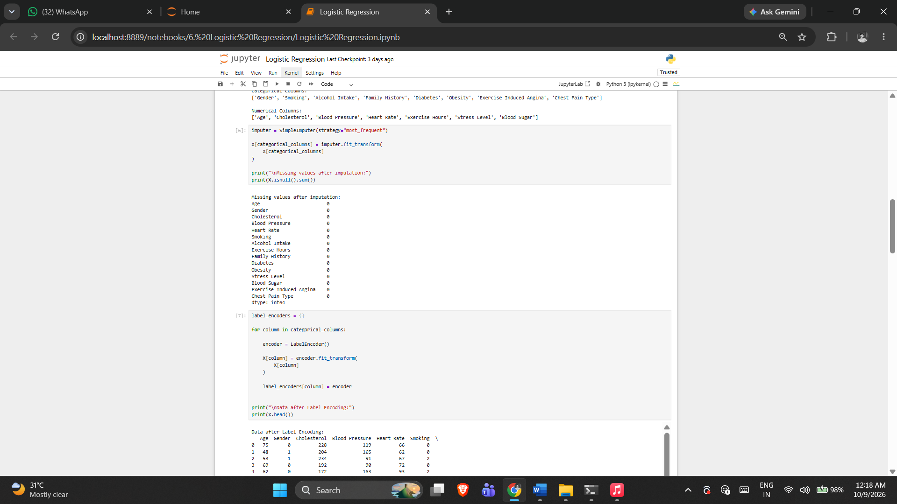

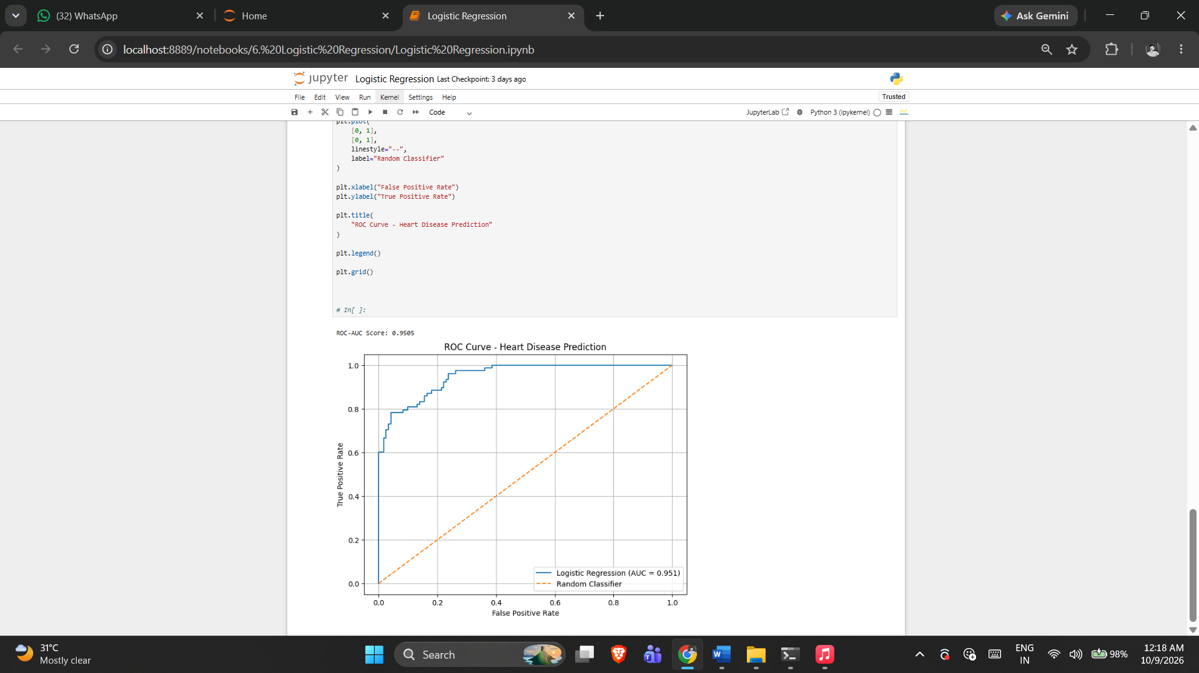

5. RESULT
Thus, the Logistic Regression practical was implemented successfully using the program from the corresponding Jupyter Notebook.

Exercise -7

K-Nearest Neighbour

1. AIM
To implement K-Nearest Neighbour classification for heart disease prediction, compare multiple K values and select the best-performing K.
2. ALGORITHM
1. Load the dataset and separate features and target.
2. Identify numerical and categorical features.
3. Split the dataset with stratification.
4. Scale numerical features and encode categorical features.
5. Train KNN for the specified K values.
6. Calculate accuracy, precision, recall and F1 score.
7. Select the best K and evaluate the final model.
3. PROGRAM

import pandas as pd
import numpy as np
import matplotlib.pyplot as plt
import seaborn as sns

from sklearn.model_selection import train_test_split
from sklearn.preprocessing import StandardScaler
from sklearn.compose import ColumnTransformer
from sklearn.preprocessing import OneHotEncoder

from sklearn.neighbors import KNeighborsClassifier

from sklearn.metrics import (
accuracy_score,
precision_score,
recall_score,
f1_score,
confusion_matrix,
classification_report,
roc_curve,
roc_auc_score
)

df = pd.read_csv("heart_disease_dataset.csv")

print("Dataset Shape:", df.shape)

print("\nFirst 5 Records:")
print(df.head())

print("\nDataset Information:")
print(df.info())

print("\nMissing Values:")
print(df.isnull().sum())

print("\nTarget Distribution:")
print(df["Heart Disease"].value_counts())

X = df.drop("Heart Disease", axis=1)

y = df["Heart Disease"]

numerical_features = X.select_dtypes(
include=["int64", "float64"]
).columns

categorical_features = X.select_dtypes(
include=["object"]
).columns

print("Numerical Features:")
print(list(numerical_features))

print("\nCategorical Features:")
print(list(categorical_features))

X_train, X_test, y_train, y_test = train_test_split(
X,
y,
test_size=0.20,
random_state=42,
stratify=y
)

print("Training Data:", X_train.shape)
print("Testing Data :", X_test.shape)

preprocessor = ColumnTransformer(
transformers=[
("num", StandardScaler(), numerical_features),
("cat", OneHotEncoder(handle_unknown="ignore"), categorical_features)
]
)

X_train_processed = preprocessor.fit_transform(X_train)
X_test_processed = preprocessor.transform(X_test)

K = 5
knn = KNeighborsClassifier(
n_neighbors=5
)

knn.fit(
X_train_processed,
y_train
)

y_pred = knn.predict(
X_test_processed
)

print("Predicted Values:")
print(y_pred[:20])

print(
classification_report(
y_test,
y_pred
)
)

k_values = [1, 3, 5, 7, 9, 11, 15, 21]

accuracy_values = []
precision_values = []
recall_values = []
f1_values = []

for k in k_values:

knn = KNeighborsClassifier(
n_neighbors=k
)

knn.fit(
X_train_processed,
y_train
)

y_pred = knn.predict(
X_test_processed
)

accuracy_values.append(
accuracy_score(
y_test,
y_pred
)
)

precision_values.append(
precision_score(
y_test,
y_pred
)
)

recall_values.append(
recall_score(
y_test,
y_pred
)
)

f1_values.append(
f1_score(
y_test,
y_pred
)
)

results = pd.DataFrame({
"K": k_values,
"Accuracy": accuracy_values,
"Precision": precision_values,
"Recall": recall_values,
"F1 Score": f1_values
})

print(results)

plt.figure(figsize=(8, 5))

plt.plot(
k_values,
accuracy_values,
marker="o"
)

plt.xlabel("K Value")
plt.ylabel("Accuracy")

plt.title("Effect of K Value on KNN Accuracy")

plt.xticks(k_values)

plt.grid()

plt.show()

best_index = np.argmax(f1_values)

best_k = k_values[best_index]

print("Best K:", best_k)

print(
"Best Accuracy:",
accuracy_values[best_index]
)

print(
"Best Precision:",
precision_values[best_index]
)

print(
"Best Recall:",
recall_values[best_index]
)

print(
"Best F1 Score:",
f1_values[best_index]
)

final_knn = KNeighborsClassifier(
n_neighbors=best_k
)

final_knn.fit(
X_train_processed,
y_train
)

final_pred = final_knn.predict(
X_test_processed
)

final_accuracy = accuracy_score(
y_test,
final_pred
)

final_precision = precision_score(
y_test,
final_pred
)

final_recall = recall_score(
y_test,
final_pred
)

final_f1 = f1_score(
y_test,
final_pred
)

final_cm = confusion_matrix(
y_test,
final_pred
)

TN, FP, FN, TP = final_cm.ravel()

final_specificity = TN / (TN + FP)

final_probability = final_knn.predict_proba(
X_test_processed
)[:, 1]

final_auc = roc_auc_score(
y_test,
final_probability
)

print("\n======================================")
print("FINAL KNN MODEL")
print("======================================")

print("Best K :", best_k)
print("Accuracy :", final_accuracy)
print("Precision :", final_precision)
print("Recall :", final_recall)
print("F1 Score :", final_f1)
print("Specificity :", final_specificity)
print("AUC :", final_auc)

4. OUTPUT

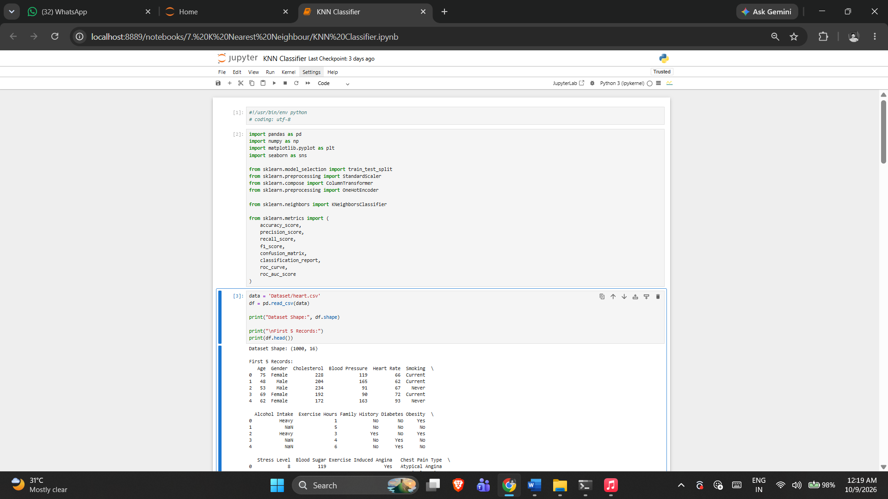

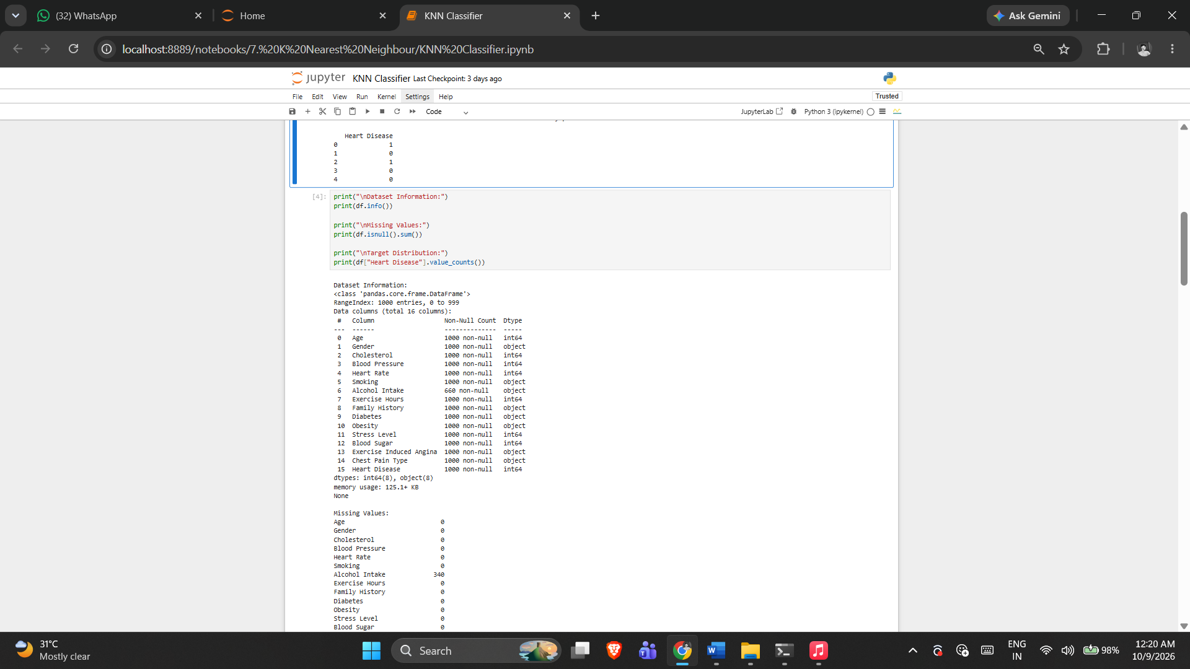
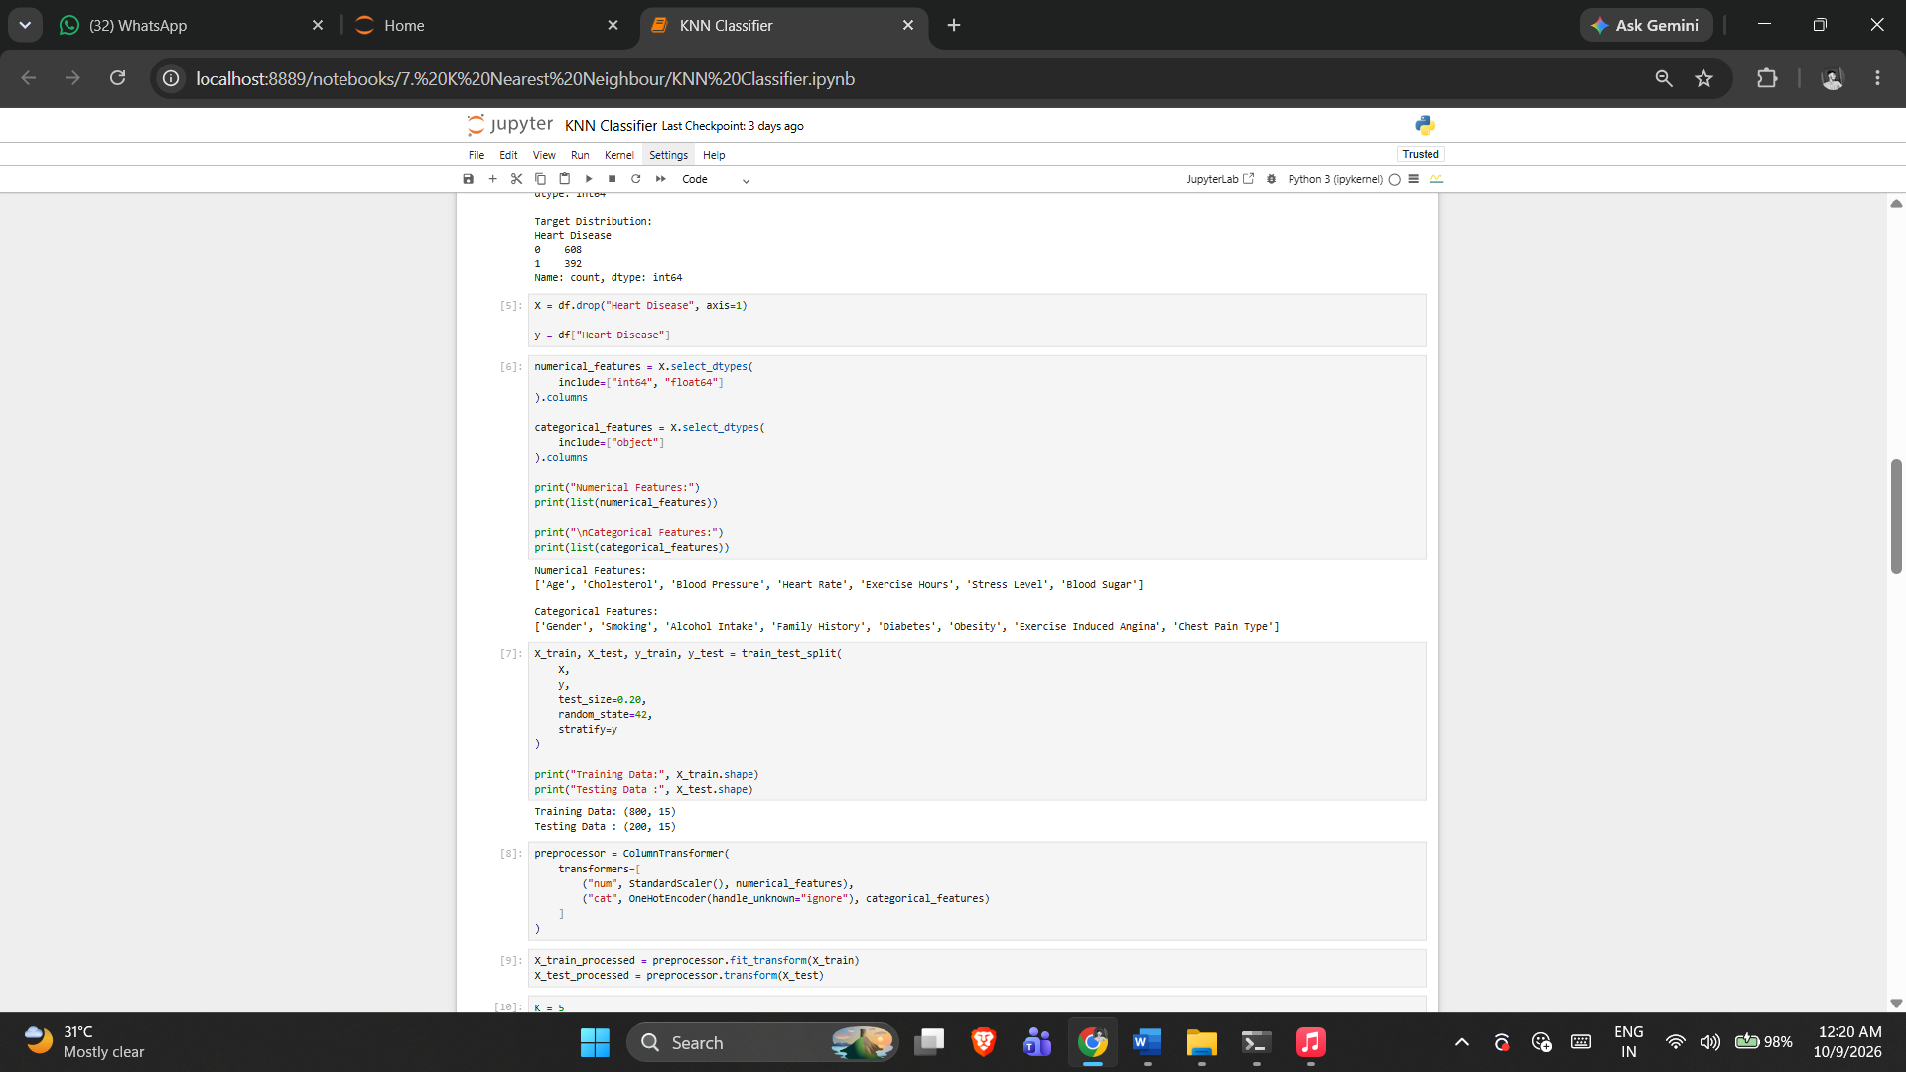

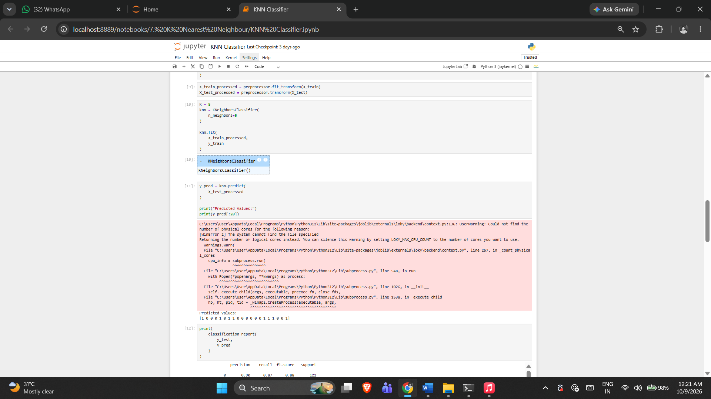

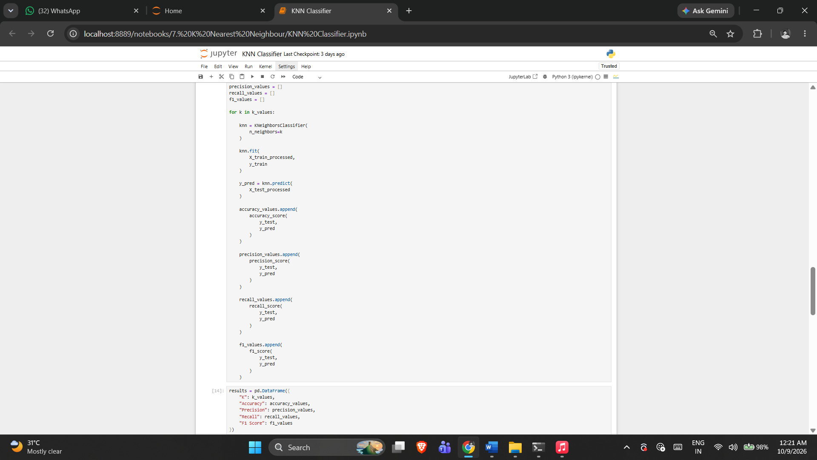

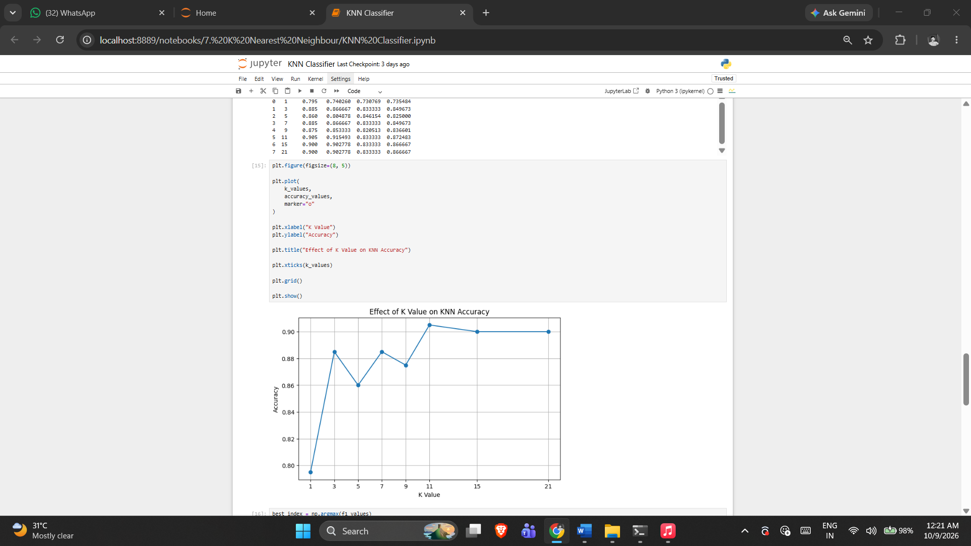

5. RESULT
Thus, the K Nearest Neighbour practical was implemented successfully using the program from the corresponding Jupyter Notebook.
Exercise -8

Decision Tree Classification
1. AIM
To build a Decision Tree classifier for heart disease prediction and evaluate and visualize the trained model.
2. ALGORITHM
1. Load the dataset and separate features and target.
2. Identify numerical and categorical features.
3. Build the preprocessing pipeline.
4. Split the data into training and testing sets.
5. Train the Decision Tree classifier.
6. Predict and calculate the notebook's evaluation metrics.
7. Visualize the trained tree.
3. PROGRAM
#!/usr/bin/env python
# coding: utf-8

import pandas as pd
import matplotlib.pyplot as plt

from sklearn.model_selection import train_test_split
from sklearn.compose import ColumnTransformer
from sklearn.preprocessing import OneHotEncoder
from sklearn.pipeline import Pipeline

from sklearn.tree import DecisionTreeClassifier
from sklearn.tree import plot_tree

from sklearn.metrics import (
accuracy_score,
precision_score,
recall_score,
f1_score,
confusion_matrix,
classification_report,
ConfusionMatrixDisplay
)

df = pd.read_csv("heart_disease_dataset.csv")

print("First 5 rows:")
print(df.head())

print("\nDataset Shape:")
print(df.shape)

X = df.drop("Heart Disease", axis=1)
y = df["Heart Disease"]

print("\nFeatures:")
print(X.columns)

print("\nTarget:")
print(y.name)

categorical_columns = X.select_dtypes(
include=["object"]
).columns

numerical_columns = X.select_dtypes(
exclude=["object"]
).columns

print("\nCategorical Columns:")
print(list(categorical_columns))

print("\nNumerical Columns:")
print(list(numerical_columns))

preprocessor = ColumnTransformer(
transformers=[
(
"cat",
OneHotEncoder(handle_unknown="ignore"),
categorical_columns
)
],
remainder="passthrough"
)

decision_tree = DecisionTreeClassifier(
criterion="gini",
max_depth=4,
random_state=42
)

model = Pipeline(
steps=[
("preprocessor", preprocessor),
("classifier", decision_tree)
]
)

model = Pipeline(
steps=[
("preprocessor", preprocessor),
("classifier", decision_tree)
]
)

X_train, X_test, y_train, y_test = train_test_split(
X,
y,
test_size=0.20,
random_state=42,
stratify=y
)

print("\nTraining Data:", X_train.shape)
print("Testing Data:", X_test.shape)

model.fit(X_train, y_train)

print("\nDecision Tree Model Trained Successfully!")

y_pred = model.predict(X_test)

accuracy = accuracy_score(y_test, y_pred)

precision = precision_score(
y_test,
y_pred,
zero_division=0
)

recall = recall_score(
y_test,
y_pred,
zero_division=0
)

f1 = f1_score(
y_test,
y_pred,
zero_division=0
)

print("\n==========================================")
print(" DECISION TREE EVALUATION")
print("==========================================")

print("Accuracy :", round(accuracy, 4))
print("Precision :", round(precision, 4))
print("Recall :", round(recall, 4))
print("F1 Score :", round(f1, 4))

# ==========================================
# 12. Classification Report
# ==========================================

print("\nClassification Report:")
print(classification_report(y_test, y_pred))

# ==========================================
# 13. Confusion Matrix
# ==========================================

cm = confusion_matrix(y_test, y_pred)

print("\nConfusion Matrix:")
print(cm)

disp = ConfusionMatrixDisplay(
confusion_matrix=cm,
display_labels=["No Heart Disease", "Heart Disease"]
)

disp.plot()

plt.title("Confusion Matrix - Decision Tree")
plt.show()

# Get the trained classifier
tree_model = model.named_steps["classifier"]

# Get feature names after One-Hot Encoding
feature_names = model.named_steps[
"preprocessor"
].get_feature_names_out()

plt.figure(figsize=(25, 12))

plot_tree(
tree_model,
feature_names=feature_names,
class_names=["No Heart Disease", "Heart Disease"],
filled=True,
rounded=True,
fontsize=8
)

plt.title("Decision Tree for Heart Disease Classification")

plt.show()

4. OUTPUT
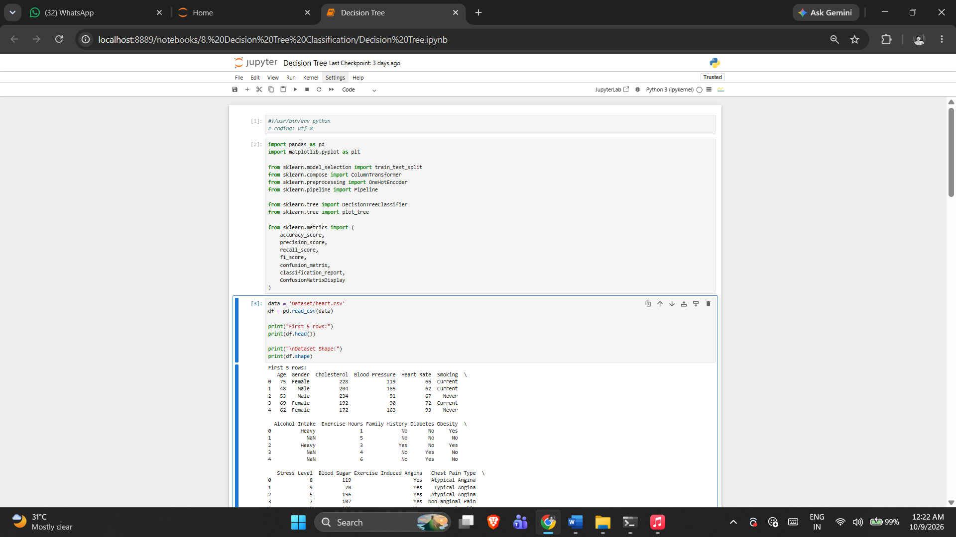

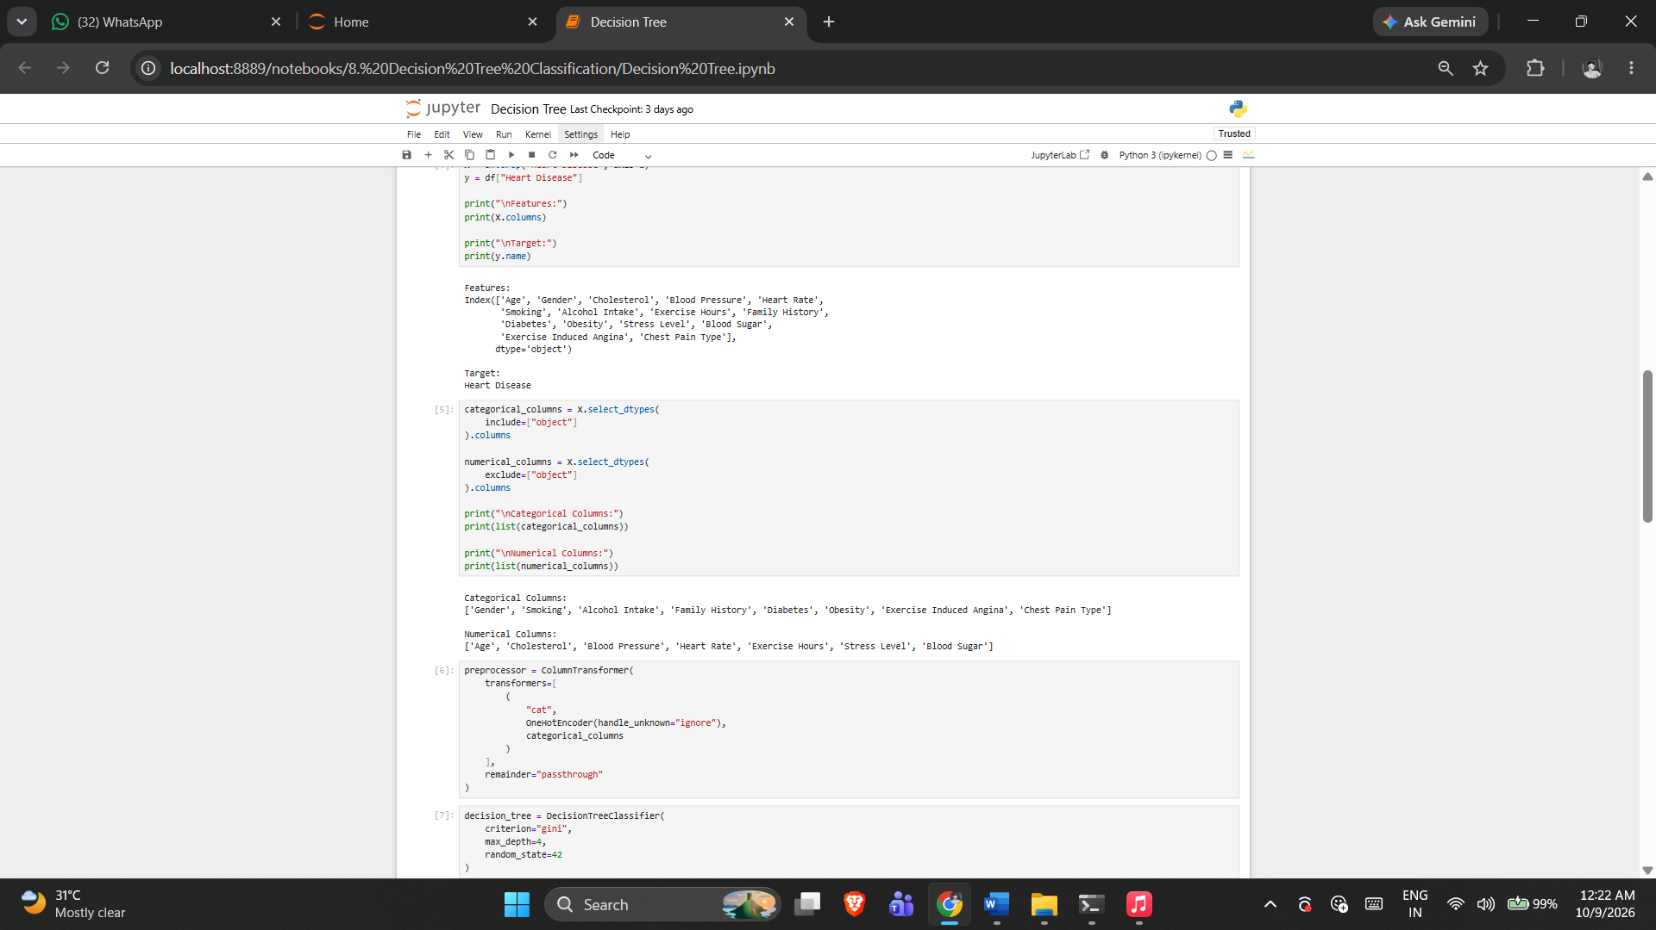

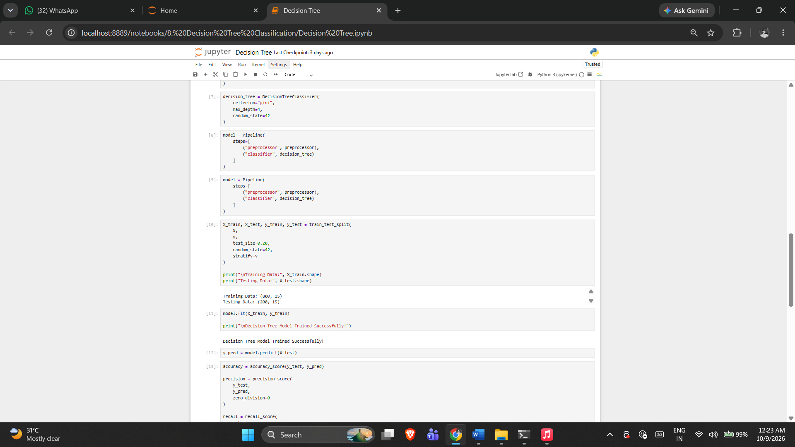

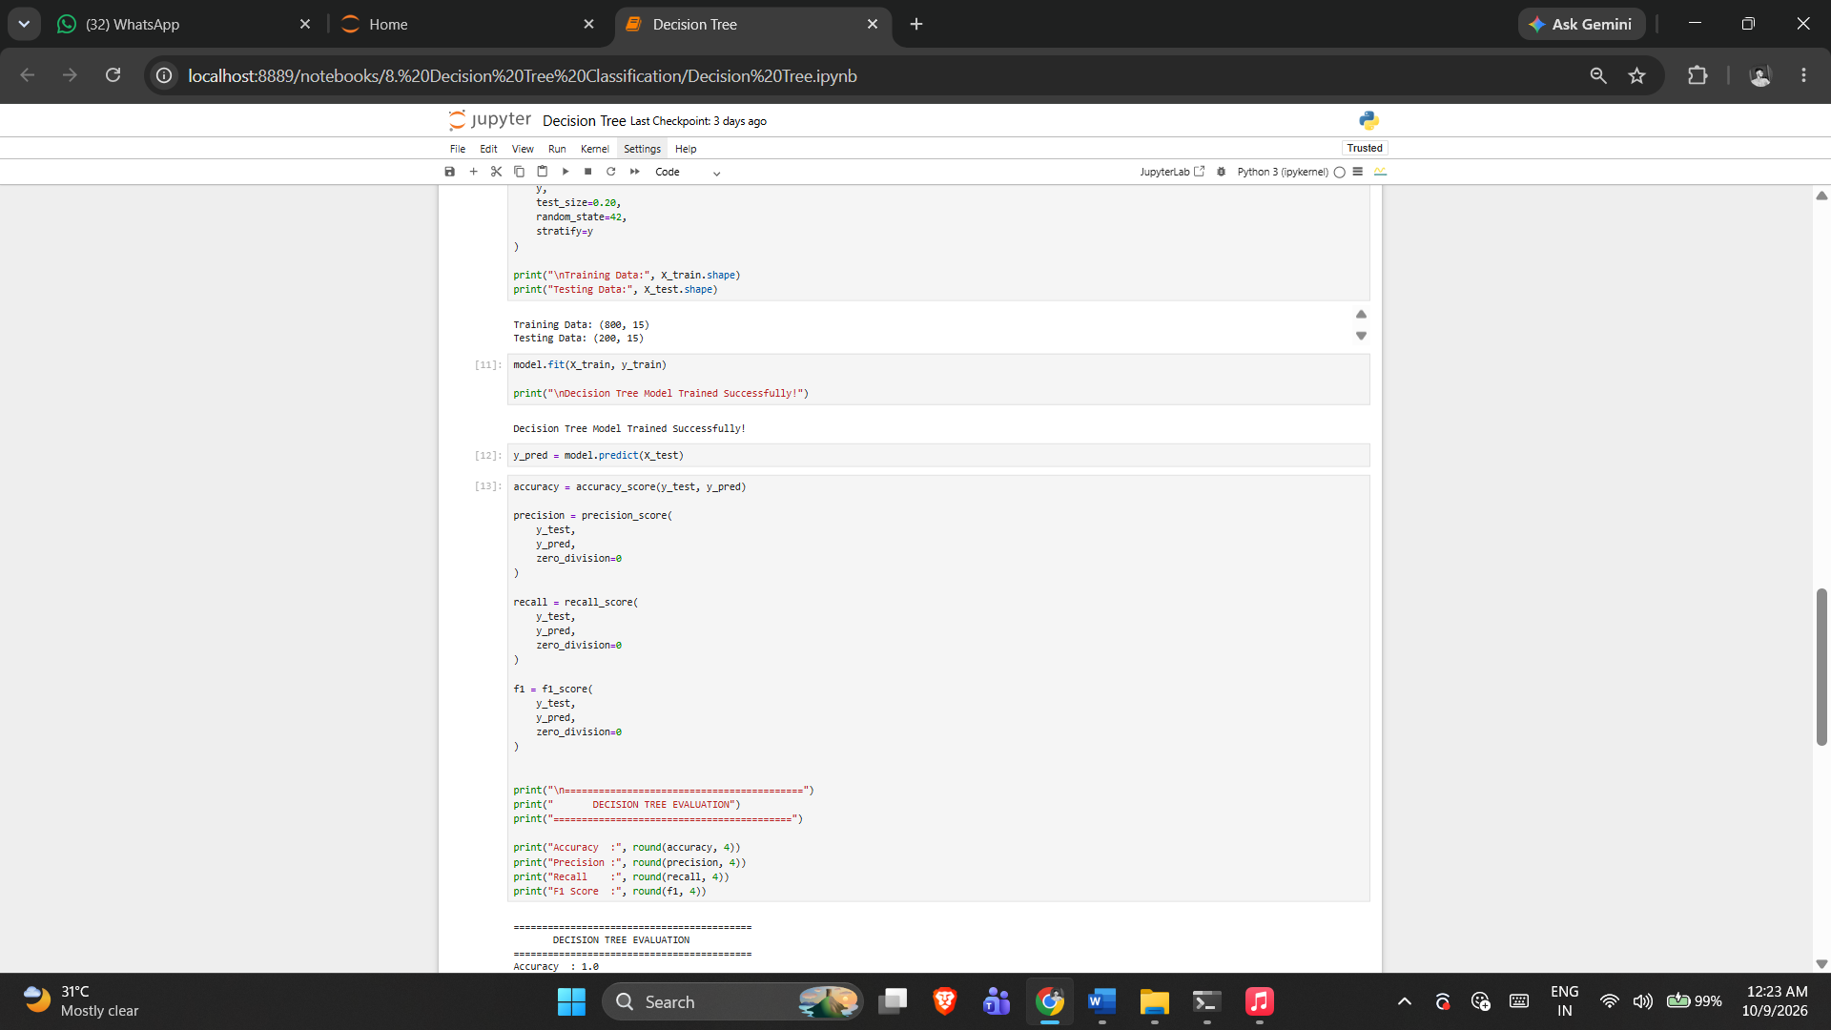

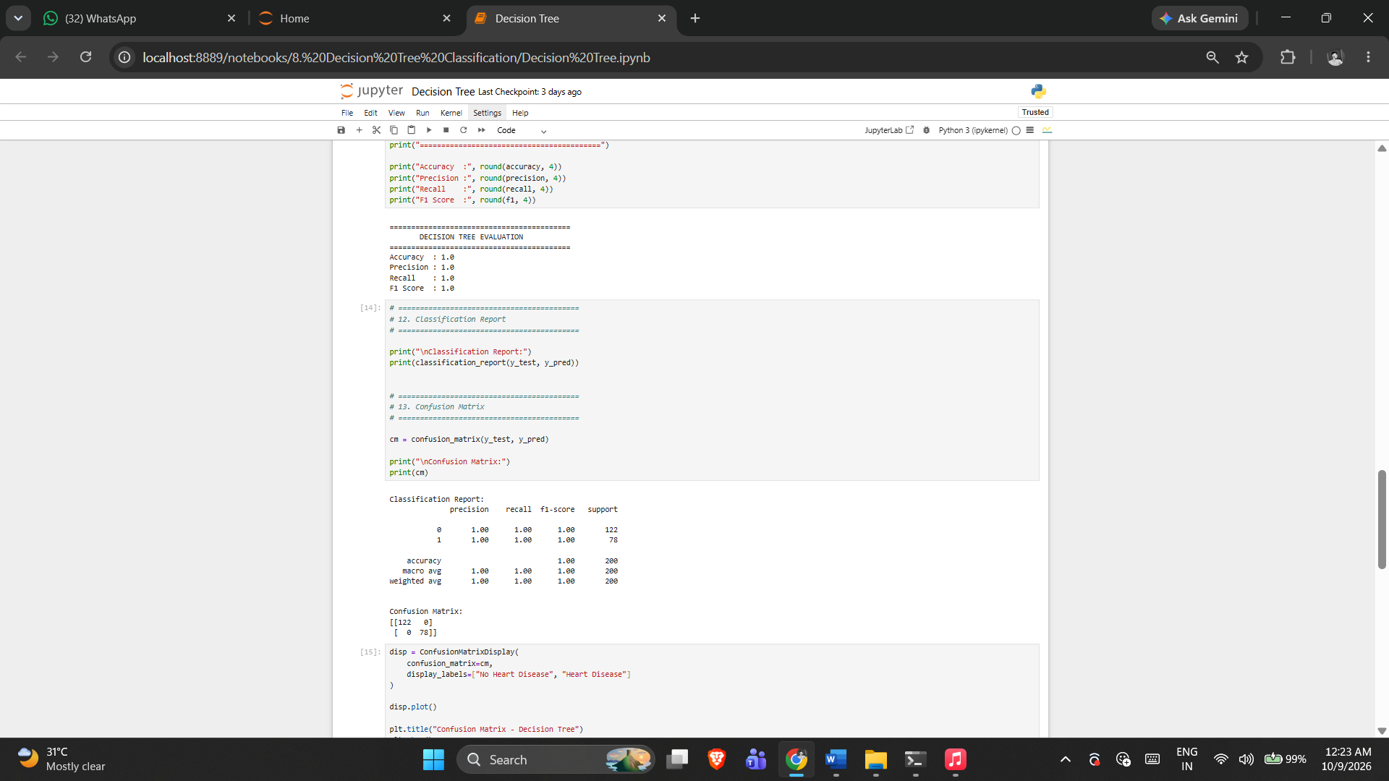

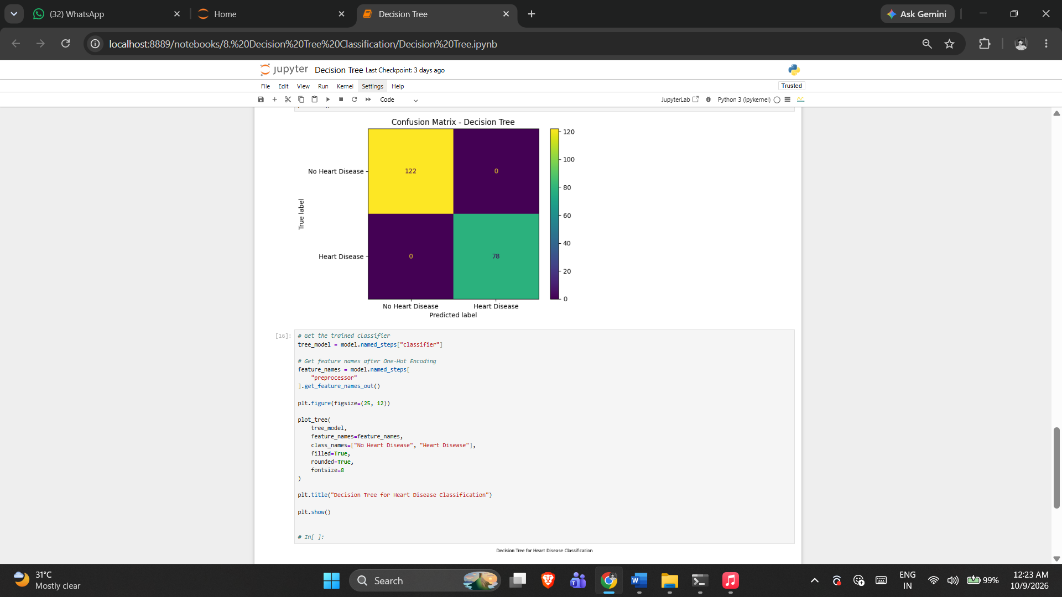

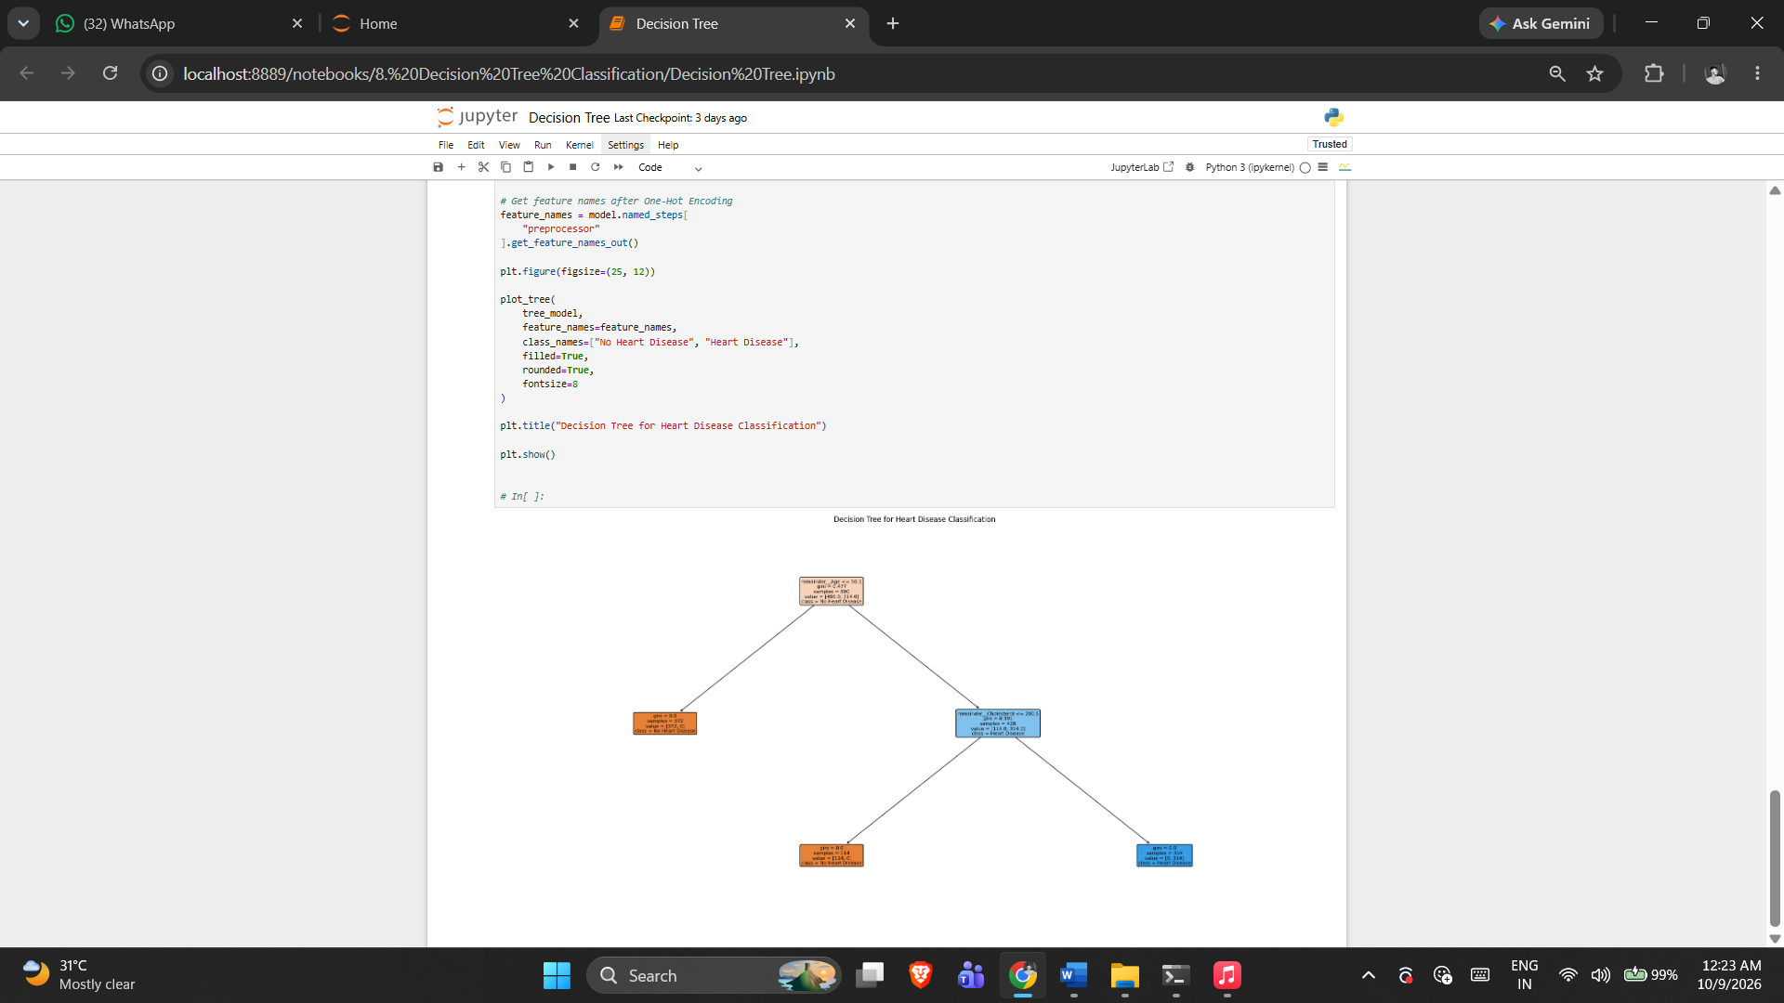

5. RESULT
Thus, the Decision Tree Classifier practical was implemented successfully using the program from the corresponding Jupyter Notebook.

Exercise -9

Random Forest Classification
1. AIM
To build and evaluate a Random Forest classifier for heart disease prediction, including ROC-AUC analysis.
2. ALGORITHM
1. Load and inspect the dataset.
2. Check structure, data types, missing values and target distribution.
3. Separate features and target.
4. Prepare categorical preprocessing.
5. Create the Random Forest classifier with notebook parameters.
6. Split, train and predict.
7. Calculate classification metrics.
8. Generate ROC curve and ROC-AUC.
3. PROGRAM
#!/usr/bin/env python
# coding: utf-8

# Import required libraries

import pandas as pd
import numpy as np
import matplotlib.pyplot as plt
import seaborn as sns

# Machine Learning libraries
from sklearn.model_selection import train_test_split
from sklearn.compose import ColumnTransformer
from sklearn.preprocessing import OneHotEncoder
from sklearn.pipeline import Pipeline
from sklearn.ensemble import RandomForestClassifier

# Evaluation metrics
from sklearn.metrics import (
accuracy_score,
precision_score,
recall_score,
f1_score,
classification_report,
confusion_matrix,
ConfusionMatrixDisplay,
roc_curve,
roc_auc_score
)

# Load the dataset

df = pd.read_csv("heart_disease_dataset.csv")

# Display first 5 rows
df.head()

# Display number of rows and columns

print("Dataset Shape:", df.shape)

# Display column names

print(df.columns)

# Display data types

df.info()

# Check missing values

print(df.isnull().sum())

# Check target class distribution

print(df["Heart Disease"].value_counts())

# X contains input features
# y contains the target variable

X = df.drop("Heart Disease", axis=1)

y = df["Heart Disease"]

print("Features Shape:", X.shape)
print("Target Shape:", y.shape)

# Identify numerical columns

numerical_features = X.select_dtypes(
include=["int64", "float64"]
).columns

# Identify categorical columns

categorical_features = X.select_dtypes(
include=["object"]
).columns

print("Numerical Features:")
print(list(numerical_features))

print("\nCategorical Features:")
print(list(categorical_features))

# Preprocessing for numerical and categorical features

preprocessor = ColumnTransformer(
transformers=[
("num", "passthrough", numerical_features),

("cat", OneHotEncoder(handle_unknown="ignore"),
categorical_features)
]
)

# Create Random Forest classifier

rf_model = RandomForestClassifier(
n_estimators=100,
criterion="gini",
max_depth=None,
min_samples_split=2,
min_samples_leaf=1,
max_features="sqrt",
random_state=42,
n_jobs=-1
)

# Combine preprocessing and Random Forest model

model = Pipeline(
steps=[
("preprocessor", preprocessor),
("classifier", rf_model)
]
)

# Split dataset into training and testing sets

X_train, X_test, y_train, y_test = train_test_split(
X,
y,
test_size=0.2,
random_state=42,
stratify=y
)

print("Training Data:", X_train.shape)
print("Testing Data:", X_test.shape)

# Train the model

model.fit(X_train, y_train)

print("Random Forest Model Trained Successfully!")

# Predict on training data

y_train_pred = model.predict(X_train)

# Predict on testing data

y_test_pred = model.predict(X_test)

print("Predictions Generated Successfully!")

# Calculate evaluation metrics

train_accuracy = accuracy_score(y_train, y_train_pred)

test_accuracy = accuracy_score(y_test, y_test_pred)

precision = precision_score(y_test, y_test_pred)

recall = recall_score(y_test, y_test_pred)

f1 = f1_score(y_test, y_test_pred)

print("Training Accuracy :", round(train_accuracy, 4))
print("Testing Accuracy :", round(test_accuracy, 4))
print("Precision :", round(precision, 4))
print("Recall :", round(recall, 4))
print("F1 Score :", round(f1, 4))

# Predict probabilities

y_test_proba = model.predict_proba(X_test)[:, 1]

# Calculate ROC curve

fpr, tpr, thresholds = roc_curve(y_test, y_test_proba)

# Calculate AUC

auc_score = roc_auc_score(y_test, y_test_proba)

print("ROC-AUC Score:", round(auc_score, 4))

# Plot ROC Curve

plt.figure(figsize=(8, 6))

plt.plot(
fpr,
tpr,
label=f"Random Forest (AUC = {auc_score:.2f})"
)

plt.plot(
[0, 1],
[0, 1],
linestyle="--",
label="Random Classifier"
)

plt.xlabel("False Positive Rate")

plt.ylabel("True Positive Rate")

plt.title("ROC Curve - Random Forest")

plt.legend()

plt.show()

4. OUTPUT

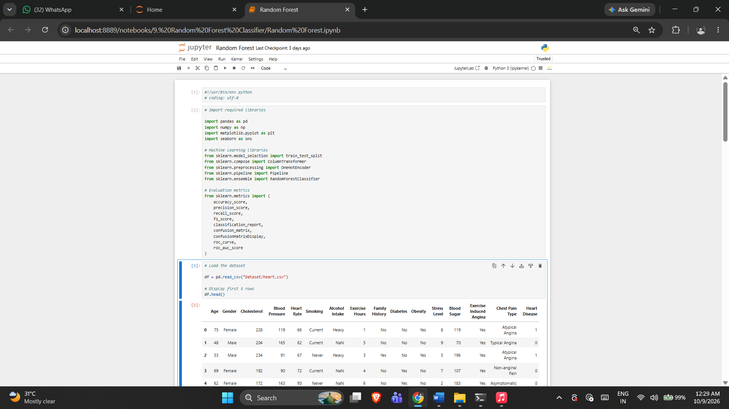

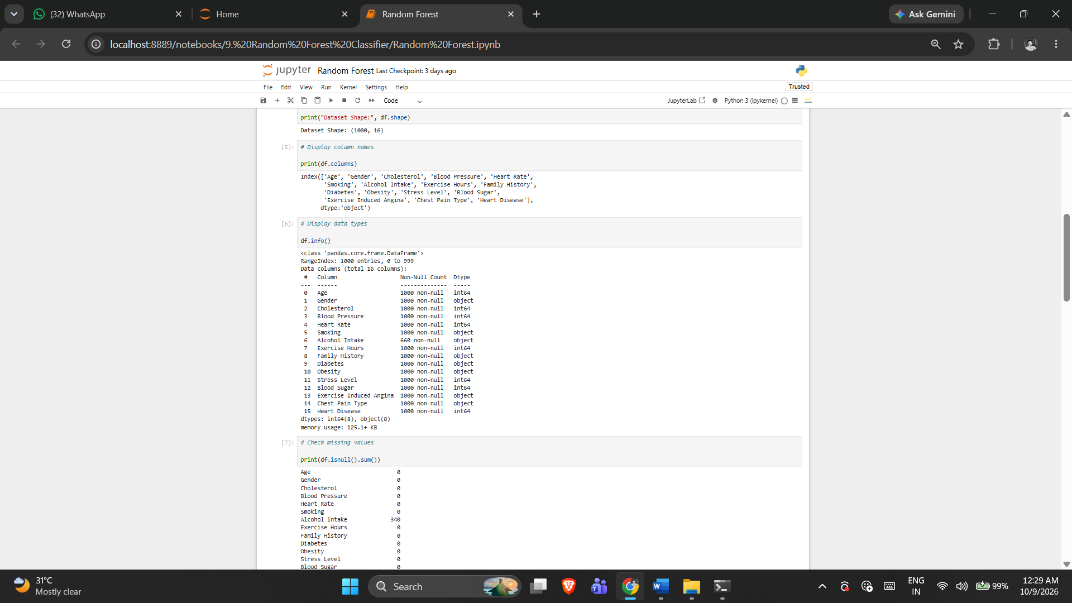

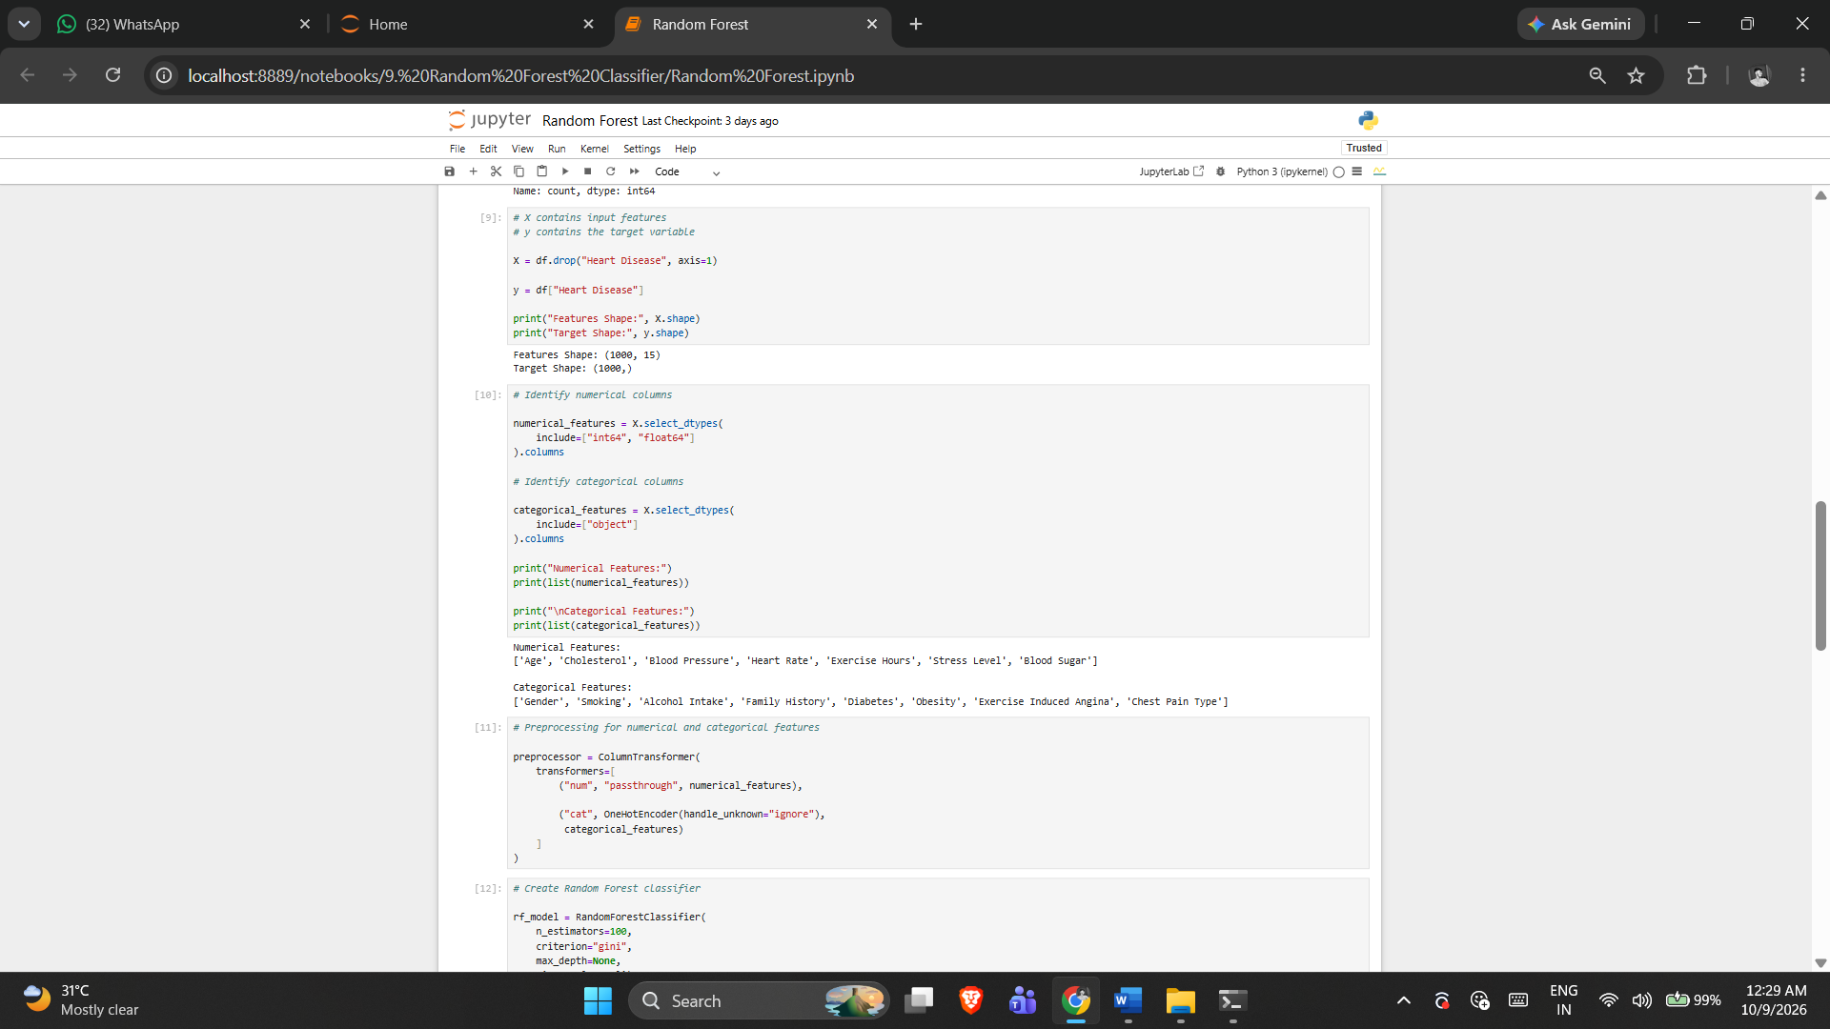

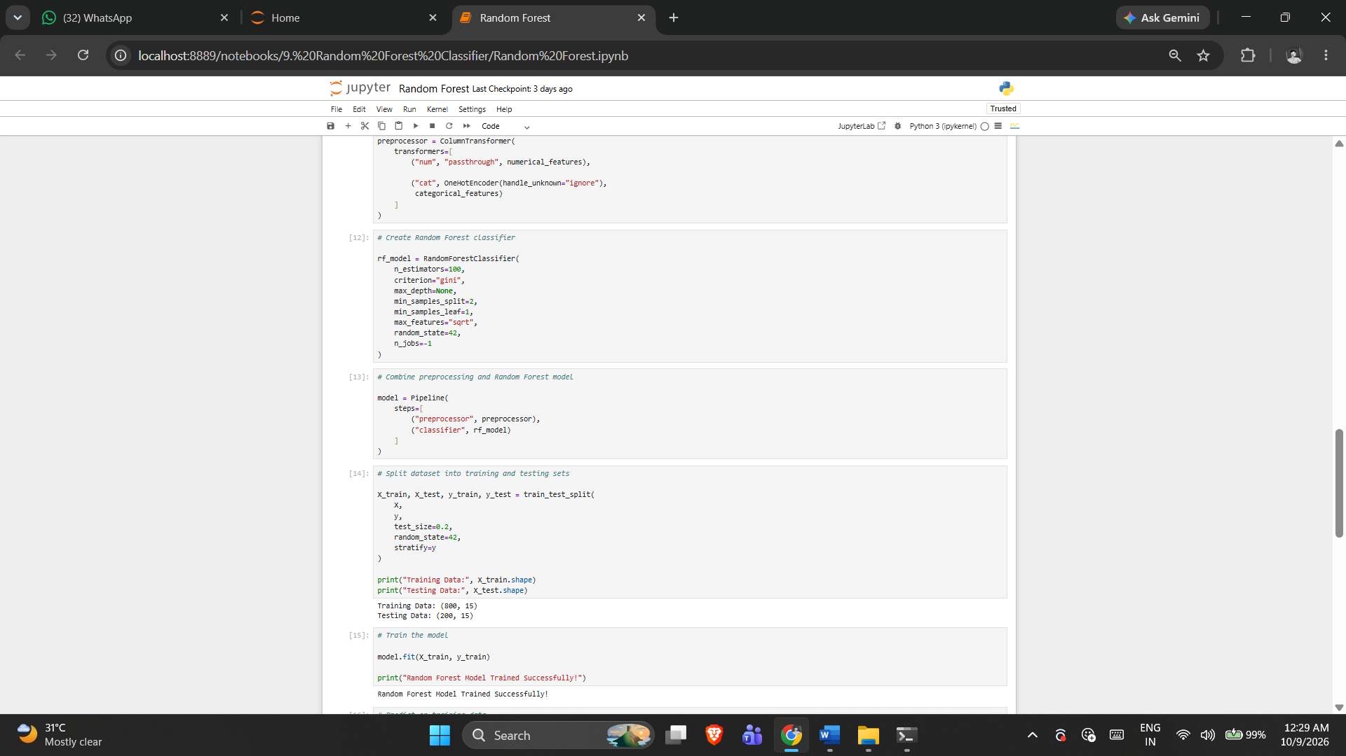

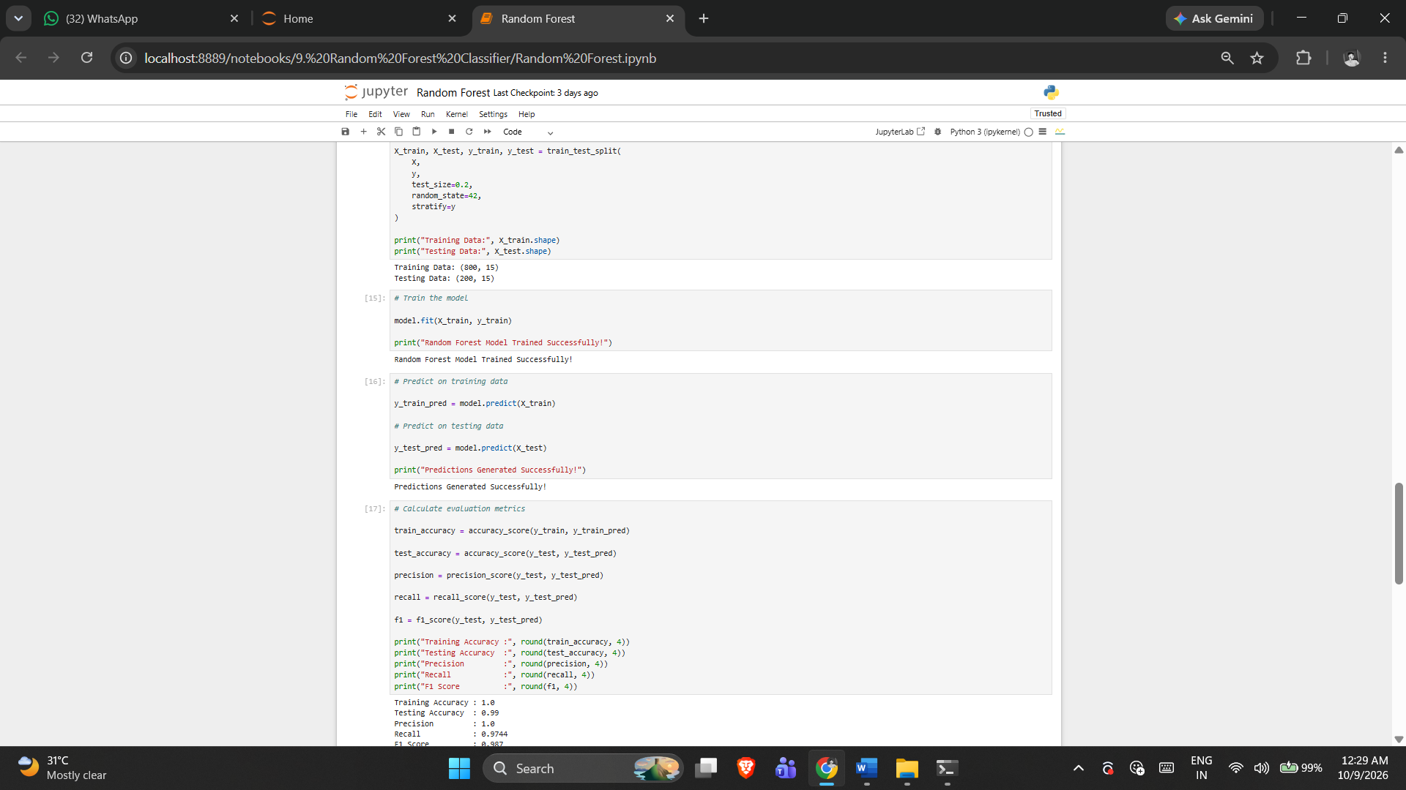

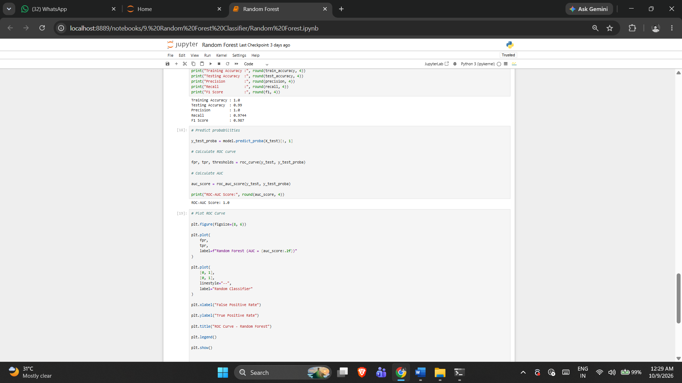

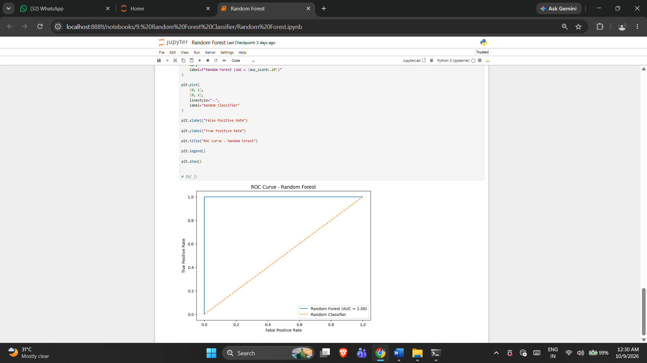

5. RESULT
Thus, the Random Forest Classifier practical was implemented successfully using the program from the corresponding Jupyter Notebook.

Exercise -10

Support Vector Machine
1. AIM
To perform SVM classification using Linear, Polynomial, RBF and Sigmoid kernels and compare their performance.
2. ALGORITHM
1. Load the dataset and separate features and target.
2. Identify numerical and categorical features.
3. Create scaling and encoding preprocessing.
4. Split the data with stratification.
5. Train SVM models using the four notebook kernels.
6. Calculate accuracy, precision, recall and F1 score.
7. Compare kernel performance in a table and plot.
3. PROGRAM
#!/usr/bin/env python
# coding: utf-8

# Step 1: Import libraries
import pandas as pd
import matplotlib.pyplot as plt

from sklearn.model_selection import train_test_split
from sklearn.compose import ColumnTransformer
from sklearn.preprocessing import StandardScaler, OneHotEncoder
from sklearn.pipeline import Pipeline
from sklearn.svm import SVC
from sklearn.metrics import (
accuracy_score,
precision_score,
recall_score,
f1_score,
classification_report,
confusion_matrix
)

df = pd.read_csv("heart_disease_dataset.csv")

print("Dataset Shape:", df.shape)
print("\nFirst 5 records:")
print(df.head())

X = df.drop("Heart Disease", axis=1)
y = df["Heart Disease"]

numeric_features = X.select_dtypes(include=["int64", "float64"]).columns
categorical_features = X.select_dtypes(include=["object"]).columns

print("\nNumerical Features:")
print(list(numeric_features))

print("\nCategorical Features:")
print(list(categorical_features))

preprocessor = ColumnTransformer(
transformers=[
("num", StandardScaler(), numeric_features),
("cat", OneHotEncoder(handle_unknown="ignore"), categorical_features)
]
)

X_train, X_test, y_train, y_test = train_test_split(
X,
y,
test_size=0.20,
random_state=42,
stratify=y
)

kernels = ["linear", "poly", "rbf", "sigmoid"]

results = []

for kernel in kernels:

model = Pipeline(
steps=[
("preprocessor", preprocessor),
("svm", SVC(kernel=kernel, random_state=42))
]
)

model.fit(X_train, y_train)

y_pred = model.predict(X_test)

accuracy = accuracy_score(y_test, y_pred)
precision = precision_score(y_test, y_pred, zero_division=0)
recall = recall_score(y_test, y_pred, zero_division=0)
f1 = f1_score(y_test, y_pred, zero_division=0)

results.append([
kernel,
accuracy,
precision,
recall,
f1
])

print("\n======================================")
print("SVM Kernel:", kernel)
print("======================================")

print("Accuracy :", accuracy)
print("Precision:", precision)
print("Recall :", recall)
print("F1 Score :", f1)

print("\nClassification Report:")
print(classification_report(
y_test,
y_pred,
zero_division=0
))

results_df = pd.DataFrame(
results,
columns=[
"Kernel",
"Accuracy",
"Precision",
"Recall",
"F1 Score"
]
)

print("\n\nKernel Comparison:")
print(results_df)

plt.figure(figsize=(8, 5))

plt.bar(
results_df["Kernel"],
results_df["Accuracy"]
)

plt.xlabel("SVM Kernel")
plt.ylabel("Accuracy")
plt.title("SVM Performance with Different Kernels")
plt.ylim(0, 1)

plt.show()

# ------------------------------------------------------------
# Result
# ------------------------------------------------------------

print("\nResult:")
print("SVM classification was successfully performed")
print("using Linear, Polynomial, RBF and Sigmoid kernels.")

4. OUTPUT

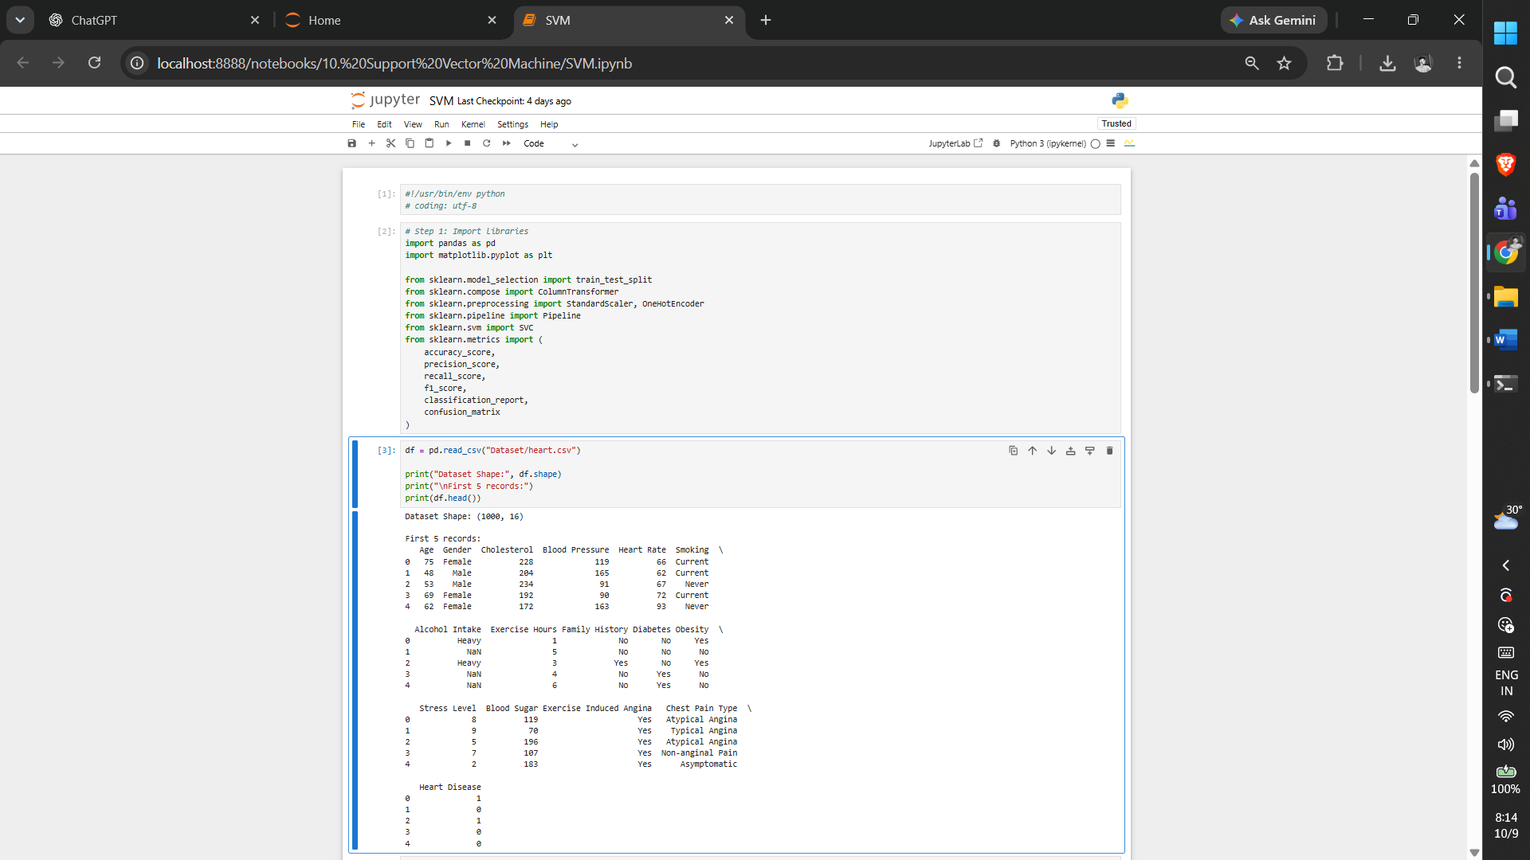

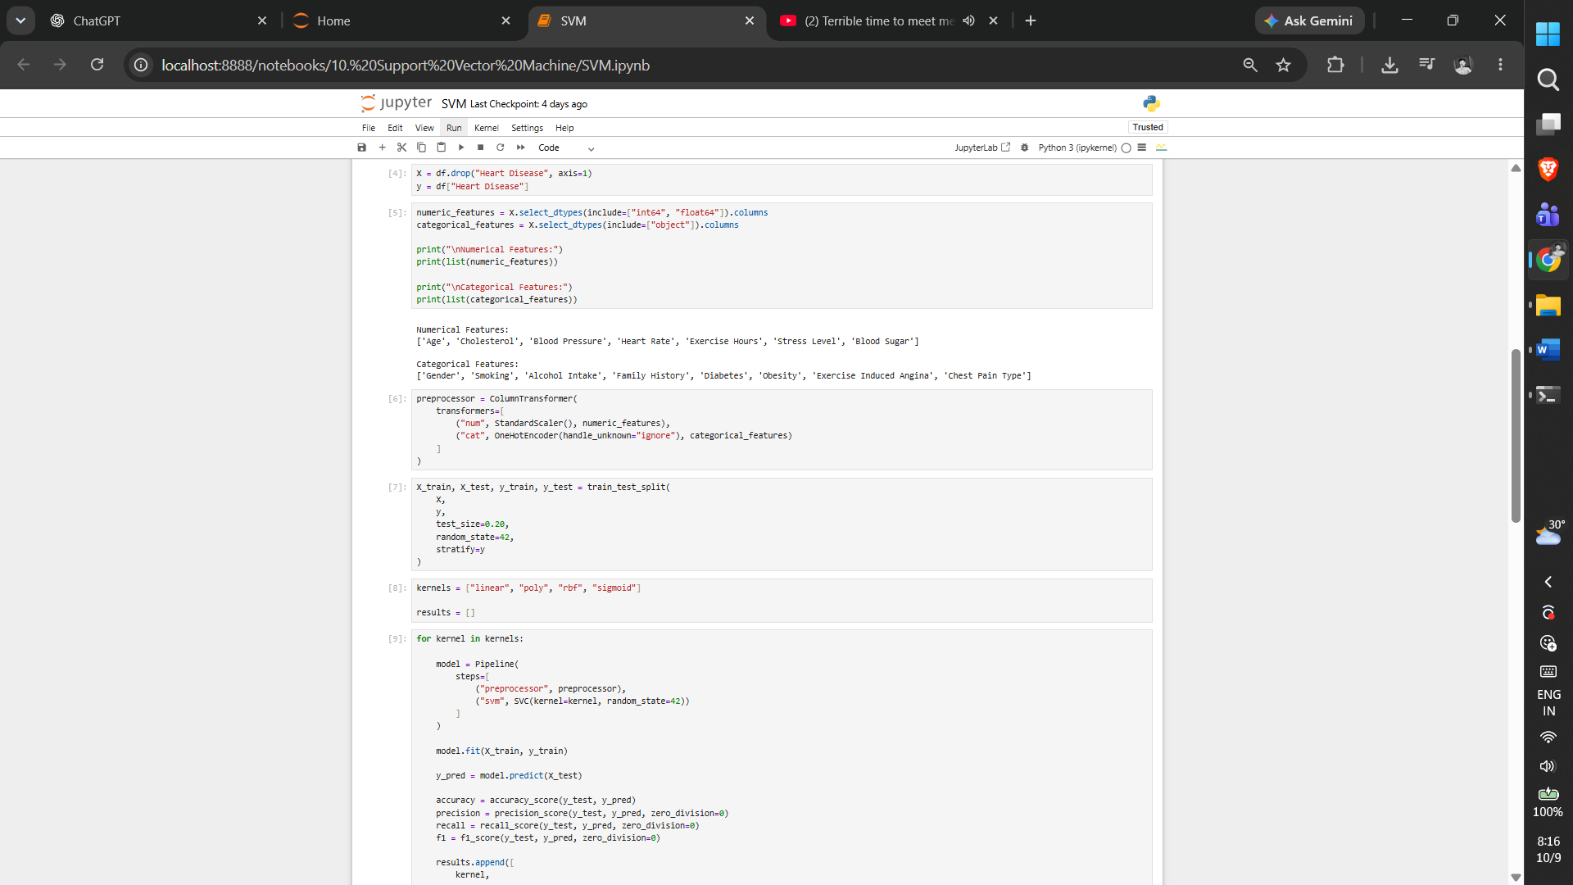

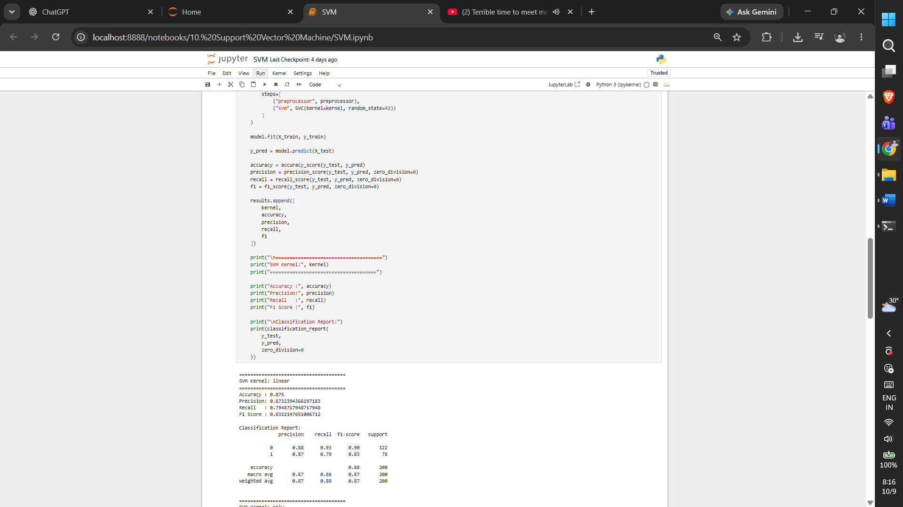

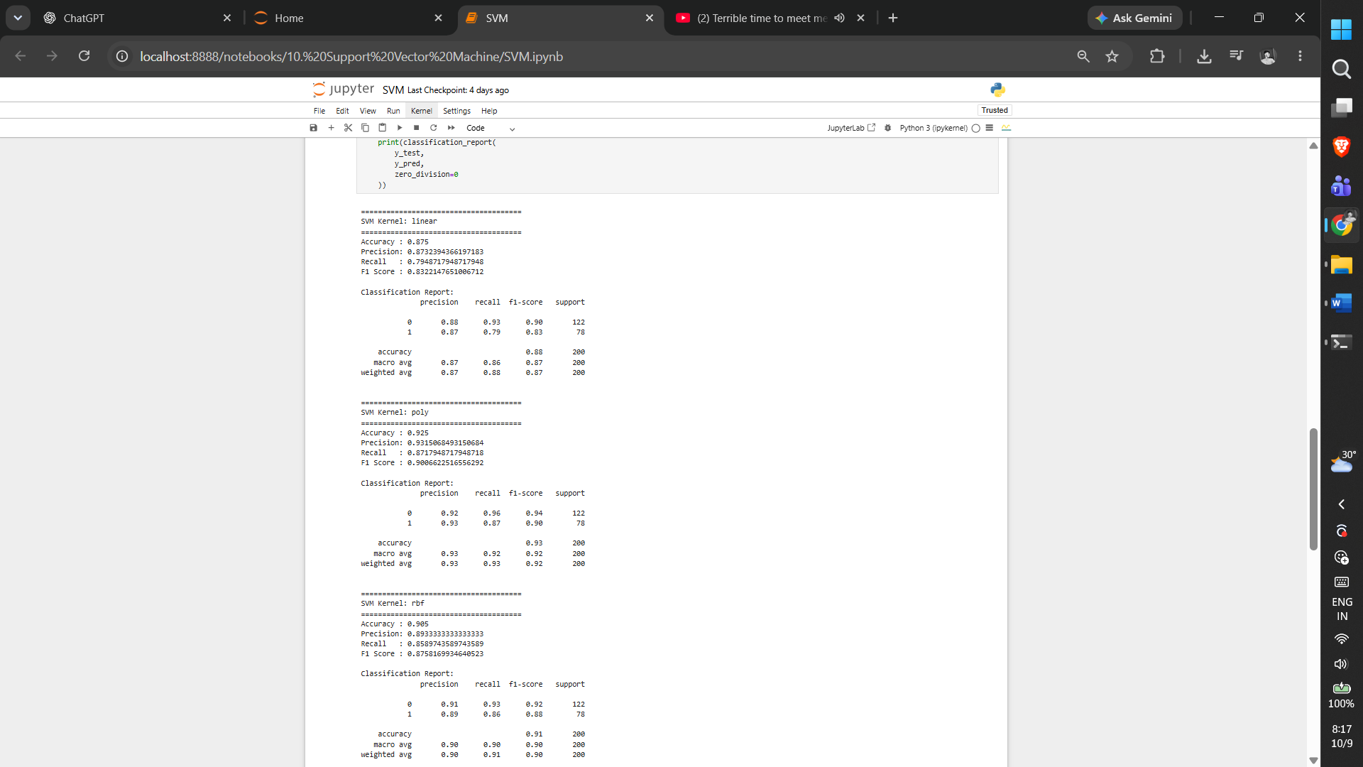

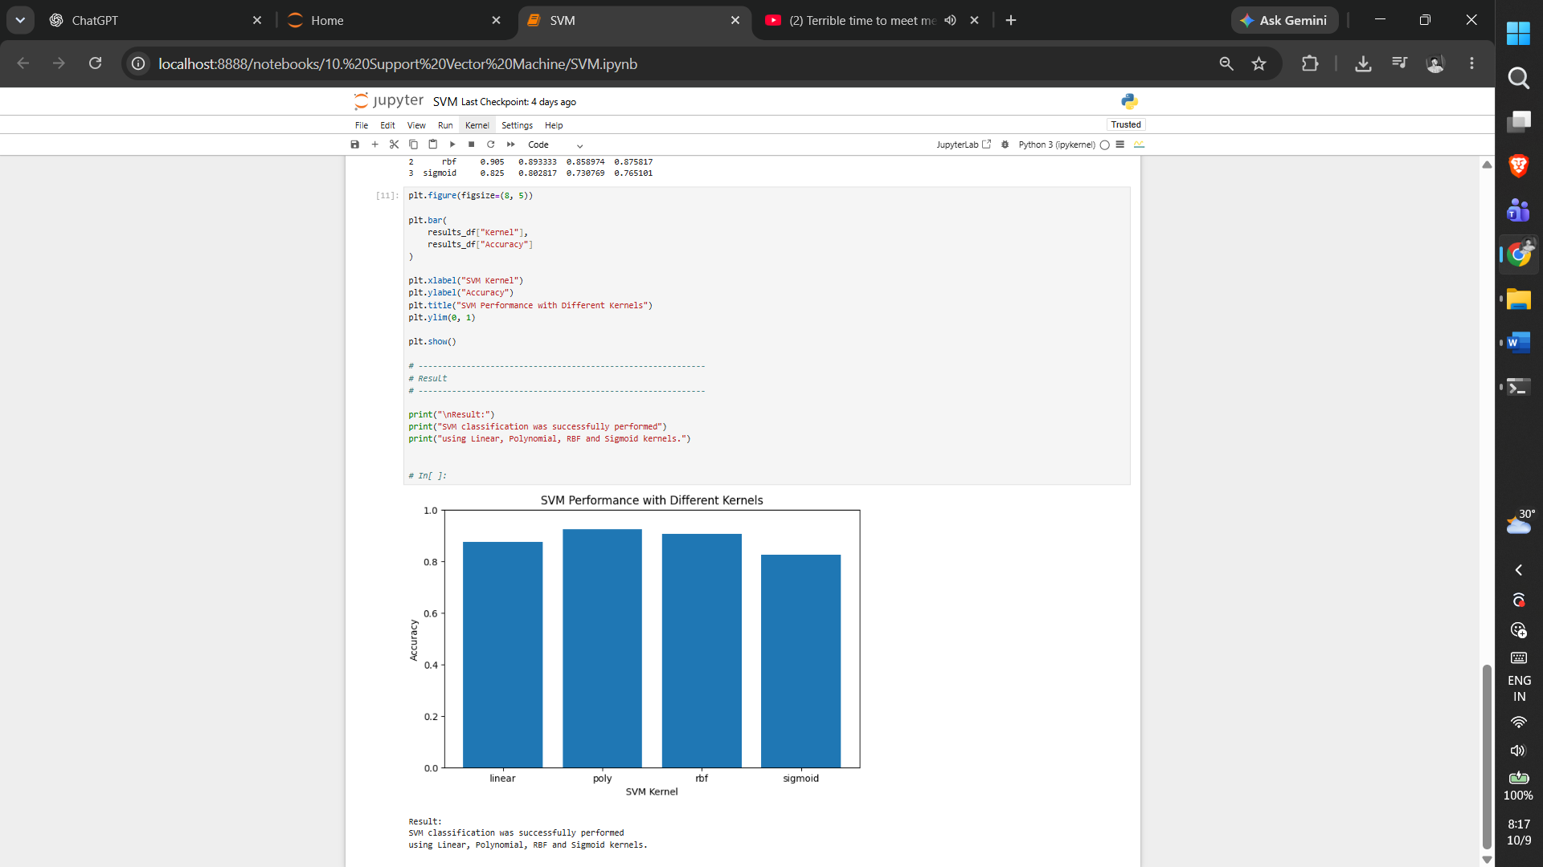

5. RESULT

Thus, the Support Vector Machine practical was implemented successfully using the program from the corresponding Jupyter Notebook.

Exercise -11

K Means Clustering
1. AIM
To perform K-Means clustering and use the Elbow Method to determine a suitable number of clusters and visualize the resulting groups.
2. ALGORITHM
1. Load and prepare the dataset.
2. Preprocess the features as implemented in the notebook.
3. Run K-Means for the specified range of K values.
4. Calculate the clustering inertia values.
5. Plot the Elbow curve.
6. Fit and visualize the selected clustering solution.
3. PROGRAM
#!/usr/bin/env python
# coding: utf-8

import pandas as pd
import matplotlib.pyplot as plt

from sklearn.compose import ColumnTransformer
from sklearn.preprocessing import StandardScaler, OneHotEncoder
from sklearn.cluster import KMeans

df = pd.read_csv("heart_disease_dataset.csv")

print("Dataset Shape:", df.shape)
print("\nFirst 5 records:")
print(df.head())

X = df.drop("Heart Disease", axis=1)

numeric_features = X.select_dtypes(
include=["int64", "float64"]
).columns

categorical_features = X.select_dtypes(
include=["object"]
).columns

preprocessor = ColumnTransformer(
transformers=[
("num", StandardScaler(), numeric_features),
("cat", OneHotEncoder(handle_unknown="ignore"), categorical_features)
]
)

X_processed = preprocessor.fit_transform(X)

# Check whether X_processed is sparse or already a NumPy array
if hasattr(X_processed, "toarray"):
X_processed = X_processed.toarray()

print("\nProcessed Data Shape:")
print(X_processed.shape)

# ------------------------------------------------------------
# Step 7: Apply Elbow Method
# ------------------------------------------------------------

inertia = []

K = range(1, 11)

for k in K:

kmeans = KMeans(
n_clusters=k,
random_state=42,
n_init=10
)

kmeans.fit(X_processed)

inertia.append(kmeans.inertia_)

plt.figure(figsize=(8, 5))

plt.plot(
K,
inertia,
marker="o"
)

plt.xlabel("Number of Clusters (K)")
plt.ylabel("Inertia")
plt.title("Elbow Method for Optimal K")

plt.xticks(K)

plt.grid(True)

plt.show()

# Change this value after observing the elbow plot.
optimal_k = 3

print("\nSelected Optimal K:", optimal_k)

kmeans = KMeans(
n_clusters=optimal_k,
random_state=42,
n_init=10
)

clusters = kmeans.fit_predict(X_processed)

df["Cluster"] = clusters

print("\nClustered Dataset:")
print(df.head(10))

print("\nNumber of records in each cluster:")
print(df["Cluster"].value_counts().sort_index())

4. OUTPUT

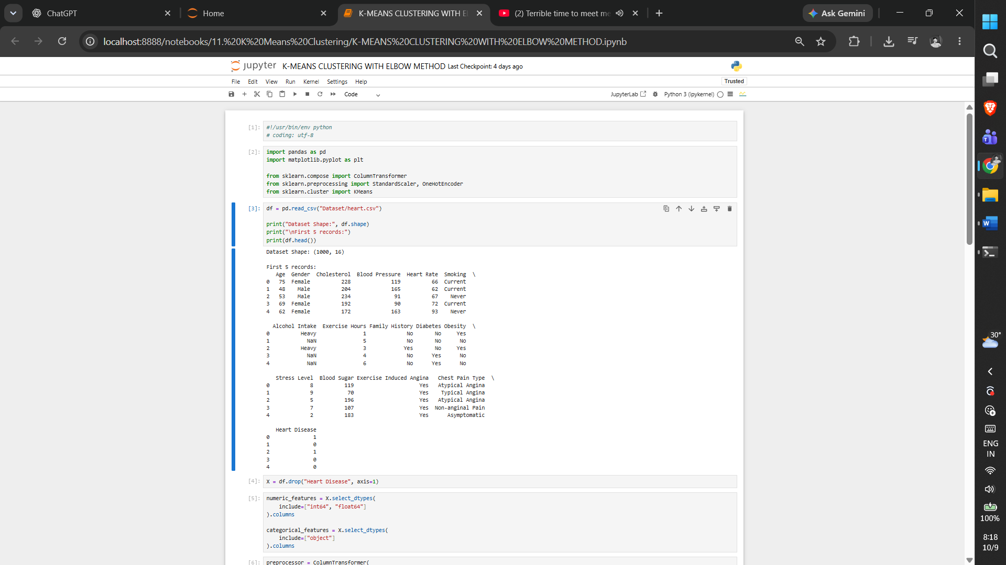

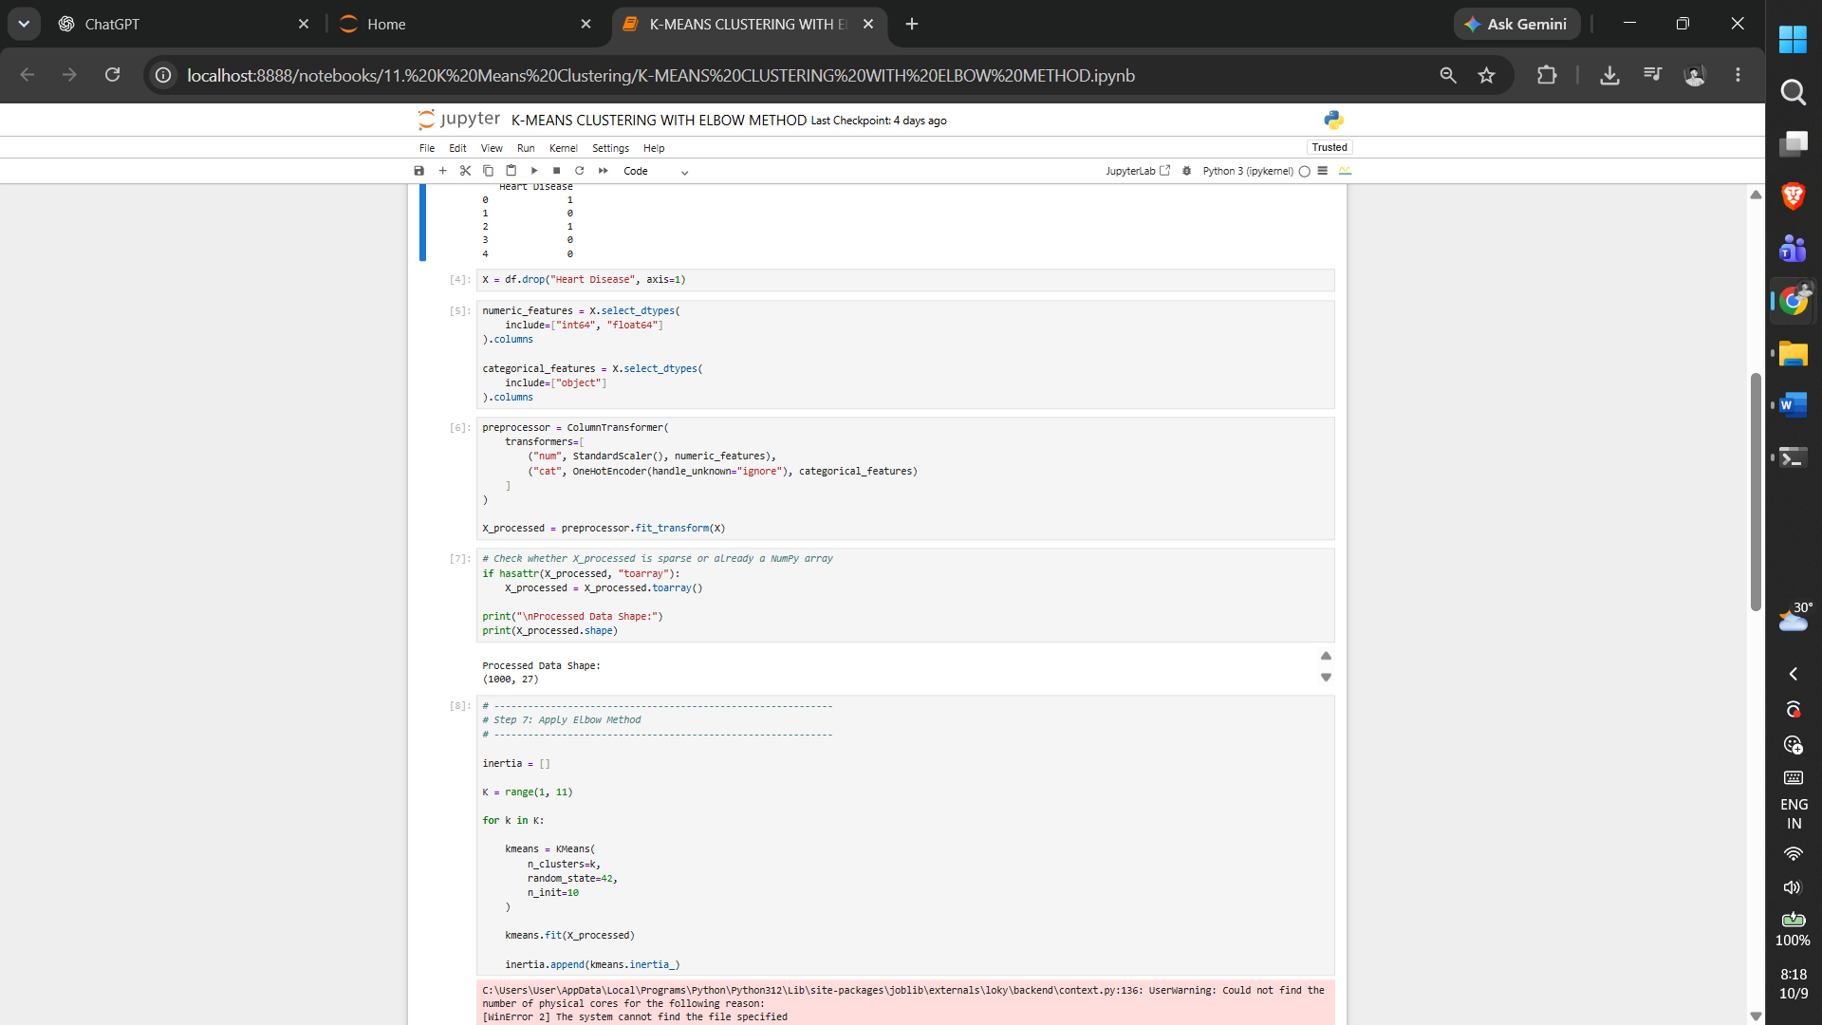

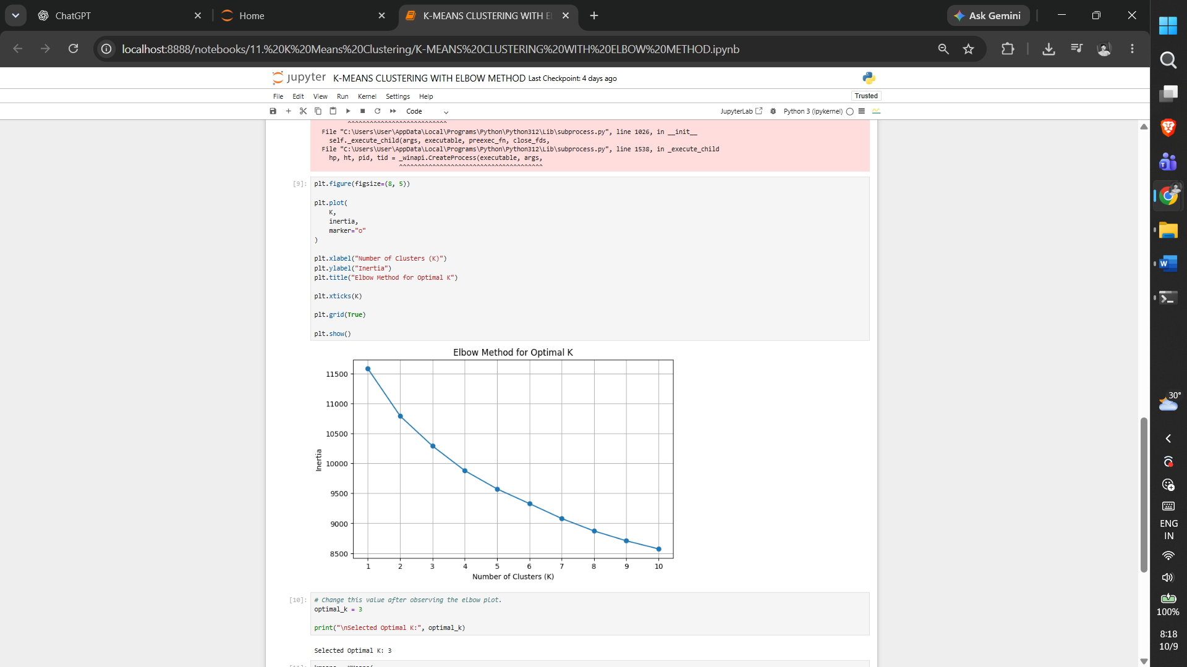

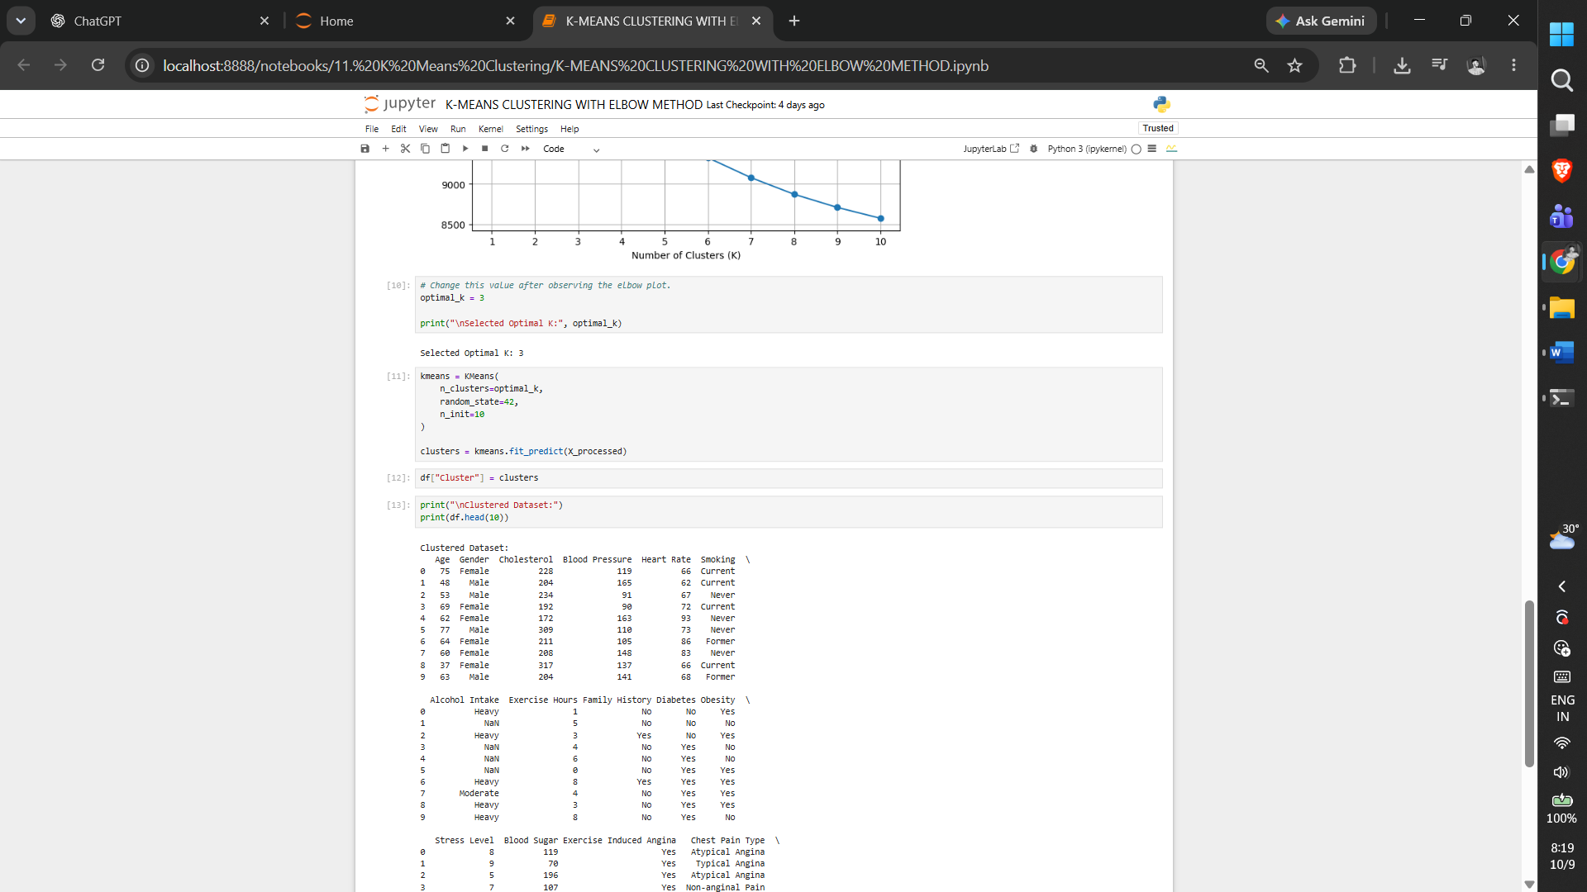
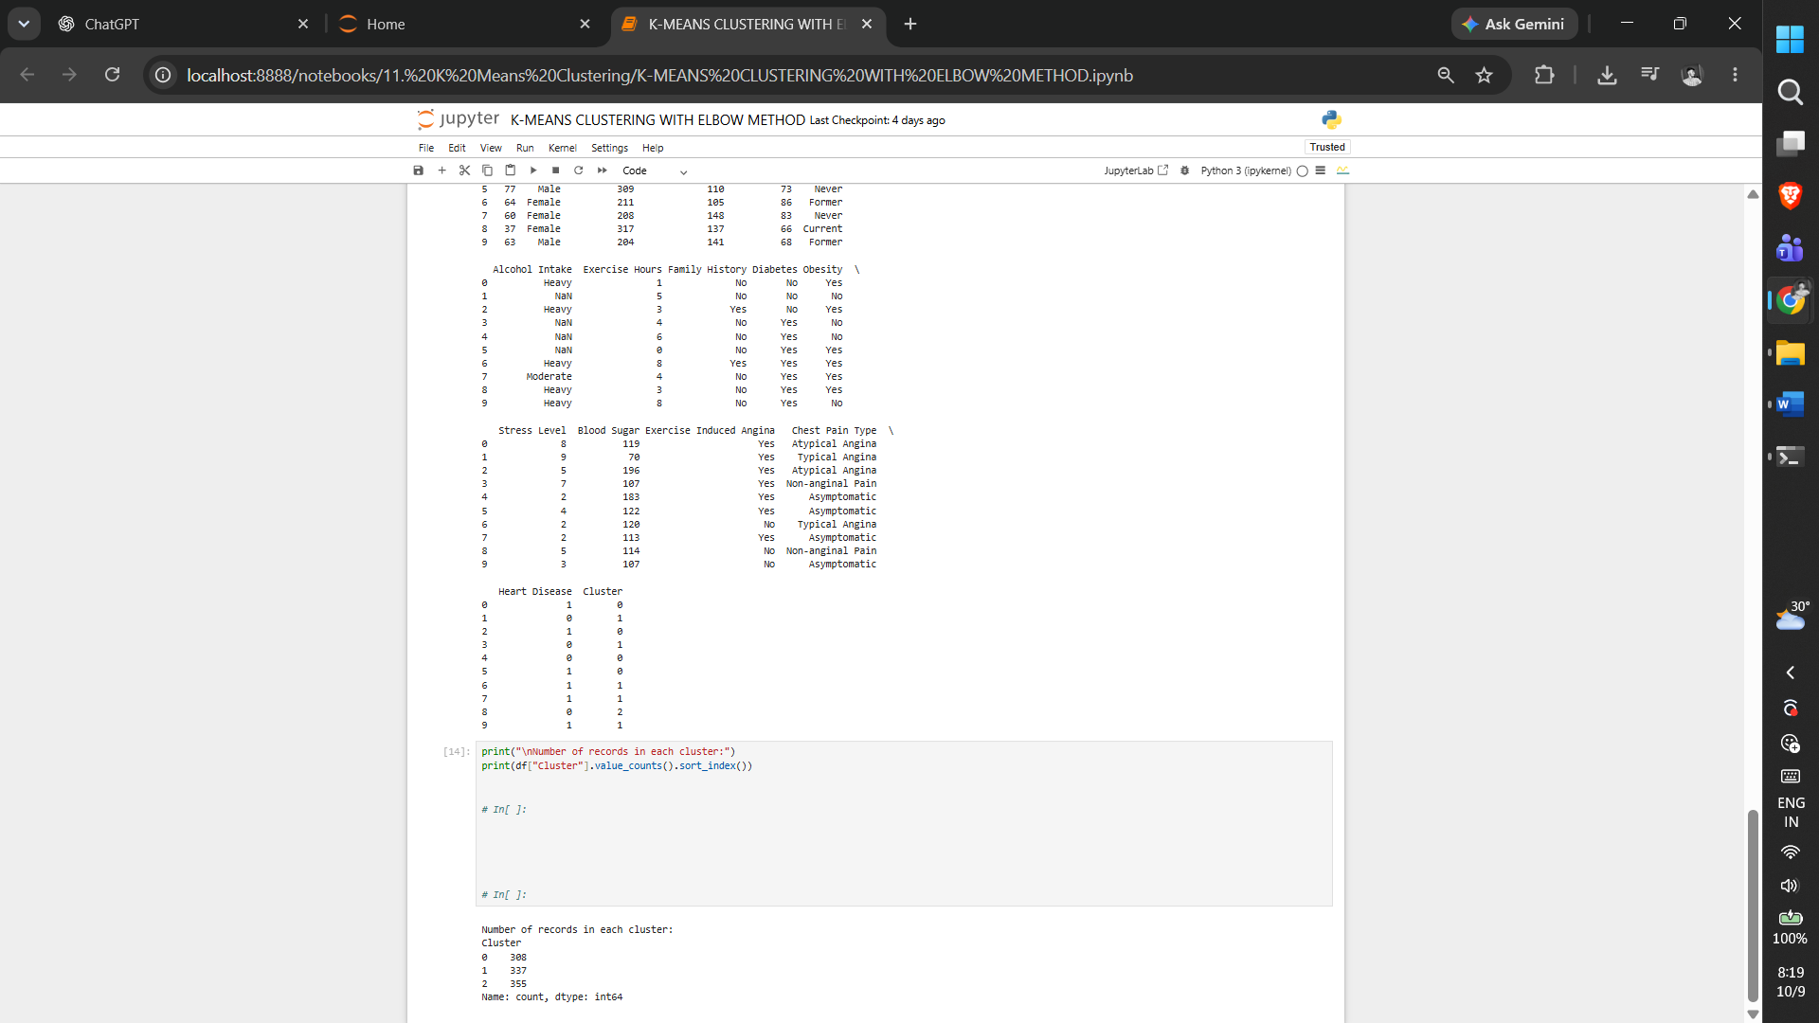

5. RESULT
Thus, the K Means Clustering practical was implemented successfully using the program from the corresponding Jupyter Notebook.

Exercise -12

Hierarchical Clustering
1. AIM
To perform hierarchical clustering on the preprocessed heart disease dataset using Ward linkage and visualize the hierarchy with a dendrogram.
2. ALGORITHM
1. Load the dataset and remove the target.
2. Identify numerical and categorical features.
3. Standardize numerical data and one-hot encode categorical data.
4. Create the processed feature matrix.
5. Perform Ward hierarchical linkage.
6. Plot the dendrogram.
3. PROGRAM
#!/usr/bin/env python
# coding: utf-8

import pandas as pd
import matplotlib.pyplot as plt

from sklearn.compose import ColumnTransformer
from sklearn.preprocessing import StandardScaler, OneHotEncoder

from scipy.cluster.hierarchy import (
dendrogram,
linkage
)

df = pd.read_csv("heart_disease_dataset.csv")

print("Dataset Shape:", df.shape)
print("\nFirst 5 records:")
print(df.head())

X = df.drop("Heart Disease", axis=1)

numeric_features = X.select_dtypes(
include=["int64", "float64"]
).columns

categorical_features = X.select_dtypes(
include=["object"]
).columns

preprocessor = ColumnTransformer(
transformers=[
("num", StandardScaler(), numeric_features),
("cat", OneHotEncoder(handle_unknown="ignore"), categorical_features)
]
)

X_processed = preprocessor.fit_transform(X)

# Check whether X_processed is sparse or already a NumPy array
if hasattr(X_processed, "toarray"):
X_processed = X_processed.toarray()

print("\nProcessed Data Shape:")
print(X_processed.shape)

linked = linkage(
X_processed,
method="ward"
)

plt.figure(figsize=(14, 7))

dendrogram(
linked,
truncate_mode="lastp",
p=30,
leaf_rotation=90,
leaf_font_size=10,
show_contracted=True
)

plt.title("Hierarchical Clustering Dendrogram")
plt.xlabel("Cluster / Data Points")
plt.ylabel("Distance")

plt.show()
4. OUTPUT

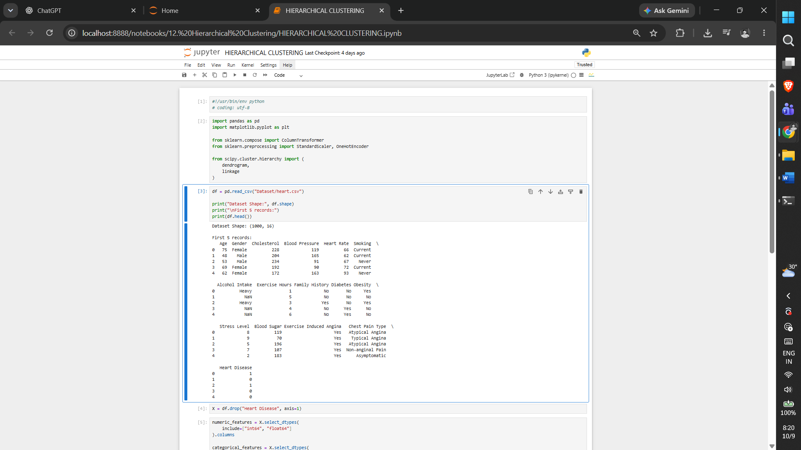

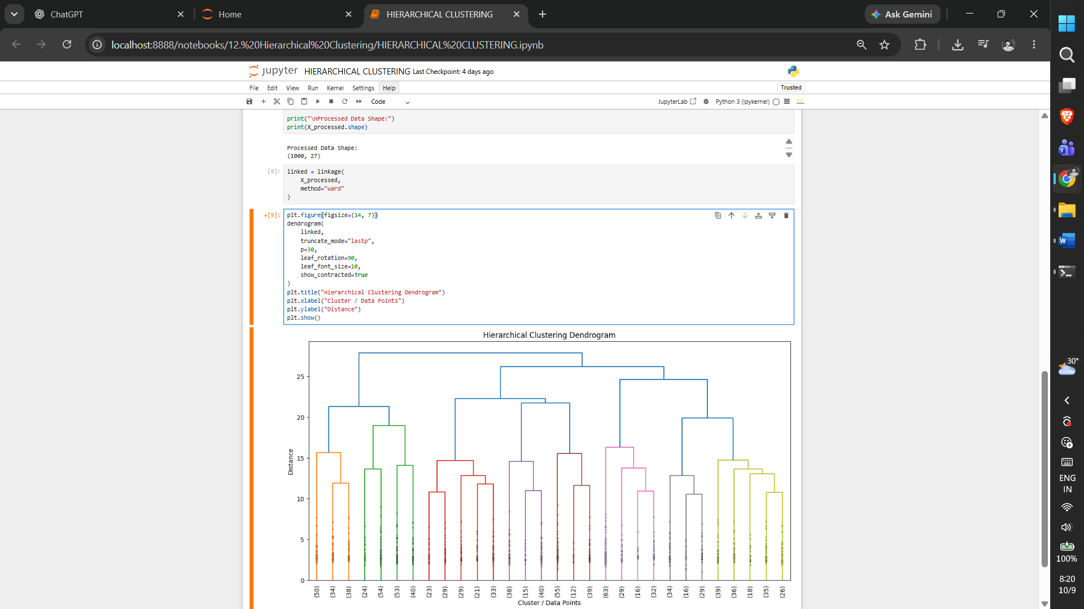
5. RESULT
Thus, the Hierarchical Clustering practical was implemented successfully using the program from the corresponding Jupyter Notebook.

Exercise -13

DBSCAN Clustering
1. AIM
To perform DBSCAN clustering on the heart disease dataset, identify clusters and noise points, and visualize the clustering result using PCA.
2. ALGORITHM
1. Load the dataset and separate the target.
2. Identify numerical and categorical features.
3. Scale numerical features and one-hot encode categorical features.
4. Apply DBSCAN using the notebook parameters.
5. Assign labels, identify noise points and count clusters.
6. Apply PCA for two-dimensional visualization.
3. PROGRAM
#!/usr/bin/env python
# coding: utf-8

import pandas as pd
import matplotlib.pyplot as plt

from sklearn.compose import ColumnTransformer
from sklearn.preprocessing import StandardScaler, OneHotEncoder
from sklearn.cluster import DBSCAN
from sklearn.decomposition import PCA

df = pd.read_csv("heart_disease_dataset.csv")

print("Dataset Shape:", df.shape)
print("\nFirst 5 records:")
print(df.head())

X = df.drop("Heart Disease", axis=1)

numeric_features = X.select_dtypes(
include=["int64", "float64"]
).columns

categorical_features = X.select_dtypes(
include=["object"]
).columns

preprocessor = ColumnTransformer(
transformers=[
("num", StandardScaler(), numeric_features),
("cat", OneHotEncoder(handle_unknown="ignore"), categorical_features)
]
)

X_processed = preprocessor.fit_transform(X)

X_processed = X_processed

dbscan = DBSCAN(
eps=1.5,
min_samples=5
)

labels = dbscan.fit_predict(X_processed)

df["Cluster"] = labels

print("\nCluster Labels:")
print(df["Cluster"].value_counts().sort_index())

noise_points = df[df["Cluster"] == -1]

print("\nNumber of Noise Points:")
print(len(noise_points))

print("\nNoise Points:")
print(noise_points.head(10))

number_of_clusters = len(
set(labels)
) - (1 if -1 in labels else 0)

print("\nNumber of Clusters:")
print(number_of_clusters)

pca = PCA(n_components=2)

X_pca = pca.fit_transform(X_processed)

plt.figure(figsize=(9, 6))

plt.scatter(
X_pca[:, 0],
X_pca[:, 1],
c=labels,
cmap="viridis",
s=40
)

plt.xlabel("Principal Component 1")
plt.ylabel("Principal Component 2")
plt.title("DBSCAN Clustering")

plt.colorbar(label="Cluster")

plt.show()

4. OUTPUT
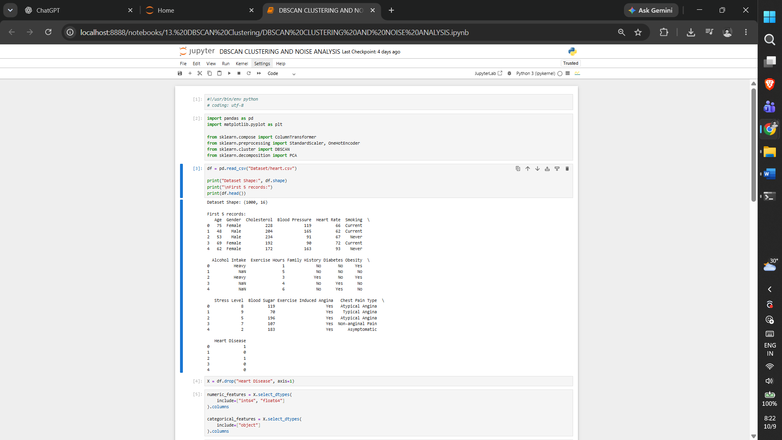

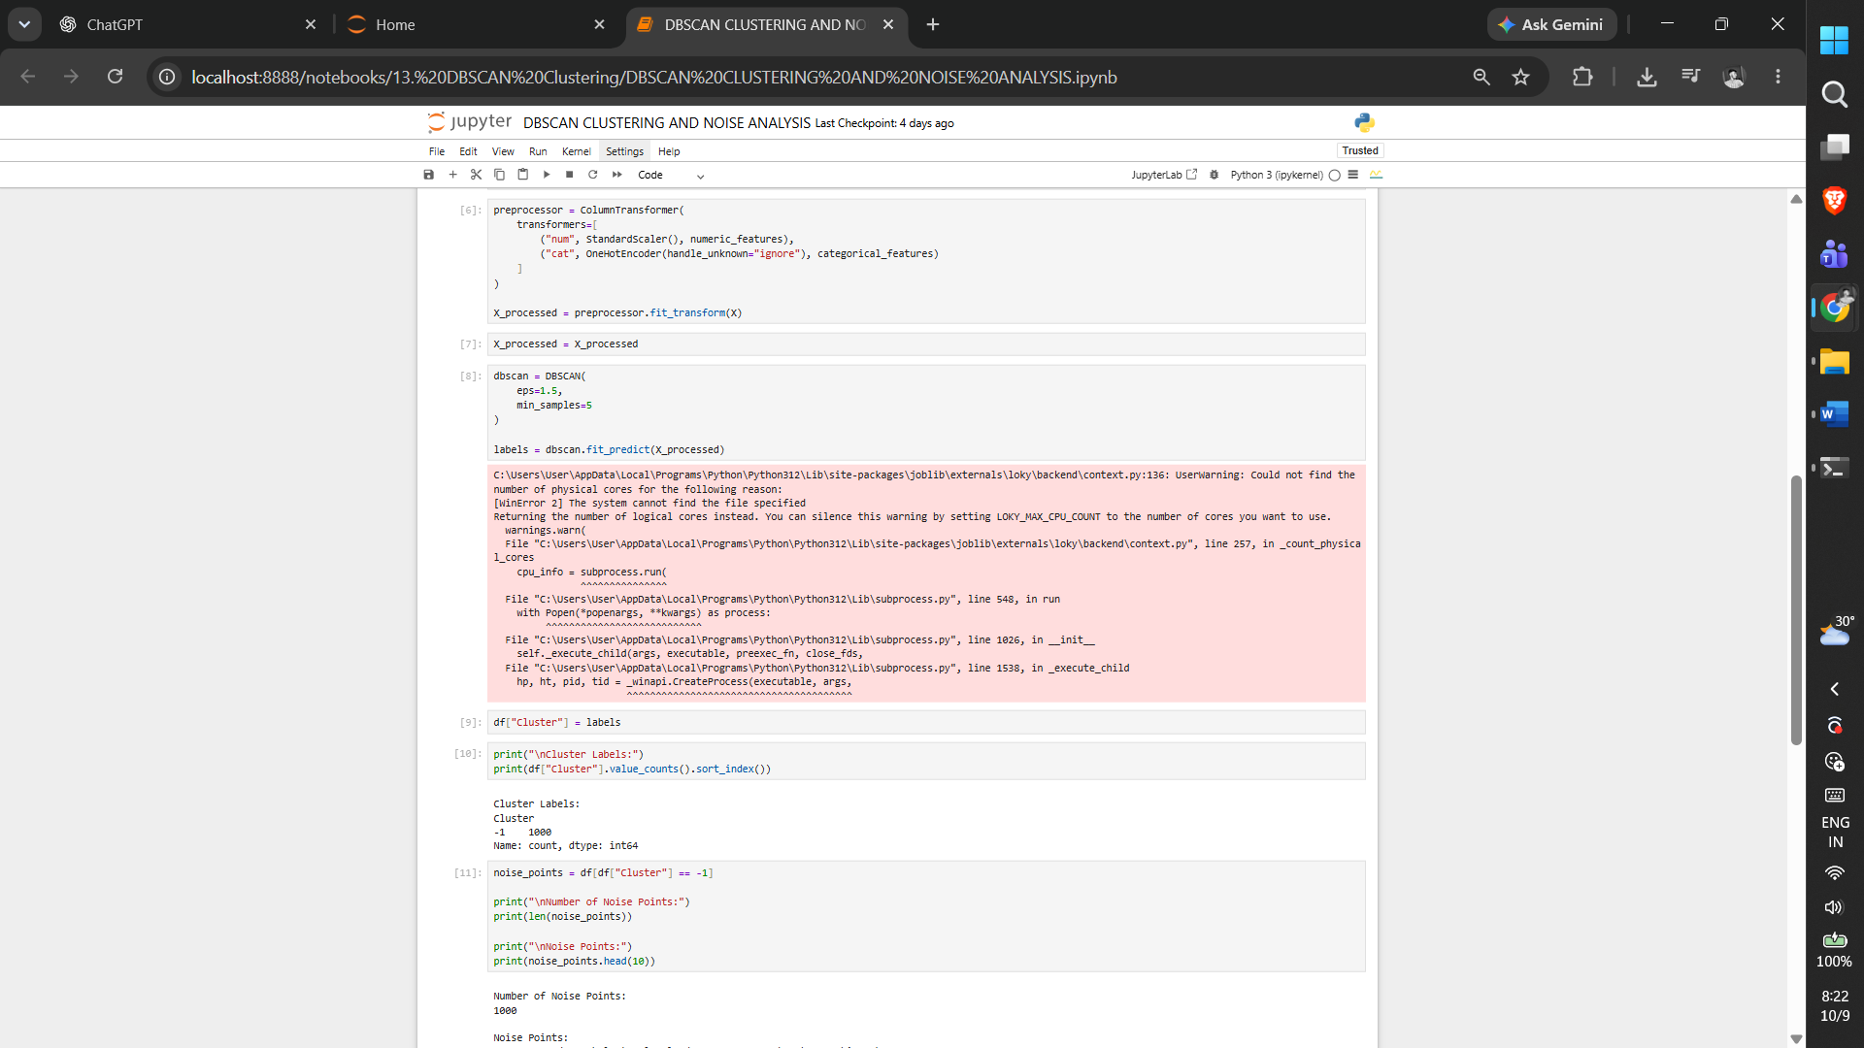

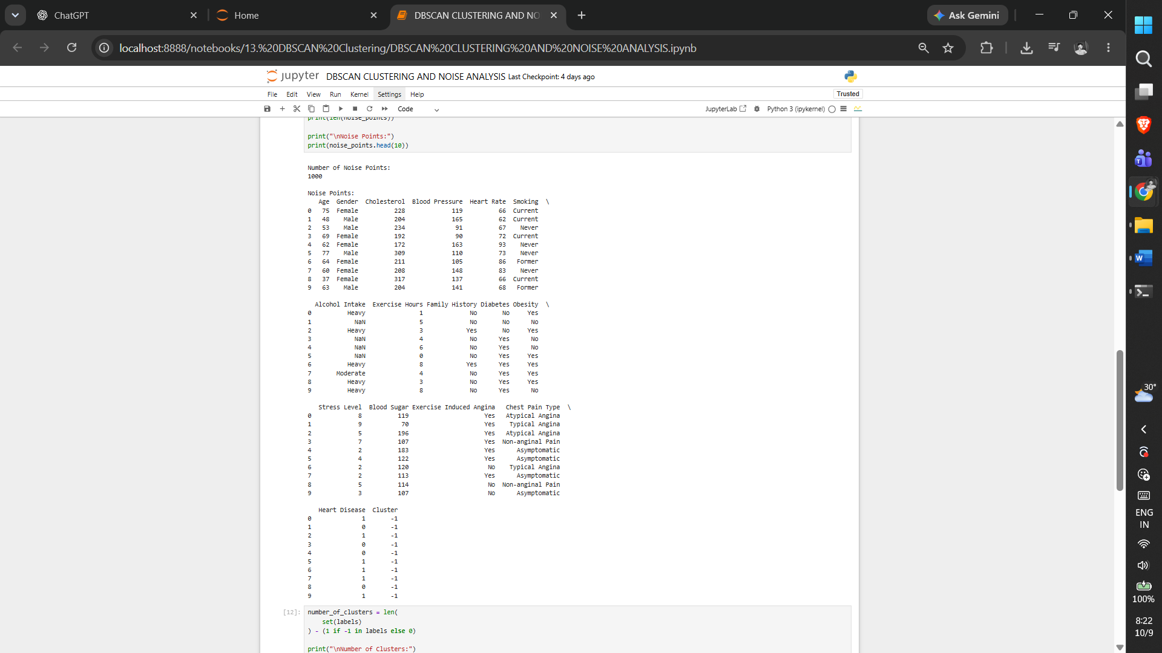

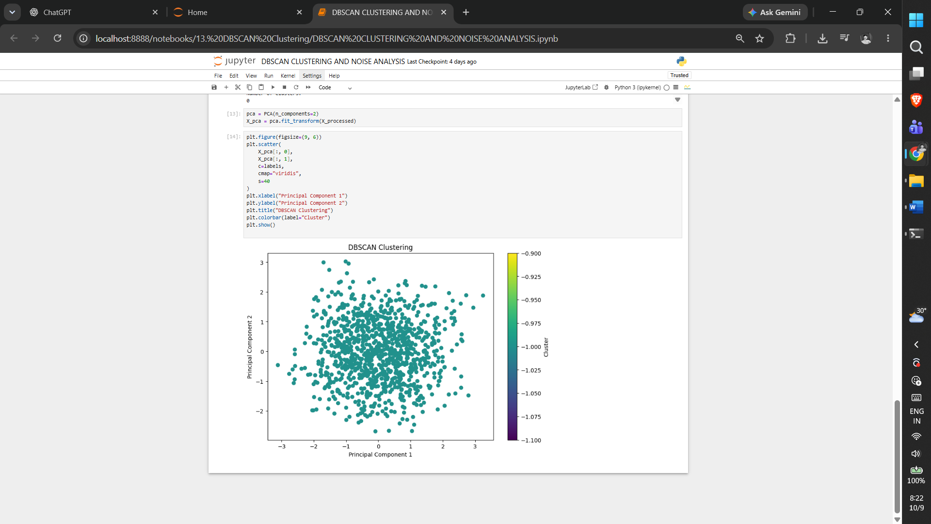

5. RESULT
Thus, the DBSCAN Clustering practical was implemented successfully using the program from the corresponding Jupyter Notebook.

Exercise -14

Principal Component Analysis
1. AIM
To apply Principal Component Analysis to reduce the preprocessed heart disease feature space to two components and measure explained variance.
2. ALGORITHM
1. Load the dataset and separate the target.
2. Identify numerical and categorical features.
3. Scale numerical features and one-hot encode categorical features.
4. Convert the processed data when required.
5. Fit PCA with two components.
6. Transform the data and calculate explained variance.
7. Plot the two principal components.
3. PROGRAM
#!/usr/bin/env python
# coding: utf-8

import pandas as pd
import matplotlib.pyplot as plt

from sklearn.compose import ColumnTransformer
from sklearn.preprocessing import StandardScaler, OneHotEncoder
from sklearn.decomposition import PCA

df = pd.read_csv("heart_disease_dataset.csv")

print("Dataset Shape:", df.shape)

print("\nFirst 5 records:")
print(df.head())

X = df.drop("Heart Disease", axis=1)

numeric_features = X.select_dtypes(
include=["int64", "float64"]
).columns

categorical_features = X.select_dtypes(
include=["object"]
).columns

preprocessor = ColumnTransformer(
transformers=[
("num", StandardScaler(), numeric_features),
("cat", OneHotEncoder(handle_unknown="ignore"), categorical_features)
]
)

X_processed = preprocessor.fit_transform(X)

# Check whether X_processed is sparse or already a NumPy array
if hasattr(X_processed, "toarray"):
X_processed = X_processed.toarray()

print("\nProcessed Data Shape:")
print(X_processed.shape)

pca = PCA(
n_components=2
)

X_pca = pca.fit_transform(X_processed)

pca_df = pd.DataFrame(
X_pca,
columns=[
"Principal Component 1",
"Principal Component 2"
]
)

print("\nPCA Transformed Data:")
print(pca_df.head())

print("\nExplained Variance Ratio:")

print(pca.explained_variance_ratio_)

total_variance = pca.explained_variance_ratio_.sum()

print("\nTotal Variance Explained:")
print(total_variance)

print(
"\nPercentage of Variance Explained:",
total_variance * 100,
"%"
)

plt.figure(figsize=(9, 6))

plt.scatter(
X_pca[:, 0],
X_pca[:, 1],
s=40
)

plt.xlabel("Principal Component 1")
plt.ylabel("Principal Component 2")

plt.title("PCA Visualization")

plt.grid(True)

plt.show()

4. OUTPUT

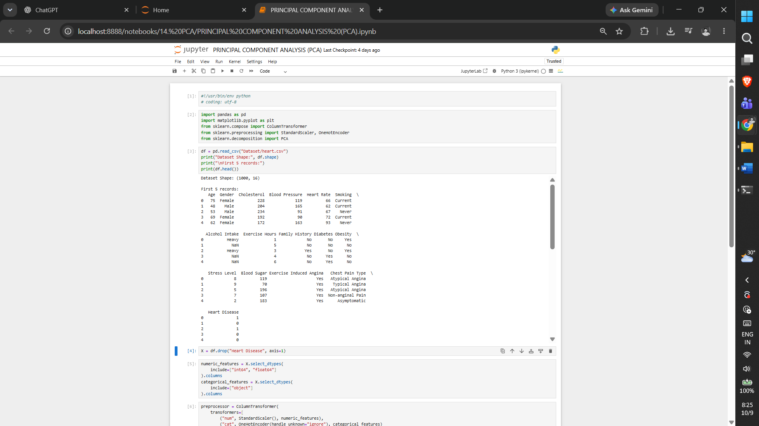

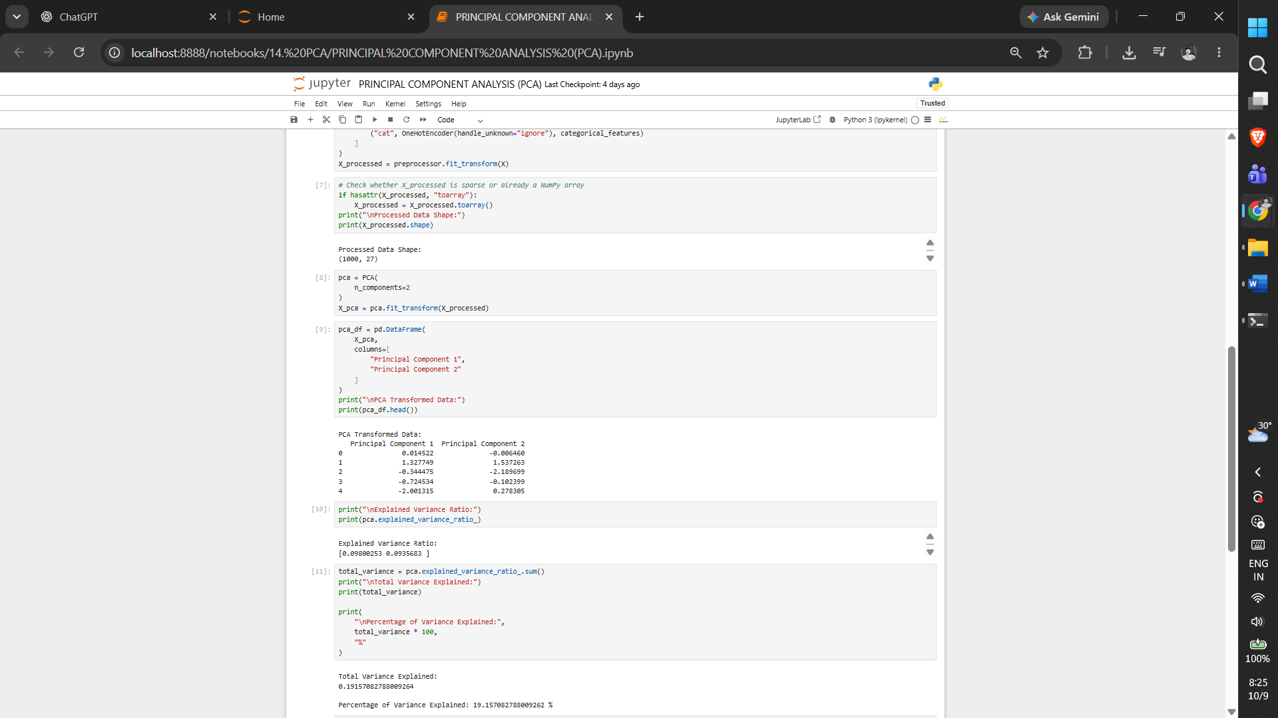

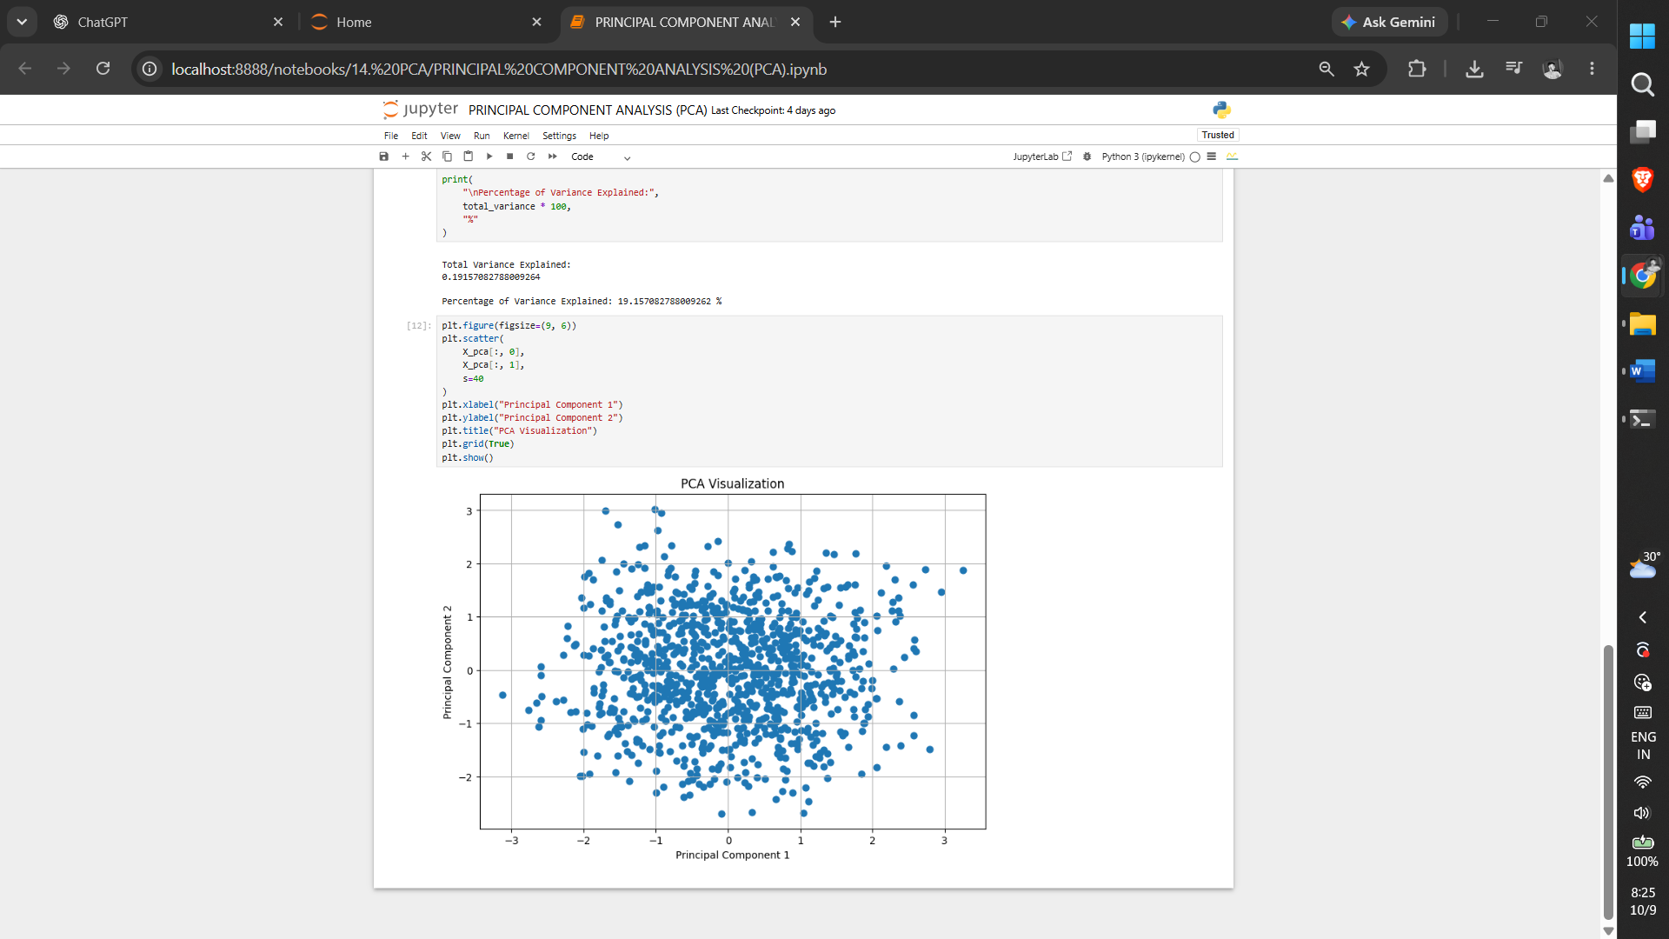
5. RESULT

Thus, the PCA practical was implemented successfully using the program from the corresponding Jupyter Notebook.

